PACPLAN
PACIFIC ISLANDS
REGIONAL
MARINE SPILL
CONTINGENCY PLAN 2013

[Endorsed at the 24th SPREP Meeting, Apia, Samoa – September 2013] [brackets to be removed upon endorsement]

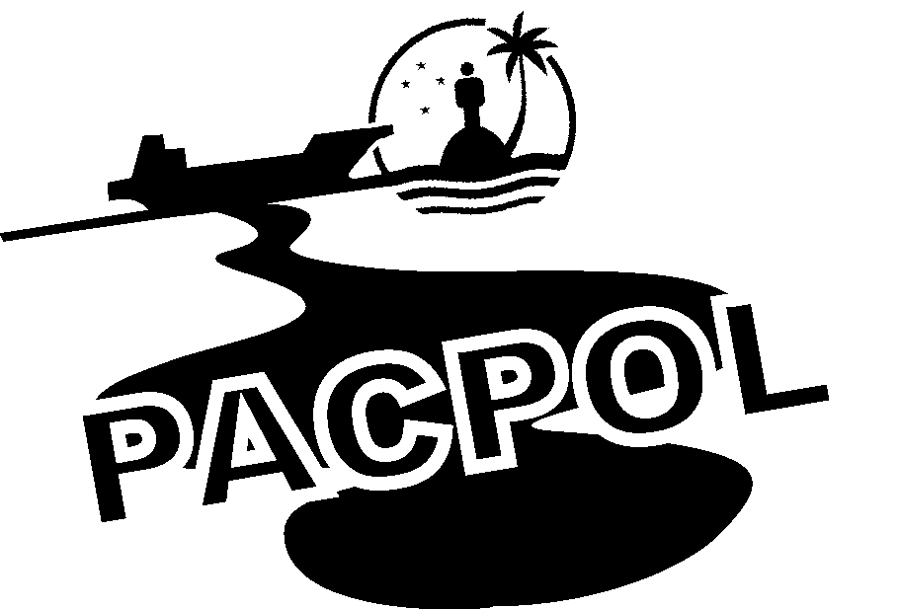
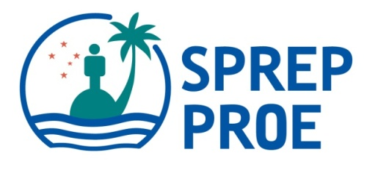

Developed by Secretariat of the Pacific Regional Environment Programme under the auspices of:
PACPOL - the Pacific Ocean Pollution Prevention Programme

SPREP
Vailima, Apia
Samoa
Tel: + 685 21929
Fax: +685 20231

Through funding assistance from


This page intentionally blank.

PLAN AMENDMENT CERTIFICATION

Proposals for amendment or additions to the text of this plan should be forward to:
Pollution Adviser
SPREP

Tel: (685) 21929 Fax: (685) 20231
E-mail: sprep@sprep.org

Amendment |  | Section | Page | Entered | Date | Signature
No | Date

This page intentionally blank.

TABLE OF CONTENTS

PLAN AMENDMENT CERTIFICATION iii
TABLE OF CONTENTS 5
GLOSSARY OF TERMS 7
1. INTRODUCTION 9
1.1 Background 9
1.2 Mandate 10
1.3 Aim & Objectives 11
1.4 Technical Scope & Tiered Response 11
1.5 Geographical Scope 14
1.6 Parties to the Plan 14
1.7 Underlying Principles & Protection Priorities 14
1.8 Risk Assessment 15
2. ROLES & RESPONSIBILITIES 18
2.1 SPREP 18
2.2 SPREP Island Member Governments 18
2.3 SPREP Metropolitan Member Governments 19
2.4 Industry 20
3. US OCEANIA REGIONAL CONTINGENCY PLAN (ORCP) 21
4. POLLUTION REPORTS & COMMUNICATIONS 22
4.1 Pacific Regional Marine Spill Reporting 22
4.2 Surveillance & Spill Detection 22
4.3 Initial Pollution Reports (POLREPS) 22
4.4 Situation Reports (SITREPS) 23
4.5 Post-Incident Reports (POSTREPS) 23
5. RESPONSE OPERATIONS 24
5.1. General 24
5.2 Incident Command System (ICS) 24
5.3 Secure Human Life, Health and Safety 25
5.4 Stem Spill Source 25
5.5 Spill Assessment & Reporting 25
5.6 Spill Surveillance and Forecasting 25
5.7 Monitor 25
5.8 Containment & Recovery at Sea 26
5.9 Use of Oil Spill Dispersants 26
5.10 Foreshore Protection 26
5.11 Foreshore Clean-up 27
5.12 Oiled Wildlife Operations 27
5.13 Oily Waste Management 27
5.14 Joint Response Operations 28
5.15 HNS Spill Response 29
6. ADMINISTRATION AND FINANCE 30
6.1 Requests for Assistance 30
6.2 Customs, Immigration & Quarantine 34
6.3 Logistics 34
6.4 Finances 35
7. RESPONSE TERMINATION & POST-SPILL ACTIVITIES 38
7.1 Response Termination 38
7.2 Equipment Cleaning/Restoration and Return 38
7.3 Response Evaluation & Debriefing 38
7.4 Damage Assessment & Monitoring 38
7.5 Environmental Restoration & Rehabilitation 39
8. PUBLIC INFORMATION 40
8.1Public Relations Officer (PRO) 40
8.2 Press Releases 40
8.3 Press Conferences 40
8.4 Community Volunteers 41
9. EQUIPMENT 42
9.1 National Resources 42
9.2 Regional Resources 42
10. TRAINING & EXERCISES 44
10.1 Regional PACPOL Activities 44
10.2 Specialist Training Courses 44
10.3 In-Country Exercises 44
10.4 Regional Register of Marine Spill Responders 45
11. ADOPTION, CONTROL & REVISION OF THE PLAN 46
11.1 Adoption of the Plan 46
11.2 Control of the Plan 46
11.3 Revision and amendment of the Plan 46
ATTACHMENTS 47
Attachment 1: PACPLAN Marine Spill Response Contacts 48
Attachment 2: Standard Pollution Report (POLREP) Form 53
Attachment 3: Standard Situation Report (SITREP) Form 55
Attachment 4: Status of the Noumea Convention and Associated Protocol Parties as at July 2012 57
Attachment 5: Status of IMO Convention Parties as at 2 Jan 2013 58
Attachment 6: Risk Assessment in the Pacific Region. 59
Attachment 7: List of SPREP Trained Marine Spill Responders as of Dec 2012. 74
Attachment 8: Model Memorandum of Understanding or Technical Agreement for Bilateral Co-operation 84
Attachment 9: Standard Request for Assistance Form 86
Attachment 10.1: Guideline to Tier 1 & 2 Equipment Stockpile. 88
Attachment 10.2: Equipment Inventory. 90
Attachment 11: Claims Guide. 98

Tables & Figures

Table 1: SPREP Member Countries and Territories
Table 2: Primary and Secondary Sources of Assistance

Figure 1: Map of Pacific Islands Countries and Territories Region
Figure 2: Total vessel traffic by frequency
Figure 3: Incident Command System structure
Figure 4: Request for Assistance

GLOSSARY OF TERMS

AIP Australian Institute of Petroleum
AMSA Australian Maritime Safety Authority
AMOSC Australian Marine Oil Spill Centre
CMC Centre for Marine Conservation
OSRL Oil Spill Response Limited
FUND Convention International Convention for the Establishment of an International Fund for Compensation for Oil Pollution Damage, 1992.
HNS Hazardous and Noxious Substances
IC Incident Commander
ICC Incident Command Centre
IMO International Maritime Organisation
INTERVENTION International Convention Relating to Intervention on the High Seas in Cases of Oil Pollution Casualties 1969
IOPC Fund International Oil Pollution Compensation Fund
ITOPF International Tanker Owners Pollution Federation
Lead Agency Entity that has operational responsibility for managing the response to a particular marine spill. The Lead Agency will vary according to the size and location of the spill.
London Convention Convention on the Prevention of Marine Pollution by Dumping of Wastes and Other Matter 1972 as amended by the Protocol of 1996
LOS (International) Law of the Sea
MARPOL International Convention for the Prevention of Pollution from Ships 1974 as amended by the Protocol of 1978
PA Pollution Adviser
POLFUND National Marine Pollution Fund
NATPLAN National Marine Spill Contingency Plan
OPRC International Convention on Oil Pollution Preparedness, Response and Co-operation 1990
OPRC-HNS Protocol on Preparedness, Response and Co-ordination to Pollution Incidents by Hazardous and Noxious Substances 2000
ORCP Oceania Regional Contingency Plan
ORRT Oceania Regional Response Team
PACPLAN Pacific Islands Regional Marine Spill Contingency Plan
PACPOL Pacific Ocean Pollution Prevention Programme
POLREP Pollution Report
Responsible Authority Government department or authority which has responsibility for administering and enforcing the national marine pollution legislation and for the overall management of the NATPLAN.
SITREP Situation Report
SPREP Secretariat of the Pacific Regional Environment Programme
SPREP Metropolitan Members The SPREP non Pacific island Members Australia, France, New Zealand, United Kingdom and the United States of America,
Noumea Convention Convention for the Protection of the Natural Resources and Environment of the South Pacific Region and related protocols
Noumea Dumping Protocol Protocol for the Prevention of Pollution of the South Pacific Region by Dumping
Noumea Pollution Emergencies Protocol Protocol concerning Co-operation in Combating Pollution Emergencies in the South Pacific Region
Tier One Spill Spills that are within the response capability and resources of an individual port or oil terminal.
Tier Two spill Sized spills that are within the national capability and resources of the individual SPREP member where the spill occurs and the impact or potential impact is limited to the waters within the jurisdiction of that SPREP member only.
Tier Three spill Spills that are of a magnitude and/or severity that is beyond the response capability and resources of the individual SPREP member where the spill occurs, and/or spills that impact or threaten to impact within the jurisdiction of two or more SPREP members. PACPLAN is limited to addressing Tier Three spills
UNCLOS United Nations Convention on the Law of the Sea
U.S. United States (of America)
USCG United States Coast Guard

This page intentionally blank.

1. INTRODUCTION

1.1 Background

Marine pollution is widely recognised as one of the four major threats to the world’s oceans, along with climate change, habitat destruction and over-exploitation of living marine resources. Spills of oil and other chemicals into the marine environment, both from ships and land-based sources, is a significant source of pollution.

In a region sometimes called ‘Oceania’, the health of the ocean is fundamental to the sustainability of all aspects of Pacific island life. The importance of coastal and marine environments to every aspect of the lives of Pacific islanders cannot be overstated, and the impacts of marine spills constitute a major concern for Pacific island peoples. Because of a lack of major land-barriers throughout the Pacific, combined with a complex pattern of trans-oceanic currents, the Pacific Ocean is perhaps the most highly connected and continuous ocean, in terms of water movement, on the planet. This compounds the seriousness of marine pollution for the region. Events in one area can have implications for other areas, as pollutants and contaminants are carried from their sources by ocean movements.

The region is not immune to the challenges of sustainable development and faces the pressures of economic development. Throughout the region there are activities associated with gas and oil exploration, and refineries are situated along the coastline or served by seagoing tanker vessels.

Pacific islands therefore need to work together, through regional arrangements to address marine pollution. No single country in the region can address this problem in isolation. There are a number of agreements, conventions, instruments, policies and other initiatives that require countries to work co-operatively to address marine pollution and protect the marine environment. At the international level these include: the international Law of the Sea (LOS), the International Convention on Oil Pollution Preparedness, Response and Co-operation 1990 (OPRC 90) and the OPRC HNS Protocol.
At the regional level they include the Convention for the Protection of the Natural Resources and Environment of the South Pacific Region (the Noumea Convention 1986) and associated Protocols.
The Secretariat of the Pacific Regional Environment Programme (SPREP), as part of its role to assist island members to address environmental issues and in accordance with the SPREP Action Plan, has developed a comprehensive programme to address marine pollution. This is called the Pacific Ocean Pollution Prevention Programme (PACPOL).

PACPOL has developed a number of initiatives to assist Pacific island members with marine spill prevention and response. Many Pacific Island Countries (PICs) have used the National Marine Spill Contingency Plan (NATPLAN) template to develop their own national plans. Many of these NATPLAN’s however are still in draft, and need to be formally approved by national processes and in some cases, still require endorsement by government.

The Pacific Islands Regional Marine Spill Contingency Plan or PACPLAN (this document), was first endorsed in 2000 and provides the framework for co-operative regional responses to major marine spills in the Pacific Islands region. This includes a description of underlying spill response philosophies and priorities, the roles and responsibilities of relevant organisations, regional and supra-regional linkages and mechanisms for accessing regional and supra-regional assistance to utilised in a pollution incident.

1.2 Mandate

In addition to the international and regional instruments referred to above, the primary mandate for PACPLAN stems from both a specific regional convention and two international conventions outlined below.

1.2.1 Noumea Pollution Protocol

The members of SPC adopted the Convention for the Protection of the Natural Resources and Environment of the South Pacific Region (the Noumea Convention), with associated Protocols at Noumea, New Caledonia on 25 November 1986. The Convention includes a Protocol Concerning Co-operation in Combating Pollution Emergencies in the South Pacific Region (Noumea Pollution Protocol). In 2006 the Noumea Convention Parties adopted two new protocols to replace the Noumea Pollution Protocol to bring them in line with the OPRC Convention and the OPRC-HNS Protocol. The new protocols are the Oil and HNS Protocols and will enter into force when ratified by 5 parties. The current Noumea Protocol 1986 provides a formal framework for co-operation between all members of SPREP when responding to marine spills. The Noumea Pollution Protocol 1986 requires Parties to:

- Take initial action at the national level to respond to pollution incidents (marine spills);

- Co-operate with other Parties in the response to pollution incidents;

- Establish and maintain, within their respective capabilities, the means of preventing and responding to pollution incidents, including;
- Enacting relevant legislation;
- Developing and maintaining contingency plans; and
- Designating a Responsible Authority.

- Exchange information with each other and report all pollution incidents to relevant authorities and other parties whose interests are likely to be affected;

- Provide assistance, within their capabilities, to other Parties who request such assistance, based on an agreement with the requesting Party or Parties and taking into account the technological means available;

- Facilitate the movement of personnel and materials needed for response; and

- Develop and maintain, where appropriate sub-regional and bilateral arrangements for preventing and responding to pollution incidents.

The full text of the Noumea Convention 1986 and associated Protocols can be obtained from the SPREP. There are 12 parties to the Noumea Convention and Pollution Protocol. Attachment 4 has a full list of Noumea Convention and associated Protocol Parties.

1.2.2 OPRC Convention and OPRC-HNS Protocol

At the international level, the International Maritime Organisation (IMO) prepared the International Convention on Oil Pollution Preparedness, Response and Co-operation 1990 (OPRC Convention). The OPRC Convention and Protocol have requirements for Parties similar to those of the Noumea Pollution Protocol 1986, as outlined above. As of June 2012, there were 5 PICs party to the OPRC Convention and 2 PICs party to the OPRC-HNS Convention. Details of this can be found at Attachment 5.

1.3 Aim & Objectives

The Aim of PACPLAN is:

- To prevent/minimise damage to marine and coastal environments and resources from marine spills, and to provide systems, frameworks and guidelines to assist with response and recovery of the environment and resources damaged by marine spills in the Pacific islands region.

The Objectives of PACPLAN are:

- To promote and implement regional co-operation in planning and training for marine spill response, and in the actual prevention of, and response to marine spills;

- To facilitate actions and cooperation consistent with both the Noumea Pollution Protocol 1986, the OPRC Convention and the OPRC-HNS Protocol at the operational level by all SPREP members, including those that are not yet parties to these instruments;

- To provide systems for the detection and reporting of marine spills within the area covered by the plan, including communications networks;

- To outline the proactive and counter-measures available to contain and minimise the impacts of a spill on life, the environment, heritage, cultural and economic interests;

- To outline the mechanism and procedures by which SPREP island members may request assistance, in the form of specialised equipment and technical experts; from each other, from SPREP metropolitan members, or from industry;

- To provide guidance for the recovery of costs of responding to marine spills;

- To outline arrangements for resourcing maintenance of PACPLAN and associated systems by the SPREP; and

- To provide a platform for information sharing and as a learning tool.

1.4 Technical Scope & Tiered Response

Traditionally, spill response plans tend to focus exclusively on oil spills. Internationally, there is increasing recognition that it is more effective and efficient to integrate oil spill response arrangements with those for all pollutants, including oil and hazardous and noxious materials (HNS) as defined in the OPRC-HNS Protocol.

PACPLAN therefore covers the response to spills into the marine environment of all forms of pollutants. However, it retains a focus on oil spills, as oil is the main pollutant likely to be spilled in the region.

PACPLAN covers spills into the marine environment from all sources.

As a regional plan, PACPLAN applies only to spills where regional co-operation and/or supra-regional assistance are needed. Under PACPLAN, such spills are classified as Tier Three spills. PACPLAN does not cover Tier One and Tier Two spills.

For the purposes of PACPLAN, Tier One, Two and Three spills are defined as follows:

Tier One

- Spills that are within the response capability and resources of industry, i.e. an individual port, oil terminal or vessel within the SPREP island member where the spill occurs.

Tier One spills should be covered by individual oil companies, port administrators and vessel operators contingency plans. Individual oil companies, port administrations and vessel operators should develop, implement and maintain such plans.

Tier Two

- Spills that are within the national capability and resources of the individual SPREP island member government where the spill occurs.

Tier Two spills should be covered by National Marine Spill Contingency Plans (NATPLANs). Each National government should develop, implement and maintain a NATPLAN, through a National Marine Pollution Committee comprising, as a minimum; the national administrations for maritime transport, environment, fisheries/marine resources and disaster management and the oil industry.

Tier Three

- Spills that are beyond the response capability and resources of the individual SPREP island member where the spill occurs; and/or

- Spills that impact or threaten to impact within the jurisdiction of two or more SPREP island members.

Response to Tier Three spills should initially be according to the relevant NATPLAN, then supported by PACPLAN. The response escalation process is detailed in respective Pacific island member government NATPLANs.

Set quantities and sizes of spills have intentionally not been used in the definition of Tiers. In some instances a relatively small spill may fit the Tier Two or even Tier Three category. Classification depends on the composition and source of the spill, the location and response capabilities and resources of the SPREP island member where the spill occurs, the prevailing conditions at the time of the spill and the types of environments impacted or threatened.

Allocation of any one spill to a particular Tier can only be done at the time of the spill, according to an assessment by the Responsible Authority of the SPREP island member where the spill occurs.

In reality spills do not fall into convenient categories, and the boundaries between Tiers will inevitably be blurred. Responsible Authorities, in consultation with the Lead Agency should always be prepared to involve the next highest Tier from the earliest moments, as it is easier to stand down an alerted system than to escalate a response by calling up the next level of support.

Fig 1 – Map of PICT Region
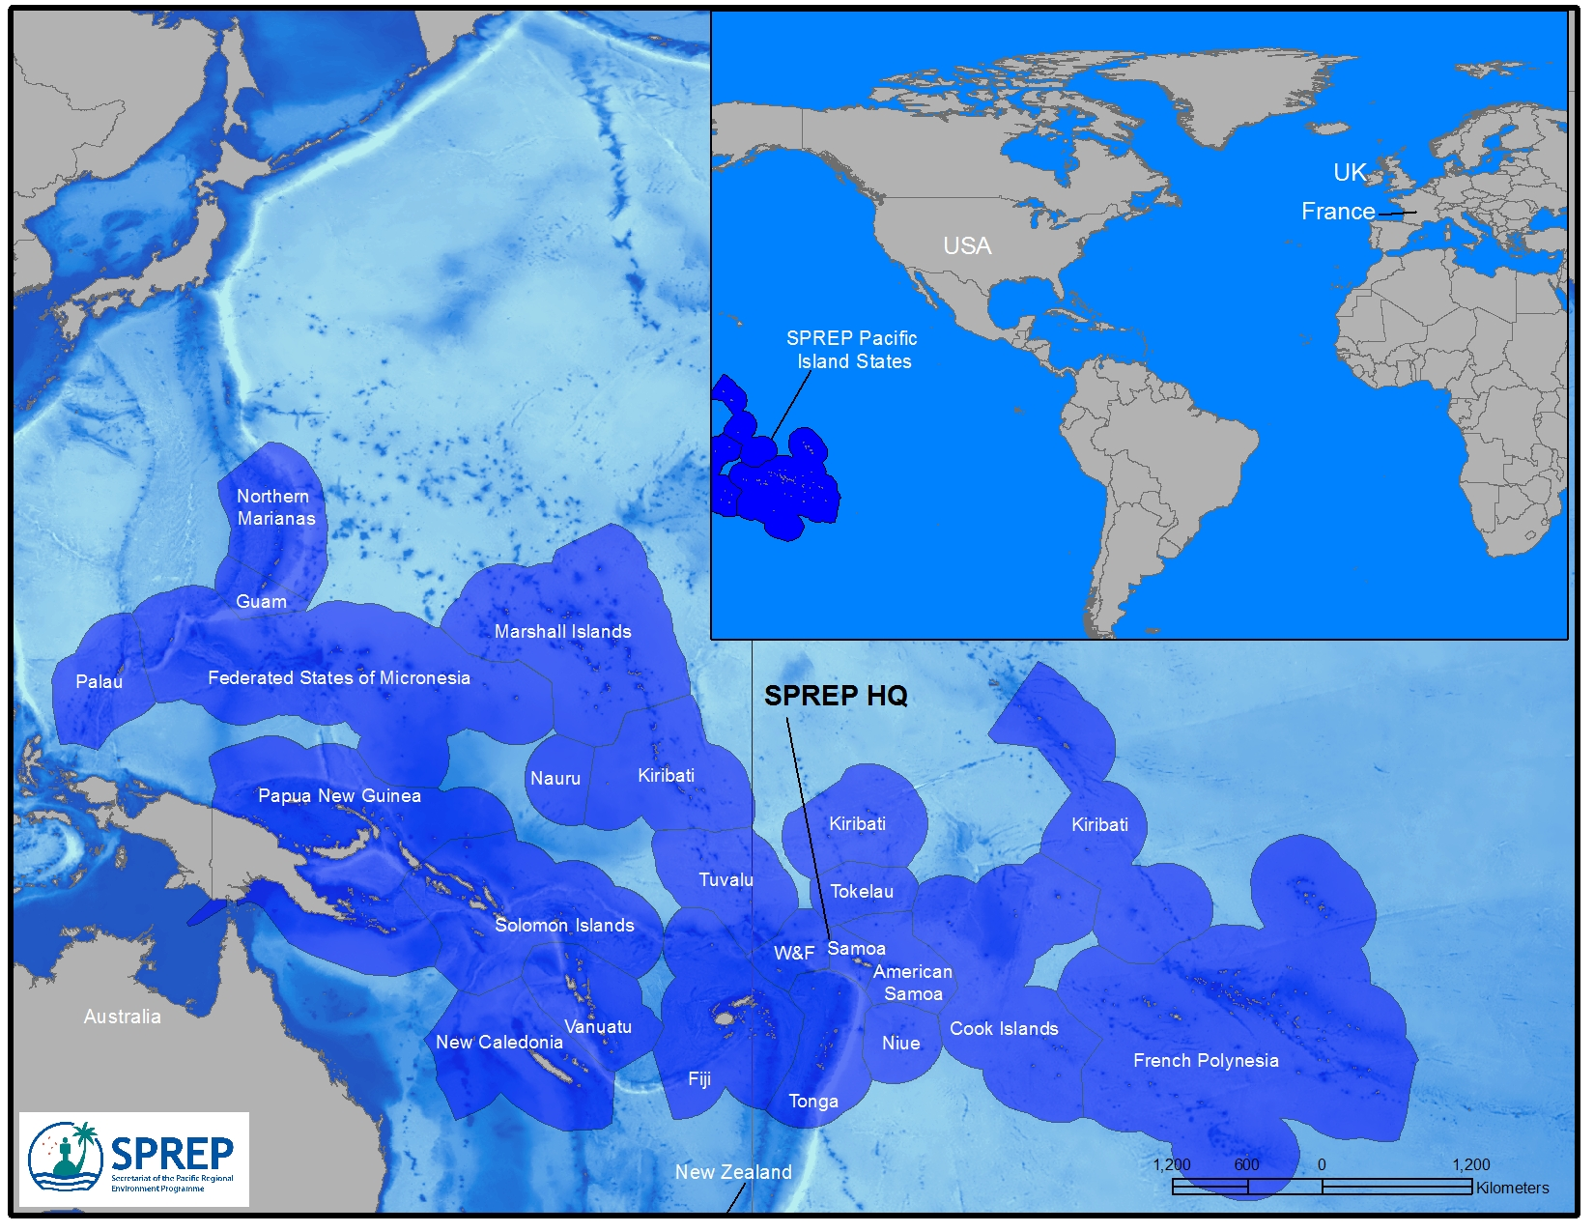

1.5 Geographical Scope

                - The geographical scope of PACPLAN, referred to hereafter as the PACPLAN Area, is the Pacific islands region, as defined by the coastlines and all marine waters within the EEZs of the 21 Pacific Island Countries and Territories which are members of SPREP (SPREP island members) (See Table One and Figure One – Map on previous page).

SPREP island members are grouped into two categories, the 14 independent and semi-independent countries (Pacific Island Countries) and the seven territories (Pacific Island territories - Table One).

In addition to the SPREP island members, there are five metropolitan countries that are also members of SPREP (Table One). They do not constitute part of the PACPLAN area of response operations, but play a vital role in implementing PACPLAN (refer sections 2.3 & 6.1.3).

Table One: SPREP Member Countries and Territories
SPREP Island Members |  | SPREP Metropolitan Members
Pacific Island Countries | Pacific Island Territories
Cook Islands | American Samoa (US) | Australia
Fiji Islands | Northern Mariana Islands (US) | France
Kiribati | French Polynesia (France) | New Zealand
Marshall Islands | Guam (US) | United States of America
Federated States of Micronesia | New Caledonia (France) | United Kingdom
Nauru | Tokelau (NZ)
Niue | Wallis & Futuna (France)
Palau
Papua New Guinea
Samoa
Solomon Islands
Tonga
Tuvalu
Vanuatu

1.6 Parties to the Plan

The Parties to PACPLAN are the 26 SPREP members (both island and metropolitan members as listed above), recognising that industry facilities within the PACPLAN Area are also indispensible partners.

1.7 Underlying Principles & Protection Priorities

PACPLAN is founded on the following general principles:

- Every effort should be made by industry and government to prevent spills of oil and other hazardous and noxious substances from occurring, as the highest priority;

- Despite prevention measures, spills will occur from time to time, hence the need to have contingency plans in place to deal effectively with such spills, at the local, national and regional/international level. PACPLAN constitutes the regional/international response plan for the Pacific islands region; and

- The response to marine spills under PACPLAN should always seek to maximise co-operation, co-ordination and integration between government and industry, and to adopt the most cost-effective, efficient and practicable response options available.

In the event of a marine spill requiring a response to be mounted under PACPLAN, the following protection priorities should be adhered to:

- Human life, health and safety;

- Biological habitat;

- Rare and endangered species;

- Cultural resources;

- Commercial resources; and

- Non-commercial property and amenity.

Human life, health and safety is always the highest priority with individual members defining their own order of protection priorities thereafter.

Within these protection priorities, marine and coastal environments and resources have varying environmental sensitivities, requiring further prioritisation of spill response efforts. The designation of environmental sensitivity grading requires assessment at a much larger scale than can be provided by a regional plan such as PACPLAN. Individual National Marine Spill Contingency Plans (NATPLANS) should designate environmental sensitivities for the coastal and marine areas of each SPREP island member. Guidance on the designation of environmental sensitivity grading is provided in the IPIECA/IMO publication Sensitivity Mapping for Oil Spill Response 2011.

The response to any spill carried out under PACPLAN should be consistent with the environmental sensitivity grading contained in the NATPLAN(s) for the SPREP island member(s) where the spill has occurred.

1.8 Risk Assessment

The PACPLAN Area is host to several categories of seagoing traffic, which can be grouped as follows:

- Transit shipping: Ships that pass through the region without stopping en-route to other destinations;

- International shipping (as distinct from transit shipping): Ships calling at the major ports of the region from outside the region, either with incoming cargo or tourists (cruise ships), or to load exports;

- Regional shipping: Ships trading (both cargo and passengers) between the countries and territories within the region;

- Domestic shipping: Ships trading (both cargo and passengers) within each country and territory in the region;

- Foreign fishing fleet: Fishing vessels from distant water fishing nations operating within the region;

- Domestic fishing fleet: Fishing vessels from the Pacific Islands themselves; and

- Miscellaneous: Private vessels, yachts and special purpose vessels such as warships and research ships.

Ship grounding is the commonest casualty type with significant pollution consequences of concern to PACPLAN. This priority risk was identified in the 2003 Marine Pollution Risk Assessment for the Pacific Islands Region. The loss of heavy fuel oil bunkers is considered the greatest oil spill threat to the region. This is supported with recent incidents such as the M/V Forum Samoa II which grounded at the Apia Samoa harbour entrance in 2009, the M/V Rena which ran aground on Astrolabe Reef New Zealand in 2011 and the M/V Pacific Adventurer in Queensland, Australia in 2009.

Figure 2 – Total vessel traffic by frequency from the 2003 Marine Pollution Risk Assessment
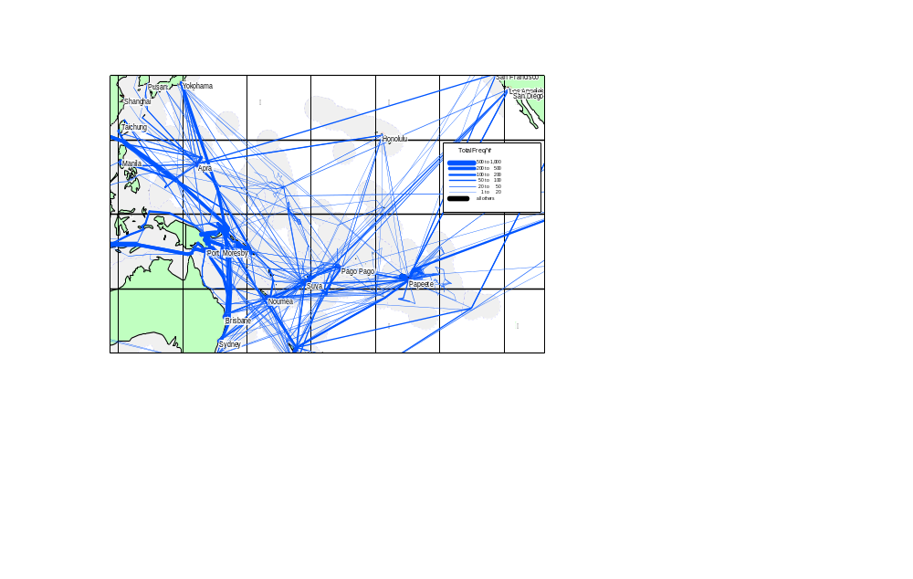

The 2003 study assessed the potential pollution risk at two levels: 1) regional level to EEZ scale, and 2) port scale.

At the EEZ to regional scale, there are clusters of high risk, as shown in Figures 2 (also refer to Attachment 6) in Fiji, French Polynesia, the Solomon Sea shores of Papua New Guinea and the Solomon Islands. The north/south passages east of Papua New Guinea (Jomard entrance, Pioneer Channel) also form a high risk corridor. There are also smaller clusters in Tonga, Samoa, American Samoa, Vanuatu and the corridor of Chuuk northward past Guam and the Northern Mariana Islands. The risks to these areas arise mainly from transit shipping and international shipping.

At the ports scale, the ports with the highest potential for oil pollution incidents are located in Guam, Papeete and Madang. The Port of Moresby with the Napa Napa refinery is also high risk. Noumea, Suva and Vuda/Lautoka although have high tanker volume have moderate oil pollution risk.

Risk of oil pollution from WWII wrecks is also of major concern to many Pacific island nations with over 800 WWII wrecks in PICTs EEZs. The largest number of WWII wrecks can be found in PNG, Solomon Islands, FSM and Palau. Because of the additional risk of unexploded ordinances, sensitivity that most of the vessels are war graves, and the ownership of WWII wrecks lies with the flag state, response to pollution incident from a WWII wreck requires bilateral negotiation between the flag state and the coastal state. SPREP can provide technical assistance upon request in the event of an incident of this nature. The response to the USS Mississinewa at Ulithi Atoll in 2002 is a case study of the type of response required in these circumstances.

2. ROLES & RESPONSIBILITIES

2.1 SPREP

The Secretariat of the Pacific Regional Environment Programme (SPREP), located in Apia, Samoa, has the following roles and responsibilities under PACPLAN:

- Maintaining and updating the Plan, including;
- Staying abreast of developments and changes that affect the content of the Plan and notifying member countries before amending the Plan;
- Managing the distribution of the Plan, which is a controlled document;
- Maintaining a register of holders of the Plan; and
- Ensuring that all holders receive updates to the Plan as they occur.

- Organising and managing PACPOL (and PACPLAN) activities, including training in marine spill response, desktop exercises of PACPLAN and regional co-ordination meetings (refer Section 10);

- Providing/co-ordinating scientific and environmental advice to member governments in the event of a spill;

- Assisting SPREP island members, if required, with requests for external assistance in the event of PACPLAN being activated (refer Section 6.1);

- Receiving, co-ordinating and disseminating reports to affected parties and reporting annual spill statistics to interested parties (refer Section 4.1);

- Maintaining and updating the SPREP Guidelines and Template for National Marine Spill Contingency Plans (SPREP NATPLAN Guidelines), and assisting SPREP island members to develop and implement NATPLANS;

- Maintaining a regional inventory of available marine spill response equipment;

- Maintaining a Regional Register of SPREP trained Marine Spill Responders. The list of trained marine spill responders is in Attachment 7 (refer Section 10.4);

- Generally assisting SPREP island members in the prevention of, planning for and response to marine spills; and

- Setting benchmark on preparedness for SPREP island members.

The SPREP will develop and maintain the necessary staff and material resources to enable it to fulfil these responsibilities, within the resources made available from the general PACPOL programme (refer Section 6.1.2).

2.2 SPREP Island Member Governments

Each SPREP island member government (including both Pacific Island Countries and Territories) has the following roles and responsibilities under PACPLAN, in accordance with national capacity:

- Maintaining a National Marine Pollution Committee (National Committee) whose tasks will include developing and maintaining a NATPLAN, necessary sub-plans for local areas such as individual ports;

- Developing national marine pollution legislation;

- Designating a Responsible Authority, that has legal responsibility for administering and enforcing the national marine pollution legislation and for the overall management of the NATPLAN. Ideally, the Responsible Authority should be the national maritime transport administration;

- Designating a Lead Agency, that has operational responsibility for managing the response to marine spills. The Lead Agency will vary according to the size and location of the spill;

- Reporting all marine spills to the SPREP, in accordance with Section 4 of PACPLAN;

- Taking effective action to respond to marine spills that occur within its jurisdiction;

- Co-operating with and assisting neighbouring countries and territories in the response to marine spills;

- Facilitating the provision and receipt of any external assistance that might be requested /provided (refer Section 6);

- Adopting relevant conventions on marine pollution prevention and complying with the national government obligations of the Noumea Pollution Protocol and the OPRC Convention as well as the OPRC-HNS Protocol as applicable (refer Sections 1.1 and 1.2);

- Reporting to the SPREP any changes in circumstances, including levels of risk of marine spills, capability to manage marine spills, internal administrative arrangements and contact details, that may require revision and updating of PACPLAN; and

- Participating in PACPOL activities.

2.3 SPREP Metropolitan Member Governments

Subject to their capabilities and the availability of relevant resources each SPREP Metropolitan member government (Australia, France, New Zealand, United Kingdom and USA), has the following roles and functions under PACPLAN:

- Assisting SPREP island members in preventing marine spills and planning and preparing for the response to marine spills. This assistance should be provided though the SPREP, under the auspices of PACPOL, in the form of financial support, support-in-kind and/or technical assistance or advice for relevant PACPOL projects, including training and equipment acquisition projects;

- Assisting SPREP island members with the actual response to marine spills, in the form of personnel and/or equipment and/or information/technical advice, when such assistance is requested and in accordance with Section 6 of PACPLAN. Such technical advice can be of great value and can be provided quickly and at no or low cost to the Metropolitan member government; and

- Participating in PACPOL activities.

2.4 Industry

Industry facilities such as oil terminals, ports and harbours, shipping and fishing companies operating in the region have the following roles and responsibilities under PACPLAN:

- Prevent spills from tankers, vessels, ports, terminals, depots and other facilities owned and/or operated by the companies;

- Immediately reporting all marine spills from their facilities both to the Lead Agency/Responsible Authority in the country/territory where the spill occurs in accordance with Section 3 of PACPLAN and the relevant NATPLAN;

- Developing and maintaining local marine spill response plans, for individual tankers, vessels, ports, terminals, depots and other facilities owned and/or operated by the companies which are potential sources of spills, and ensuring that these plans are compatible and integrated with relevant NATPLANS;

- Establishing, storing and maintaining stockpiles of marine spill response equipment for individual tankers, vessels, ports, terminals, depots and other facilities owned and/or operated by the companies, with the types and amounts of equipment being appropriate to the level of risk at each facility;

- Ensuring that staff are appropriately trained in marine spill prevention and response;

- Taking effective action to respond to marine spills that occur at industry facilities;

- Co-operating with, and assisting governments in the response to marine spills, in the form of personnel and/or equipment, when such assistance is requested and in accordance with each country/territory’s NATPLAN;

- Providing the resources of industry Tier 3 providers through the Global Response Network (including AMOSC and/or OSRL) (refer Section 6.1.4);

- Establishing and maintaining linkages with industry OSROS’s (Oil Spill Response Organisations) such as AMOSC and OSRL (through membership) for the provision of the OSRO support to an industry based spill or by requesting Pacific Island governments;

- Actively participating in the National Committees in each SPREP island member country and territory, and in planning, exercises and training activities; and

- Participating in PACPOL activities.

3. US OCEANIA REGIONAL CONTINGENCY PLAN (ORCP)

Under the United States (US) Oil Pollution Act of 1990 (OPA 90), Regional Response Teams (RRT’s) are established for various regions of US jurisdiction, including an Oceania Regional Response Team (ORRT) for the US Pacific islands. These comprise the Territory of American Samoa, the Territory of Guam, the State of Hawaii and the Commonwealth of the Northern Mariana Islands.

ORRT is an inter-agency team comprising U.S. Federal, State and Local government agencies chaired jointly by District 14 of the U.S. Coast Guard (USCG) in Hawaii and Region 9 of the U.S. Environmental Protection Agency (USEPA) in San Francisco. ORRT advises on response planning and actual responses to marine spills in the US Pacific Islands.

ORRT has developed an Oceania Regional Contingency Plan (ORCP) and local Area Committees have developed Area Contingency Plans for Hawaii, American Samoa, and the Mariana Islands (Guam and CNMI). Responses to marine spills in the U.S. Pacific islands are conducted under these plans, consistent with the federal National Contingency Plan, and not PACPLAN.

However, the US Pacific islands (excluding Hawaii) may request external assistance from non-US participants under PACPLAN, in accordance with Section 6. Like-wise, non-U.S. participants may request assistance from the US and/or U.S. Pacific islands under PACPLAN, in accordance with Section 6.

4. POLLUTION REPORTS & COMMUNICATIONS

4.1 Pacific Regional Marine Spill Reporting

Under PACPLAN, the SPREP has established and maintains marine spill reporting through its office in Apia, Samoa.

All reports should be transmitted through the SPREP email address or fax number, providing a focal point for receiving and relaying information concerning any marine pollution incident in the region. This information will then enable:

- Reporting through Pollution Reports (POLREPS) of all marine spills in the region;

- Alerting of other entities potentially affected by a spill; and

- Monitoring the progress of a spill through Situation Reports (SITREPS), allowing updates to be provided to affected parties.

The contact details for reporting are contained in Attachment 1 and are provided on the standard POLREP and SITREP transmission forms (Attachment 2 and 3).

It should be noted that the SPREP is NOT an emergency response facility, and is only functional during normal business hours. Its main purpose is for the collection, analysis and dissemination of spill data. The Responsible Authorities in each country/territory should ensure that national marine spill emergency reporting and alerting systems are established and maintained (refer Sections 4.2. - 4.5.).

4.2 Surveillance & Spill Detection

The initial detection of marine spills is something that can be planned for. All personnel in various industries and government agencies involved in tasks where it is possible to be the first to observe a spill need to be able to do so. These include but are not restricted to ships’ crew, aircraft crew, oil company employees, port personnel and members of the general public, should be required to and be able to report a spill to the relevant authorities. The requirement for reporting spills to the relevant authorities should be mandated under national marine pollution legislation, including penalties for failure to report a spill.

In order to enable spills to be reported, it is important for the Responsible Authority in each Pacific Island Country/Territory to broadly publicise relevant pollution emergency contact numbers. Methods of publicising contact numbers include the emergency section of telephone directories, notices to mariners; notices to aircrew, signage at boat ramps, marinas and ports, bumper/boat stickers and educational posters and pamphlets.

PACPOL utilises existing surveillance platforms and programmes such as the Pacific patrol boats programme, the Forum Fisheries Agency (FFA) aerial surveillance programme and routine civil aviation observations.

4.3 Initial Pollution Reports (POLREPS)

Any spill should be immediately reported to the Responsible Authority. (Attachment 1 provides contact details for the Responsible Authorities in each Pacific Island Country/territory). This includes any spill observed by a ship’s Master or crew, aircraft crew, oil company employee, port personnel or any other person observing a marine spill.

The Responsible Authority should complete a POLREP, using the standard format contained in Attachment 2, and transmit this to the SPREP via email or facsimile. POLREPS should be transmitted to the SPREP for all spills, not just Tier Three spills.

The Responsible Authority in each country/territory should also disseminate all POLREPS to all affected/interested parties, including those whose interests are potentially affected by the spill, such as neighbouring governments if it appears likely that the spill may affect their sea areas and/or shorelines.

4.4 Situation Reports (SITREPS)

In order to provide periodic updates on pollution incidents, the Responsible Authority in the country/territory where the spill has occurred, should transmit SITREPS to the SPREP and all affected/interested parties via email or facsimile at regular intervals throughout the spill, using the standard format contained in Attachment 3.

4.5 Post-Incident Reports (POSTREPS)

After a pollution incident, the Responsible Authority of each government affected should prepare a brief report including:

- Assessment of the response operation, including reference to equipment used, its effectiveness, additional equipment, and training needs;
- Documentation of clean-up costs;
- Assessment of environmental and economic damage;
- Details of problems encountered; and
- Recommendations regarding amendment or revision of NATPLANs/PACPLAN.

When each government has compiled these individual reports, the Incident Commander and other personnel should liaise with the SPREP to review their collective experiences and compile an overall Post-incident Report (POSTREP) that will include the root causes and lessons learnt for all SPREP members, including as appropriate, any recommendations for revising PACPLAN (in accordance with procedures in Section 11).

5. RESPONSE OPERATIONS

5.1. General

It is not the purpose of PACPLAN to provide detailed technical information on the specific methods and techniques that should be used to respond to a marine spill. These should be provided in the respective NATPLANS of each Pacific island country and territory. However, in responding to a marine spill, a logical sequence of actions should be followed as outlined in Sections 5.3 to 5.13.

5.2 Incident Command System (ICS)

Response operations cannot be effectively carried out unless there is a clear organisational structure to command and control the response. This structure should be established by the designated Lead Agency of the government in each country/territory, and detailed within each NATPLAN.

Figure 3 – Incident Command System (ICS) Structure
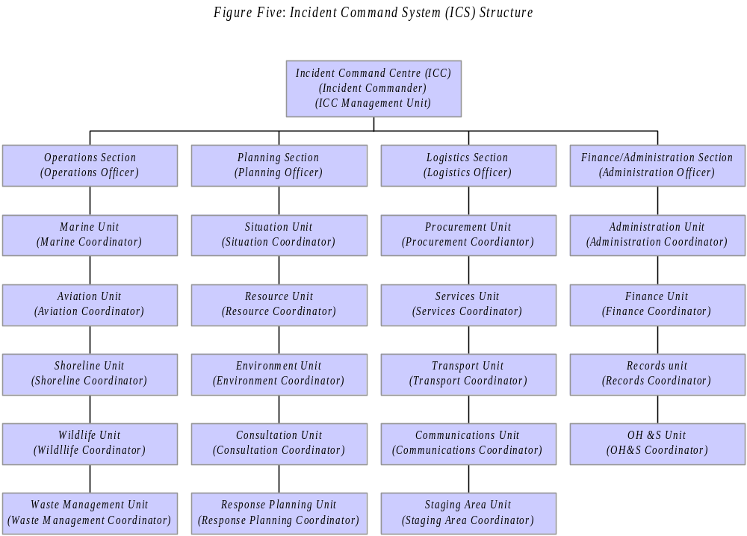

Many developed countries, including Australia, New Zealand and the U.S. have adopted a standard Incident Command System (ICS). To ensure consistency and inter-operability, a simplified version of the ICS is the preferred arrangement for SPREP island members.

The overall structure of the preferred ICS is depicted in Figure 3. The Incident Commander is the ultimate decision-making authority in relation to spill response activities, and should be vested with the necessary decision-making powers. Further details on ICS, including a breakdown of the roles and responsibilities of the various groups, are provided in the SPREP NATPLAN Guidelines.

5.3 Secure Human Life, Health and Safety

The highest priority when a spill has occurred is to take action to ensure that the risk to human life, health and safety is minimized to as low as reasonable practical. This should take precedence over all other actions.

5.4 Stem Spill Source

A priority action is to attempt to stop the flow of oil (or other pollutant in the case of spills other than oil), in order to minimise the potential size, extent and severity of the spill.

5.5 Spill Assessment & Reporting

The nature, size, extent, severity and likely movement of the spill should be assessed, and a POLREP completed and transmitted urgently to the Lead Agency and the SPREP, in accordance with Section 4.2.

Assessment of the spill should include an attempt to classify it as Tier One, Two or Three (refer Section 1.3), and determine whether or not PACPLAN should be activated. The assessment of Tier levels may change over time and should be periodically reviewed during the spill.

5.6 Spill Surveillance and Forecasting

It is vital that the likely movement of the spill is assessed, in order to identify possible impact areas and determine the most appropriate response options. Visual observation of any spill is essential and the Responsible Authority under the respective NATPLAN(s) should use those resources identified in the NATPLAN(s), such as charter, military, or commercial aircraft, to assess and monitor the movement of the spill. Advice on this can be sought from the SPREP.

Meteorological and hydrographic data should be obtained by the Responsible Authority(ies) and analysed to obtain predictions of expected spill movement. Local knowledge from people such as fishermen and mariners should be used as a valuable additional source of expertise on likely spill movement.

Information on the availability of spill trajectory modelling systems for various areas can be requested from SPREP metropolitan members, in accordance with Section 6.

5.7 Monitor

Should surveillance and forecasting indicate that the spill is unlikely to impact on sensitive areas and is likely to remain in open water, then the best option may be to leave the spill alone, allowing natural physical and biological degradation to occur.

However, it is vital that the movement of the spill is closely monitored, through continuing surveillance and forecasting (as per Section 5.6). The next stage of response operations should be activated if even the slightest possibility of a pollutant impact on a sensitive area (s).

5.8 Containment & Recovery at Sea

Should surveillance and forecasting indicate that the spill may impact on sensitive areas, the possibility of containing and recovering the oil to prevent such impact should be pursued. The techniques and equipment available for containment and recovery should be outlined in the relevant NATPLAN(s) for the country/territory(ies) affected by the spill.

The ability to conduct effective containment and recovery operations will be limited by the nature of the spill, available equipment, prevailing conditions and logistical considerations. In many instances, especially in open water, containment and recovery may not be feasible.

5.9 Use of Oil Spill Dispersants

Another possible option to prevent or minimise the spill from impacting on the coast is to disperse it at sea, using chemical dispersants. The techniques and equipment available for the application of dispersants should be outlined in the relevant NATPLAN(s) for the country/territory(ies) where the spill has occurred.

The use of dispersants should only occur under strict supervision and under authority of the IC (the SPREP can provide advice), and in accordance with SPREP Guidelines On the Use of Oil Spill Dispersants (available from the SPREP and contained in the SPREP NATPLAN Guidelines), taking into account the IMO Dispersant Guidelines.

5.10 Foreshore Protection

In most circumstances, despite best efforts to contain and recover and/or disperse a spill at sea, a weather-driven spill is highly likely to impact on coastal environments and resources.

Efforts will therefore be needed to protect foreshores. Options include the use of oil spill booms to physically prevent oil from impacting on the foreshore, or to direct it to preferred collection points (such as a sandy beach), where it can be recovered.

The techniques and equipment available for foreshore protection should be outlined in the relevant NATPLAN(s) for the country/territory(ies) where the spill threatens to impact.

The ability to conduct effective foreshore protection operations will be limited by the nature of the spill, available equipment and personnel, prevailing conditions and logistical considerations. In virtually every situation, it will only be feasible to protect a relatively small area of foreshore. It is therefore critically important to clearly establish protection priorities, in accordance with the relative environmental sensitivities and resource values of the potentially threatened coastal environments and resources.

The designation of environmental sensitivity grading should involve assessment at a much larger scale than can be provided by a regional plan such as PACPLAN. Individual NATPLANS should designate relative environmental sensitivities for coastal and marine areas, and foreshore protection operations should give priority to protecting the most valuable/sensitive coastal environments and resources as identified in these environmental sensitivity grading.

In the event that detailed environmental sensitivity grading and protection priorities are not available, the following general protection priorities should be used, consistent with Section 1.5 of PACPLAN:

- Biological habitat;

- Rare and endangered species;

- Cultural resources;

- Commercial resources; and

- Non-commercial property and amenity.

5.11 Foreshore Clean-up

In the event that a spill does impact on coastal resources and environments, foreshore clean-up operations may be needed. However, before proceeding with a clean up, the option of leaving the oil (or other pollutant) alone and allowing natural physical and biological degradation to occur, should be evaluated.

The techniques and equipment available for foreshore clean up should be outlined in the relevant NATPLAN(s) for the country/territory(ies) where the spill has impacted. An important consideration during foreshore clean up is to ensure that clean up operations do not cause greater environmental damage than the spill itself (for example heavy machinery damaging sand-dunes, use of dispersants on foreshores driving oil into the substrate etc).

5.12 Oiled Wildlife Operations

It is highly likely that wildlife will become contaminated in the event of a spill, including sea-birds and shorebirds, marine reptiles (e.g. nesting turtles) and possibly marine mammals.

The techniques and equipment available for rescuing, cleaning and rehabilitating affected wildlife should be outlined in the relevant NATPLAN(s) for the country/territory(ies) where the spill has impacted. Because of the complexity of such operations, it may be appropriate to have a separate oiled wildlife plan as a sub-set of each NATPLAN.

The status of wildlife species as rare, threatened and/or endangered under international biodiversity and species protection conventions and classification systems (e.g. IUCN Red List Categories) should be considered in prioritising oiled wildlife response. The SPREP can provide technical advice in this regard. Requests for such assistance should be made in accordance with Section 6.

5.13 Oily Waste Management

An often difficult problem created by oiled foreshore clean-up is the generation of quantities of recovered oil and oily waste, which needs to be treated, recycled and/or disposed of. The problems of oily waste management are exacerbated on small islands such as those of the region, due to severe limits on management options.

Oily waste management arrangements should be outlined in the relevant NATPLAN(s) for the country/territory(ies) where the spill has impacted.

In many circumstances in the Pacific islands region, the best option may be to ship oily waste off the island that has been impacted, to a destination which has the proper waste management facilities. This option may require some form of external assistance. Requests for such assistance should be made in accordance with Section 6.

The transboundary movement (i.e. shipment between countries) of waste oil and oily wastes is regulated under two conventions, one global and the other regional. The global convention is the “Basel Convention on the Control of Transboundary Movements of Hazardous Wastes and their Disposal” (the Basel Convention). The regional convention is the “Convention to Ban the Importation into Forum Island Countries of Hazardous and Radioactive Wastes and to Control the Transboundary Movement and Management of Hazardous Wastes within the South Pacific Region” (the Waigani Convention).

Any shipment of waste oil and/or oily waste collected from a spill clean-up should therefore comply with any applicable requirements of these two conventions. The SPREP can provide technical advice in this regard. Requests for such assistance should be made in accordance with Section 6.

5.14 Joint Response Operations

The response to some marine spills under PACPLAN may need to involve joint response operations by two or more coastal States i.e. SPREP island member governments and the vessel flag State. Such situations include:

- A spill within one jurisdiction which moves or threatens to move into an adjacent jurisdiction(s); and

- A spill in international waters which moves or threatens to move into two or more adjacent jurisdictions.

Under these circumstances, the government whose waters are closest to the pollution incident should generally assume the lead role and report the spill to the SPREP. This government should also track the spill and perform any necessary initial response. The flag State of any vessel involved should be notified immediately and the response coordinated with that State as well.

The Responsible Authority should inform neighbouring government(s) and these should activate their own response plans in close co-ordination with the government that has assumed the lead role.

Any government may escalate the response by calling for assistance from other SPREP island members, metropolitan members, industry facilities and/or other external parties, in accordance with Section 6.

In the event that the spill moves across national sea boundaries, an agreement or arrangement should be reached between the governments concerned for the orderly transfer of the lead role and on-scene co-ordination function.

In preparation for possible joint operations, neighbouring countries/territories may wish to develop joint marine spill response plans and enter into bilateral or multilateral Memorandums of Understanding (MoU) or Technical Agreements, which, amongst other things, should:

- Clearly define command and liaison structures for joint response operations;

- Outline procedures for co-operative use of vessels, aircraft and spill response equipment including logistical considerations;

- Identify agreed protection priorities; and

- Provide arrangements for marine operations in, or overflying of, each other’s territory.

Surveillance flights to evaluate or assist in the response to marine spills may need to involve the overflight of territorial and internal waters of another government. In order to optimise the use of aerial resources, each government should make advance arrangements with neighbouring governments for the rapid granting of permission for overflights and for the use of their airport facilities. Such arrangements should be included in respective NATPLANS and any applicable joint response plans.

Attachment 8: Model Memorandum of Understanding for Bilateral Co-operation provides a model of a MoU or TA that countries/territories may use as the basis for developing their joint response arrangements.

5.15 HNS Spill Response

As outlined under Section 1.3, PACPLAN is designed to cover the response to spills into the marine environment of all types of pollutants, including oil, hazardous and noxious substances (HNS).

However, technical details within PACPLAN relate primarily to marine oil spills. This reflects the fact that oil is the main pollutant likely to be spilled in the region, and the fact that the discipline of oil spill response is far more developed and advanced than that of HNS spill response.

In the event of a HNS spill within the PACPLAN Area, the general procedures and arrangements of PACPLAN should be followed. In addition, the NATPLAN of each SPREP island member, if developed in accordance with the SPREP NATPLAN Guidelines, should cover the response to HNS spills. The NATPLANS should therefore outline the techniques and equipment available for HNS spill response in each country/territory.

Should a SPREP island member where the HNS spill has occurred need technical advice and assistance with the response, this should be requested in accordance with Section 6. The response capabilities available from SPREP metropolitan members and industry providers should be collated as part of the inventory stockpiles in the Attachment 10.

6. ADMINISTRATION AND FINANCE

6.1 Requests for Assistance

The Responsible Authority of each island member is the only authority authorised to initiate a request for external assistance under PACPLAN. Once the Responsible Authority assesses a spill to be a Tier Three spill (refer Sections 1.3 and 6.5), a Diplomatic Note and a Request for Assistance form (Attachment 9) should be completed. Both documents are to be transmitted via email or facsimile directly to the local embassy of the member from which assistance is requested (refer Attachment 1 for contact details for assistance providers), and copied to the SPREP.

Figure 4 – Request for Assistance

The U.S. Pacific island territories (American Samoa, Guam and Northern Marianas), when requesting assistance from the U.S., should do so in accordance with the U.S. ORCP, and not PACPLAN. Likewise, French Pacific island territories (French Polynesia, New Caledonia and Wallis and Futuna) should seek assistance in accordance with the ‘Plan Orsec maritime contingency plan’ and not PACPLAN. The U.S. and France Pacific island territories should use the PACPLAN procedures when requesting assistance from non-U.S. or French States.

Whilst requests for assistance should be made directly from the requesting country/territory to the assistance provider, a requesting country/territory may ask the SPREP to facilitate the request for assistance as per Figure 4 above.

In requesting assistance, the requesting country/territory should provide as much information as possible about the nature of the spill and be as specific as possible about the type of assistance required. Determination of the most appropriate assistance package should be carried out through discussions/communications between the requesting country/territory and the assistance provider.

The onus is on the Responsible Authority in their country/territory to manage the overall spill response effort. This includes facilitating the activities of the assistance providers by ensuring customs, immigration, quarantine and logistics arrangements are in place (refer Sections 6.2 and 6.3) and providing the command and control elements of the response. If the above responsibilities cannot be met the effectiveness of external assistance will be hampered.

Five levels of assistance are available, as outlined below.

6.1.1 Assistance from a Neighbouring SPREP Island Governments

SPREP island governments could seek assistance from neighbouring island governments. Such requests for assistance should be made directly between the neighbouring governments, and copied to the SPREP (refer Figure 4). They should be in accordance with any relevant MoU or TA between the neighbouring governments and any applicable joint response plan(s) that the neighbours may have in place (refer Section 5.14).

6.1.2 Assistance from SPREP

In the event of a marine spill in a SPREP island member country/territory, the SPREP may be asked to provide or arrange technical advice in the following areas:

- The availability and application of spill trajectory prediction systems;

- The use of oil spill dispersants, including application of the SPREP Guidelines on the Use of Oil Spill Dispersants;

- Environmental sensitivity ratings and protection priorities;

- Oiled wildlife operations;

- Oily waste management; and

- Environmental and scientific matters relating to the spill response in general.

Such advice would generally be provided remotely by the SPREP from its office in Samoa (refer Figure 4).

In addition to being able to provide technical advice in the above areas, SPREP would also be able to arrange for the provision of technical advice in other, non-environmental areas. These include operational disciplines and assistance to countries and territories in requesting external assistance, in accordance with Sections 6.1.3 to 6.1.5 below.

6.1.3 Assistance from SPREP Metropolitan Governments

Should the spill be of a magnitude and/or severity that additional assistance is required, SPREP island members should seek assistance from a Metropolitan member.

Under PACPLAN each SPREP island member is allocated a SPREP Metropolitan member as a primary and secondary source of assistance (see Table 2). This table should serve as guidance only as the decision to approach any Metropolitan member, or any other potential source of assistance will be made depending on the circumstances of each spill and a particular Metropolitan member may not be able to provide the requested assistance in a given circumstance

Table Two: Primary and Secondary Sources of Assistance - Divisions of Responsibility
Assistance Provider | Primary source of assistance for: | Secondary source of assistance for:
Australia | Nauru | FSM
 | Papua New Guinea | Fiji
 | Solomon Islands | Guam
 | Tuvalu | New Caledonia
 | Vanuatu | Northern Mariana Islands
 | Kiribati | Palau
 |  | Tonga
 |  | RMI
France | French Polynesia | Cook Islands
 | New Caledonia | Niue
 | Wallis & Futuna | Vanuatu
New Zealand | Cook Islands | American Samoa
 | Fiji | Nauru
 | Niue | Papua New Guinea
 | Samoa | Solomon Islands
 | Tokelau | Wallis & Futuna
 | Tonga
USA | American Samoa | French Polynesia
 | FSM | Kiribati
 | Guam | Tokelau
 | Marshall Islands | Tuvalu
 | Northern Mariana Islands | Samoa
 | Palau

6.1.4 Assistance from the Oil Industry

6.1.4.1 In-Country Industry

In the first instance, SPREP island governments that desire assistance from industry providers should seek it from the industries that operate within its jurisdiction. Such requests for assistance should be made directly between the government and the industry provider, and be copied to the SPREP. They should be in accordance with the relevant NATPLAN, which should outline the mechanisms for integration between in-country government and industry capabilities.

In general, the oil industry should be entirely responsible for the physical resourcing of the response to spills from its own facilities, under the command and control of the government Responsible Authority. The industry should also provide assistance to government for the response to non-industry spills on a cost-recovery basis, with costs being recovered from the polluter.

6.1.4.2 Australian Marine Oil Spill Centre (AMOSC)

AMOSC is an Australian industry funded Oil Spill Response Organisation based out of Geelong in Melbourne. The centre was created in 1991 for industry responses to oil spills. AMOSC holds the largest Tier 3 stockpile of equipment in Australia and operates an industry based Core Group of around 100 prepared oil spill responders.

The role of AMOSC is to support and advice member companies on oil spill response and includes conducting oil spill response training courses in IMO levels I, II and III. AMOSC also provides support and assistance to AMSA through the Australian National Plan for oil spill response. AMOSC can provide training, advice and support to SPREP members as required and through fee-based courses either in Australia or throughout the Pacific Islands.

AMOSC is available to all SPREP governments through the Australian Government and AMSA when assistance is required to either provide advice or respond to an oil spill. The Australian Government and AMOSC have established protocols enabling response support by AMOSC to be effected rapidly. These protocols are fundamental to supporting spill response in the Pacific Islands. In the event of a spill, this service will be fully recovered (through rental of equipment and staff time) from the responsible ‘spiller’.

AMOSC is also available to all oil companies operating in the Pacific Islands through membership or callout (acknowledging the applicable fees for non members). Membership of AMOSC can be accessed through the Australian Institute of Petroleum (AIP); www.aip.com.au

The AMOSC 24 hour callout number is; (0061) 0438 379328
The AMOSC office number is; (0061) 03 5272 1555

6.1.4.3 Oil Spill Response Limited (OSRL)

OSRL is a Tier 3 response industry-owned cooperative which exists to respond effectively to oil spills wherever in the world they may occur. OSRL membership consists of over 120 environmentally responsible corporations (oil majors, national / independents oil companies and companies operating in the oil supply chain) whose activities count for over 60% of global oil production.

OSRL has attended over 350 spill incidents in the past 25 years and holds the experience and expertise to deliver a wide range of preparedness services from bases in the UK, Singapore and Bahrain. OSRL services include technical advisory, provision of specialist personnel, equipment hire and maintenance, and oil spill response training.

OSRL is on standby, 24 hours a day, 365 days a year, with equipment capable of deployment inland, near shore and offshore environments. Containment and recovery equipment, dispersant application systems, in-situ burning equipment, and shoreline cleanup materials are available to enable a response to all oil spill situations.

6.1.4.4 Assistance from Other Entities.

Pacific island countries/territories may wish to request assistance from sources which are not participants in PACPLAN such as the International Maritime Organization (IMO), United Nations Environment Programme (UNEP) and the Global Environment Facility (GEF), and international industry groups such as the International Tanker Owners Pollution Federation Ltd (ITOPF).

SPREP member governments should use normal diplomatic channels when requesting assistance from these sources. The SPREP itself may be able to facilitate such requests, but would only to do so when efforts to secure assistance from PACPLAN participants are exhausted.

6.2 Customs, Immigration & Quarantine

For the effective provision of external assistance under PACPLAN, it is vital to move equipment, materials and personnel on-site without undue delay or formality. It is essential that each government participating in PACPLAN has in place administrative arrangements to expedite customs, immigration and/or quarantine procedures for equipment and personnel entering or leaving its territory for the purpose of assisting it or another government in responding to a marine spill or the threat thereof. IMO are in the process of developing guidelines for international assistance to be ready in 2013 that will be useful for inclusion in NATPLANs.

Details of such arrangements should be included in each country/territory’s NATPLAN and promulgated to all governments participating in PACPLAN, and to other parties which may be called upon to assist in the event of a pollution incident. Details should include the essential customs, immigration and quarantine information that is required by the appropriate national authority to facilitate special arrangements. Ideally, such arrangements should include provisions for the rapid issue or waiving of entry visas as well as the arrangements for temporary importation of spill response equipment and material free of duty and/or import taxes.

6.3 Logistics

In the event of a major spill, considerable amounts of equipment and expertise may be mobilised on an international scale to assist the country/territory(ies) requesting such assistance.

Before this is done it is critical that a full evaluation is carried out to ensure that equipment and materials that are appropriate to the particular circumstances of the spill are the ones that are mobilised, and that the necessary logistical support is available locally. Logistical support that may be needed locally includes aircraft unloading equipment, transport, cranes, vessels and oil storage facilities. In addition, the party requesting assistance should have in place:

- Pre-agreed arrangements for hire/contracting, payment, and insurance of equipment and personnel;

- A proper system to manage the health and safety of personnel sent to the affected country;

- Proper accommodation and hospitality services for personnel sent to the affected country;

- Security arrangements to safeguard equipment;

- Proper equipment maintenance and decontamination facilities and systems, so that equipment is returned ready for future use; and

- Communication facilities

Requesting parties should bear in mind that the onus is generally on the Responsible Authority in their country/territory to manage the overall spill response effort, including facilitating the activities of the assistance providers and providing the command and control elements of the response.

6.4 Finances

6.4.1 Funding of Spill Response – Insurers of Vessels

More than 90% of the worlds shipping fleet are entered with a Protection and Indemnity Club (P&I Club) which provide coverage for liability relating to loss or damage directly caused by a ship-sourced pollutant.

When a vessel is identified as responsible for a spill incident it is important to liaise with the P&I Club representative immediately who will be appointed to co-ordinate any claims. Responsible Authorities should carry out the processing of any claims to P&I Clubs in a prompt and professional manner.

The Responsible Authority and Lead Agency need to maintain detailed financial records, including all supporting information required where a claim is to be made to P&I Club insurers of vessels. P&I insurers only repay expenses that are reasonable and can be satisfactorily supported by documentation.

Under the compensation and liability conventions such as the Civil Liability Convention (CLC), and Bunkers Convention, claims for compensation for oil pollution damage may be bought against the owner of the ship that caused the damage (or their insurer). In certain circumstances for spills from oil tankers, claims may be bought against the IOPC Fund if the ship-owners liability is exceeded or the ship-owner is uninsured and the state is a party to the CLC.

The general criteria for claims to be successful either through the P&I Clubs and IOPC Fund is as follows:

- any expense/loss needs to actually have been incurred;
- any expense must meet measures which are deemed reasonable and justifiable;
- a claimant’s expense/loss or damage is admissible only if and to the extent that it can be considered to be caused by contamination;
- there needs to be a link of causation between the expense/loss or damage covered by the claim and the contamination caused by the spill;
- a claimant is entitled to compensation only if they have suffered a quantifiable economic loss; and
- a claimant needs to prove the amount of their loss or damage by producing appropriate documents or other evidence.

Justifiable expenses that are incurred as a result of activities financed through National Marine Pollution Funds (see Section 6.4.3) and activities carried out as a result of an external request for assistance (see Section 6.4.4) may be recoverable from the P&I Club. Governments can only do so if the vessel is insured and as such need to put in place requirements for vessels to have insurance.

6.4.2 Funding of Spill Response – Detention of Vessels to Secure Cost Recovery

In accordance with Article 220 of UNCLOS, in some circumstances a suspected vessel can be detained in connection with a pollution incident in territorial waters. In regional countries like Australia this approach has been found to be very helpful in securing guaranteed monies for cleanup costs as well as criminal fines levied on the spiller.

When consistent with international law, the Responsible Authority can detain a suspected vessel and request a security in the form of a bank guarantee or Letter of Undertaking issued by the vessels P&I Club insurer. The level of the guarantee is an amount that in the Responsible Authority’s opinion is equivalent to the amount of all penalties, other amounts of money, costs and expenses that could be payable by the master and owner of the vessel if found responsible for the pollution breach.

6.4.3 Funding of Spill Responses - National Marine Pollution Funds (POLFUNDS)

It is recognised that many of the governments in the PACPLAN Area have inadequate resources, including financial reserves, to deal with major oil spills. From the moment a spill response commences, the ability to incur expenditure is critical, or the Responsible Authority will be unable to undertake essential operations such as the mobilisation of aircraft and vessels.

For spills from oil industry facilities, such expenditure should be covered directly by the relevant Company. For spills from non-oil industry facilities, the Responsible Authority needs to be able to incur expenditure.

To counter the problem of lack of financial reserves and lack of delegation to incur expenditure, the Regional Model Marine Pollution Legislation promulgated by SPREP and SPC includes provision for the collection of a pollution levy from shipping calling at a country/territory’s ports.

Under the regional model legislation, the proceeds from this levy are deposited into a trust fund (National Marine Pollution Fund or POLFUND), and for use in marine spill response. A board of trustees, comprising as a minimum a representative from the government Responsible Authority, the oil industry and the shipping industry administer the POLFUND. Any expenditure from the POLFUND requires approval from the board of trustees, with administrative arrangements that allow rapid approval in the event of a genuine pollution emergency.

The legislation also provides for a cap on the fund, which is set according to the pollution risk and the acceptance that the POLFUND is only intended to underwrite the initial phases of a spill response. The relatively low volume of shipping in Pacific island countries/territories and the need to minimise the cost-imposition on the shipping and oil industries from the marine pollution levy, dictate that individual POLFUNDs are highly unlikely to be capable of covering the full costs of a spill response.

The above arrangements are not available if a Pacific island country/territory’s marine pollution legislation does not include the marine pollution levy/POLFUND provisions promulgated by the SPREP/SPC regional model legislation. It is the responsibility of individual governments to ensure that mechanisms are in place to financially enable the initial operations needed to respond to a marine spill. The POLFUND arrangements promulgated by SPREP and SPC provide a useful model for adoption by countries/territories.

6.4.4 Funding External Assistance - Cost Recovery & Reimbursement

Once the POLFUND (or other financial mechanism as established in a country/territory) financially enables initial response operations, the assistance provider should provide financial underwriting of any subsequent external assistance, with full cost recovery processed once response operations are completed.

The reimbursement of costs for external assistance is dealt with in accordance with the OPRC Convention and OPRC-HNS Protocol where applicable. Under Annexes to those agreements, unless otherwise agreed, Parties bear the costs of action taken on their own initiative, and reimburse other Parties for action taken at their request.

However the requesting country/territory may ask the assistance provider to waive reimbursement of expenses that exceed the amount recovered from the polluter. In such cases, the OPRC Convention and OPRC-HNS Protocol requires assistance providers to give due consideration to the needs of the developing countries.

Also, the requesting country/territory and the assistance provider should co-operate in attempting full cost recovery from the polluter, under existing legal regimes where applicable (such as the 1992 Civil Liability Convention, the 1992 Fund Convention, and the Bunkers Convention).

To assist in the recovery of costs, each government shall maintain individual records of action taken and equipment and other resources used, including detailed and complete records of all costs incurred. These records can be utilised both to support cost recovery, claims for compensation and for subsequent analysis of actions taken during the pollution incident, in order to revise PACPLAN.

Justifiable external assistance costs may also be recoverable from the P & I Clubs.

6.4.3 Maintenance of PACPLAN

Whilst the SPREP is responsible for maintaining PACPLAN and associated systems, additional resources will need to continue to be made available to carry out these functions.

As PACPLAN is focussed on implementing the Pollution Protocol of the Noumea Convention, member countries, through their annual voluntary contributions contribute to the maintenance of PACPLAN. Alternatively the maintenance of PACPLAN could also be financed through contributions from member POLFUNDs proposed in the Regional Model Marine Pollution Prevention Legislation.

7. RESPONSE TERMINATION & POST-SPILL ACTIVITIES

7.1 Response Termination

In any marine spill response operation, a point is reached where either the objectives of the response are reached or the cost and effort involved in continuing clean-up operations exceed the environmental benefits to be gained. The Incident Commander, in consultation with advisers and the National Committee, should determine the termination point for the response. The advice from scientific/environmental experts, including any provided through external assistance, will be of paramount importance in determining when the environmental effectiveness of continued spill clean-up efforts do not justify continued expenditure.

Once a decision to terminate a spill response is made, it should be communicated to all affected/interested parties and also to the SPREP.

7.2 Equipment Cleaning/Restoration and Return

Oiled equipment should be cleaned as soon as possible after use. Cleaning should be carried out in accordance with the manufacturer’s instructions and in a controlled situation where run-off can be contained without causing further pollution.

All oil collected from cleaning operations should be disposed of in accordance with the oily waste management procedures outlined in the relevant NATPLAN (refer Section 5.13).

Once cleaning is completed, all equipment that has been provided through external assistance should be inspected and checked-off, and arrangements made in consultation with the assistance provider for return or replacement of the equipment.

7.3 Response Evaluation & Debriefing

As soon as possible after termination of clean up, a full de-brief session should be held. The aim of the debrief session is not to assess the performance of individuals, but to evaluate the response and to translate any lessons learned into improvements and/or revisions to the relevant NATPLAN and PACPLAN, so as to improve the effectiveness of any future spill responses.

7.4 Damage Assessment & Monitoring

Following a marine spill it may be warranted to conduct post-spill damage assessment and monitoring activities, in order to scientifically and quantitatively assess:

- Ecological damage; and

- Impacts on commercial resources and activities such as fisheries, aquaculture and tourism.

It can also provide a baseline against which to measure recovery from the spill.

The information gathered can assist with:

- Determination of compensation claims;

- Better understanding of the effects of spills and the ability of the environment to recover from such effects;

- Better understanding of the effects and effectiveness of the various clean-up techniques used; and

- Identification of any necessary ongoing restoration and rehabilitation requirements for damaged environments and resources.

Post-spill damage assessment and monitoring plans should be contained in each country/territory’s NATPLAN. Responsibility for such plans should rest with the government agency responsible for developing such plans.

The SPREP can provide or arrange for technical advice and assistance in the area of post-spill damage assessment and monitoring. Requests for such assistance should be directed to the SPREP.

7.5 Environmental Restoration & Rehabilitation

Following a spill, actions may be needed to restore and rehabilitate damaged ecosystems and resources, for example replanting mangroves killed by a spill, rehabilitating beaches damaged by clean-up activities or transplanting coral to a high-use tourist area impacted by a spill.

Post-spill restoration and rehabilitation plans should be contained in each country/territory’s NATPLAN. Responsibility for such plans should generally rest with the government agency responsible for developing such plans.

It is important to note that insurance for example from the P&I cover, does not normally include restoration and rehabilitation costs.

The SPREP can provide or arrange for technical advice and assistance on post-spill restoration and rehabilitation. Requests for such assistance should be directed to the SPREP.

8. PUBLIC INFORMATION

8.1Public Relations Officer (PRO)

After the activation of the Plan, the Responsible Authority should designate a Public Relations Officer who will be seconded to the Incident Command Centre’s (ICC) Management Unit.

The PRO will be responsible for:

- managing public relations;
- maintaining contacts with the media;
b) preparing press releases on behalf of the Incident Commander (IC); and
c) following the information released by the media and providing any points of clarification.

8.2 Press Releases

During the entire period between the activation and the deactivation of the Plan, press releases should be prepared and distributed to the press by the PRO on the basis of confirmed information cleared by the IC. These press releases should contain information concerning:

- the pollution incident and the development of the situation;
- injuries of personnel and damage to vessels, equipment, etc.
- technical data on the source of the pollution (vessels involved, oil terminals, offshore units …) type of characteristics of the pollutant, etc.
- the measures taken and planned to combat pollution;
- the progress of the response measures.

The following guidelines should be observed when preparing press releases:

- prepare titles / headlines;
- give priority to the most recent and important information;
- use simple sentences and give only one idea per sentence;
- when using quoting estimates, conjectures and suppositions be clear that these are based on best information available at the time;
- avoid giving opinions on environmental or other unquantifiable damages; and
- provide a point of contact for further information
- .

Maps showing the area of the incident, the evolution of the spill and the sites of the response operations should accompany press releases whenever possible. Pictures, where available, can also help convey information effectively.

All press releases should be vetted and approved by the IC before distribution to the press.

8.3 Press Conferences

After the activation of the Plan, the Lead Authority may decide, in consultation with the IC, to organize press conferences for briefing the media as necessary.

The following persons may take part in such press conferences:

- IC
- specially designated expert members of the ICC Management Unit
- PRO
- representative(s) of the Lead Authority
- representatives of the other Parties (e.g. Liaison Officers)
- representatives of the operators of the facility at the origin of the pollution (ship and cargo owners and/or their insurers, terminal or offshore units operators …)

Written information on the main facts concerning the pollution incident and the Joint Response Operations, maps and photographs may be prepared in advance by the PRO and approved by the IC for use during the press conference.

Guidelines concerning the preparation of press releases (see Section 8.2) should also be observed by participants in press conferences.

8.4 Community Volunteers

Depending on the magnitude and nature of the oil spill, members of the public may wish to volunteer their help. While the additional manpower and skills may be beneficial, proper consideration must be given before accepting a volunteer brigade. It is the responsibility of the Planning Section Resource Unit Coordinator to manage and oversee all aspects of volunteer participation including recruitment, induction and deployment.

9. EQUIPMENT

9.1 National Resources

Effective marine spill response cannot be carried out unless appropriate equipment is available.

Each Pacific island country and territory should establish and maintain a national marine spill response equipment inventory capable of dealing with Tier Two spills, as defined in Section 1.3. This inventory and procedures to access it should be contained in each country/territory’s NATPLAN.

The national equipment inventory should be a joint government/industry arrangement, with both parties contributing and having access to the equipment. In general, industry should provide the equipment necessary to respond to Tier One spills from its own facilities, and government should provide the balance of the stockpile necessary to bring the capability up to Tier Two level.

In determining equipment needs, industry and government should work closely together to ensure compatibility and inter-operability, and that the equipment procured is the most appropriate for the level of spill risk and local conditions.

A list of the recommended Tier 1 and Tier 2 stockpile is in Attachment 10.1.

The high capital cost and significant storage and maintenance requirements of spill response equipment mean that regionally appropriate technology and local resources should constitute as much of the equipment inventory as possible.

9.2 Regional Resources

There is no proposal under PACPLAN to establish a regional stockpile of equipment, as it is felt that this would simply duplicate what is already available through external assistance.

The most significant stockpiles of marine spill response equipment held within the region are:

- American Samoa (USCG and oil industry/contractor);

- Fiji (Oil Industry);

- Guam (USCG and oil industry/contractor); and

- New Caledonia (French Navy).

Access to this equipment is via the Request for Assistance procedures outlined in Section 3 and 6.
The most significant stockpiles of equipment adjacent to the PACPLAN Area of Operations are:

- Auckland (New Zealand National Plan resources);

- Brisbane, Darwin, Melbourne, Sydney & Townsville (Australian National Plan resources);

- Geelong (AMOSC);

- Hawaii (USCG);

- San Francisco (USCG Pacific Strike Team); and

- Singapore (OSRL)

Access to this equipment is via the Request for Assistance procedures outlined in Sections 3 and 6.

An equipment inventory of main items in each stockpile is in Attachment 10.2.

10. TRAINING & EXERCISES

10.1 Regional PACPOL Activities

Marine spill response plans such as PACPLAN are only effective if relevant personnel receive adequate training and if the Plan is exercised and reviewed on a regular basis.

The primary regional training activity for PACPLAN will be PACPOL Project MI1: Exercises and Training. The MI1 workshops can be regional as well as national and are organised by the SPREP. The regional exercise and training workshop is organised every 2 years and has three components:

- A four-day training course in marine spill response;

- A one day desktop exercise of a regional response to a major spill under PACPLAN; and

- A half day PACPOL co-ordination meeting.

The four day training course is based on the IMO level 2 & 3 model course and is designed to target middle-management personnel from government environmental, maritime administrations and the oil industry in Pacific island countries/territories, who play key roles in the response to marine spills within their respective countries/territories.

The workshops are designed to provide a general but reasonably detailed overview of all aspects of the response to marine spills, and provide the participants with the knowledge and skills necessary to develop effective marine spill response arrangements within their countries/territories.

10.2 Specialist Training Courses

Although there are specialist spill training activities offered in countries adjacent to the region (Australia, NZ and U.S.A.) it is envisaged that every opportunity should be taken to provide detailed training in specialist areas (e.g. first level responder, environmental and scientific support co-ordinator etc), in-country at the national level. This not only cost effective in that it provides opportunities for multiple persons to be trained as opposed to the one or two persons being sent offshore but also the training is being provided at the environment to which the skills will be applied. The regional oil industry should continue with in-country training of its personnel at its oil terminals and depots and also continue to send personnel to training courses at industry providers (e.g. AMOSC, OSRL) as an important contribution to regional training.

This combination of a regional workshop and opportunistic attendance at specialist courses either in-country, or in countries adjacent to the region should provide the optimum level of marine spill training for the region, within the limits of available resources.

10.3 In-Country Exercises

Under each country/territory’s NATPLAN, a national marine spill response exercise should be held in each country/territory on an annual basis. Such exercises should be joint government/ industry activities and seek to further develop government/industry integration. Whilst responsibility for organising these in-country exercises rests with each National Committee, the SPREP can provide technical advice and assistance.

PACPOL has a project that is most relevant to NATPLANs - Project MI 1: Exercises and Training. These national workshops are organised by the SPREP covering all PICs every 2 yrs and has three components:

- A four-day training course in marine spill response;

- A one day desktop exercise of a regional response to a major spill under PACPLAN; and

- A half day National Marine Pollution co-ordination meeting.

The four day training course is based on the IMO level 1, 2 or 3 model courses and is designed to target middle-management personnel from government environmental and maritime administrations and the Tier One facilities, who play key roles in the response to marine spills.

The workshops are designed to provide a general but reasonably detailed overview of all aspects of the response to marine spills, and provide the participants with the knowledge and skills necessary to develop effective marine spill response arrangements at the national and agency levels.

10.4 Regional Register of Marine Spill Responders

As part of its role under PACPLAN, the SPREP has established a Regional Register of trained Marine Spill Responders. This database includes details of all regional government and oil industry personnel who have attended the SPREP activities, plus those who have attended specialist training courses such as those offered by AMSA, AMOSC, MNZ, OSRL, and USCG. It will allow tracking of training recipients, ensuring optimum selection of participants for future workshops and training. It will also provide a list of personnel who could assist with actual spill responses.

In order to assist SPREP with ensuring that the database is complete and up-to-date, the Responsible Authority in each country/territory, AMOSC and OSRL should submit to SPREP annual lists of personnel who have received training other than the SPREP PACPOL activities, including the details of the training received.

11. ADOPTION, CONTROL & REVISION OF THE PLAN

11.1 Adoption of the Plan

[PACPLAN has been adopted by consensus at the 24th intergovernmental meeting of the Secretariat of the Pacific Regional Environment Programme (SPREP) and contracting parties to the Noumea Convention held in Apia, Samoa in September 2013.] [brackets to be removed upon adoption]

11.2 Control of the Plan

A controlled copy of the PACPLAN should be maintained on the SPREP website with the full contact details of focal points for each participant in the Plan in order to facilitate revision and updating. A list of participants in Plan focal points can be found in Attachment 1.

11.3 Revision and amendment of the Plan

The main body of PACPLAN should only be revised by an intergovernmental meeting of SPREP and contracting parties to the Noumea Convention.

Proposed revisions of PACPLAN may be submitted by any SPREP member to the SPREP for circulation to other members for consideration. To be considered for adoption at an intergovernmental meeting of SPREP, any proposed revision to the plan should generally be circulated at least 90 days prior to that meeting.

Technical information contained in informational attachments, such as contact details, should be revised and updated regularly, and new informational attachments added as needed, by the SPREP without the need for adoption by an intergovernmental meeting of SPREP. Revisions and updates will be made available on the SPREP website and circulated by the SPREP to all participants of the plan.

The accuracy of technical information contained in informational appendices that relates to individual participants to the Plan, is the responsibility of each participant in the Plan. All participants in the Plan should report to the SPREP, any relevant changes in circumstances, including levels of risk of marine spills, capability to manage marine spills, internal administrative arrangements and contact details, that may merit revision and updating of the Plan. The SPREP will then be responsible for posting updates on the SPREP website and circulating such updates to all participants of the Plan.

ATTACHMENTS

Attachment 1: PACPLAN Marine Spill Response Contacts

Table One: SPREP

SPREP
Pollution Adviser  Secretariat of the Pacific Regional Environment Programme  PO Box 240, Apia, SAMOA  Ph (685) 21929  Fax (685) 20231  Email sprep@sprep.org  Please transmit all POLREPs to email sprep@sprep.org or fax (685) 20231  for entry into the PACREP database. | Director  Waste Management and Pollution Control Division  Secretariat of the Pacific Regional Environment Programme  PO Box 240, Apia, SAMOA  Ph (685) 21929  Fax (685) 20231  Email wasteteam@sprep.org

Table Two: Responsible Authority (Maritime Administration), Environment Administration and SPREP National Focal Point for each SPREP Member Country/Territory.

(The preferred Responsible Authority for assuming command of marine spill response in each country/territory is the national maritime administration. The Responsible Authority should chair a National Marine Pollution Committee, whose membership should include, as a minimum, the national environment administration, the national fisheries/marine resources administration, the national disaster management administration, the port administration and the local oil industry. Note that for bilateral assistance requests should follow the bilateral diplomatic request process through the locally based embassy of the metropolitan member in country.)

Country/Territory | 1. Responsible Authority (Maritime Administration) | 2. SPREP Operational National Focal Point (Environment Administration) | 3. SPREP Diplomatic National Focal Point
Pacific Island Countries
Cook Is | Secretary  Ministry of Transport  PO Box 61, Rarotonga  Ph (682) 28810  Fax (682) 28816 | Director  Environmental Services  PO Box 371, Rarotonga  Ph (682) 21256  Fax(682) 22256  Resources@environment.org.ck | Secretary  Ministry of Foreign Affairs and Immigration  PO Box 105, Rarotonga  Ph (682) 29347  Fax (682) 212 47  secfa@foraffairs.gov.ck
FSM | Secretary  Department of Transportation, Communication and Infrastructure  PO Box PS2, Palikir, Pohnpei  Ph (691) 320 2865  Fax (691) 320 5853  transfm@mail.fm | Director  Office of Environment and Emergency Management  PO Box PS 69, Palikir, Pohnpei  Ph (691) 320 8814 / 8815  Fax (691) 320 8936  andrewy@mail.fm | Secretary  Department of Foreign Affairs  PO Box PS 123, Palikir, Pohnpei  Ph (691) 320 2613  Fax (691) 320 2933
Fiji | CEO  Maritime Safety Authority of Fiji  4th Floor Kadavu House  PO Box 326, Suva  Ph (679) 315 266  Fax (679) 303251  Att: Phil Hill – Manager Pollution Response Services | Director  Department of Environment.  Ministry of Urban Development, Housing & Environment.  PO Box 2109, Govt. Bldgs., Suva  Ph (679) 3311 699  Fax (679) 3312 879  Jdavetanivalu@environment.gov.fj | Permanent Secretary  Ministry of Urban Development, Housing & Environment.  PO Box 2131, Govt. Bldgs., Suva  Ph (679) 211 416  Fax (679) 303 515
Kiribati | Director of Marine  Ministry of Communication, Transport and Tourism Dev.  PO Box 487  Beitio, Tarawa  Ph (686) 26003  Fax (686) 26572 | Secretary  Ministry of Environment, Lands & Agricultural Development  PO Box 234, Bikenibeu, Tarawa  Ph (686) 28211  Fax (686) 28234  Att: Mrs. Nenenteiti Teariki, OIC ECD.  nenenteitir@environment.gov.ki | Secretary  Ministry of Foreign Affairs & Immigration  PO Box 68, Bairiki, Tarawa  Ph (686) 21342  Fax (686) 21466  secretary@mfa.gov.ki
Marshalls | Secretary  Mr. Phil Philippo  Ministry of Transport & Communications  POBox 1079  Majuro 96960 | Mr. Lowell Alik  General Manager  Environmental Protection Agency  PO Box 1322, Majuro  Ph (692) 625 3035  Fax (692) 625 5202  E: lowellalik@gmail.com | Ms. Kino S. Kabua  Secretary  Ministry of Foreign Affairs  PO Box 1349, Majuro, RMI 96960  Tel: (692) 625 3181 / 3012 Fax (692) 625 4979  Att: Mr. Warwick Harris, Act Director OEPPC  Tel: (692) 625 7944 / 7945 Fax (692) 625 7918  E: warwick47@gmail.com
Nauru | Mr. Kemp Detenamo  Director  Ministry of Transport  AIWO District, Republic of Nauru  Ph (674) 557 3122/3089  Fax (674) 557 3117/3188  E: kemp.detenamo@naurugov.nr  Mr. Lesi Olsson  (Secretary of Transport)  Ph: (674) 557 3122 / 3571  Email: lesi.olsson@naurugov.nr | Contact via 3. | Mr. Russ Kun  Secretary  Department of External Affairs  Republic of Nauru  Ph (674) 557 3042  E: russ.kun@naurugov.nr  Mr. Tanko Star  Director  Department of CIE  Republic of Nauru  Ph: (674) 557 3117  E: tanko.star@naurugov.nr
Niue | Mr David Talagi  Director  Public Works Department  Alofi  Ph (683) 4297/4194  Fax (683) 4151  Email pwd.director@mail.gov.nu | Mr. Sauni Tongatule  Director for Environment  Department of Environment  PO Box 80, Alofi, Niue  Ph (683) 4021  Fax (683) 4391  Sauni.tongatule@mail.gov.nu | Secretary to Government  Premier’s Department  PO Box 40, Alofi  Ph (683) 4200  Fax (683) 4232  external@mail.gov.nu
Palau | Mr. William Hayes Moses  Director  Bureau of Commercial Department  PO Box 1471, Koror  Ph (680) 767 4343/4224  Fax (680) 767 3207/5100  E: dot@palaunet.com  Wm.moses@palaunet.com | Executive Officer  Environmental Quality Protection Board  PO Box 8086, Koror  Ph (680) 488 1630  Fax (680) 488 2963  eqpb@palaunet.com | Minister of State  Office of the Minister  PO Box 100, Koror  Ph (680) 767 2490  Fax (680) 767 2963
PNG | CEO/General Manager  National Maritime Safety Authority  PO Box 668, Port Moresby  Ph (675) 321 1244  Fax (675) 321 0873 | Secretary  Department of Environment & Conservation  PO Box 6601, Boroko  Ph (675) 325 0180  Fax (675) 325 0182 | As per 2.
Samoa | Mr. Vaaelua Nofo Va’aelua  CEO  Ministry of Works, Transport and Infrastructure  Private mail bag, Apia  Ph (685) 21611  Fax (685) 28688 | Mr. Taulealeausumai Laavasa Malua  CEO  Minstry of Environment and Natural Resources  Private Mail Bag, Apia  Ph (685) 25019  Fax (685) 23176 | Mr. Mose Aiono  CEO  Ministry of Foreign Affairs  PO Box L1859, Apia  Ph (685) 63333  Fax (685) 21504
Solomon Islands | Mr. Edward Tokuru  Director  Solomon Islands Maritime Safety Administration  Ministry of Infrastructure and Development  PO Box G32, Honiara  Ph (677) 21535  Fax (677) 23798 | Chief Environment & Conservation Officer  Environment & Conservation Division  Ministry of Forests, Environment & Conservation  PO Box G24, Honiara  Ph (677) 21521  Fax (677) 21245 | As per 2.
Tonga | CEO for Infrastructure  Ministry of Infrastructure  PO Box 845, Nukualofa  Ph (676) 22 555 / 26 322  Fax (676) 28032  Email: rfaoliu@gmail.com  marine@transport.gov.to | Secretary  Ministry of Lands, Survey, Environment,  Climate Change and Natural Resources  PO Box 5, Nukualofa  Ph (676) 23210 / 25050  Fax (676) 23216 | As per 2.
Tuvalu | Secretary  Ministry of Communications, Transport and Tourism  Vaiaku, Funafuti  Ph (688) 20052  Fax (688) 20722 | Director  Department of Environment  Private Mail Bag, Vaiaku, Funafuti, Tuvalu  Ph (688) 20179  Fax (688) 20843 | Secretary to Government  Office of the Prime Minister  Private Mail Bag, Funafuti  Ph (688) 20801  Fax (688) 20819
Vanuatu | Mr. Morris Kaloran  Director General  Ministry of Infrastructure and Public Utilities. Port Vila  Ph (678) 22790 Fax (678) 27714  Email: mkaloran@vanuatu.gov.vu  Att: Markmon J Batie, Manager Maritime Affairs  E: mjabatie@vanuatu.gov.vu | Mr. Albert Williams  Director of Environment  Department, PMB 9063  Port Vila  Ph (678) 25302  Fax (678) 23565  Email awilliams@vanuatu.gov.vu | Director-General  Ministry of Lands and Natural Resources  Private Mail Bag 9007, Port Vila  Ph (678) 23105  Fax (678) 25165
Pacific Island Territories
American Samoa | Supervisor  U.S. Coast Guard  Marine Safety Detachment  P.O. Box 249, Pago Pago, 96799  Ph (684) 633-2299  Fax (684) 633-1933 | Director  American Samoa Environmental Protection Agency  Office of the Governor  Pago Pago  Ph (684) 633 2304  Fax (684) 633 5801 | As per 2.
French Polynesia | Commandant de la zone maritime  Polynesie francaisie  SP 91325  00204 Armées –  Polynesie francaisie  Ph (689) 46 50 00  Fax (689) 46 50 56  24 hour contact  ph (689) 46 24 32  Fax (689) 42 39 15 | Charge  Delegation a l’Environment  BP 4562, Papaeete, Tahiti,  Polynesie Francaise  Ph (689) 43 24 09  Fax (689) 41 92 52  delenv@mail.pf | Special Adviser for Foreign Affairs  Department of External Relations  BP 2551 Papaeete, Tahiti, Polynesie Francaisie  Ph (689) 5347 28  Fax (689) 432011
Guam | Commanding Officer  U.S. Coast Guard  Marine Safety Office Guam  PSC 455, Box 176  FPO, AP 96540-1056  Ph (671) 339-2001  Fax (671) 339-2005 | National SPREP Representative  Guam Environmental Protection Agency  15-6101 Mariner Ave, Tiyan, Barrigada  Ph (671) 472 8863  Fax (671) 477 9402 | As per 2.
New Caledonia | Commandant de la zone maritime Nouvelle-Caledonoie  BP 38  98843 Noumea cedex  Nouvelle-Caledonie  Ph (687) 29 30 73 / 74  24 hour contact  Ph (687) 29 23 32  Fax (678) 29 23 03 | Contact via 3. | SPREP Correspondent  Government Delegate for New Caledonia and Wallis/Futuna  French High Commission  BP M2 Noumea  Ph (687) 272822  Fax (687) 27 2828
Northern Marianas | Supervisor  U.S. Coast Guard  Marine Safety Detachment  Emergency Operations Center  Capitol Hill  Saipan MP 96950-5000  Ph (670) 233-9495  Fax (670) 233-9493 | Director  Division of Environmental Quality  P O Box 13.4  Saipan MP 96950  Ph (670) 664 8500  Fax (670) 664 8540  deq.director@saipan.com | SPREP Contact  Caller Box 1007  Saipan MP 96950  Ph (670) 664 2200  Fax (670) 664 2211  British High Commission  PO Box 1812, Wellington  New Zealand  Ph (64) 4 4726 049  Fax (64) 4 711 974
Tokelau | Mr. Asofa Fereti, Director Transport, Maritime and Supplies  Office of the Council for the Ongoing Government of Tokelau  PO Box 3298,  Apia, Samoa  Ph: (685) 20822 / 20823: Fax: (685) 21761  E: director_tss@lesamoa.net | Mr. Mike Perez - Director Environment, Economic Development and Natural Resources  Office of the Council for the Ongoing Government of Tokelau  PO Box 3298,  Apia, Samoa  Ph: (685) 20822 / 20823: Fax: (685) 21761 | Mr. Jovilisi Suveinakama, General Manager Apia/National  Office of the Council for the Ongoing Government of Tokelau  PO Box 3298,  Apia, Samoa  Ph: (685) 20822 / 20823: Fax: (685) 21761  E: jovilisi@lesamoa.net
Wallis & Futuna | Monsieur Viane Hoatau  Chef du Service des Affairs Maritimes  Des Ports, Phares et Balises Wallis & Futuna  Mata-Utu, BP 569 Ile, Wallis  98 600 Pacifique Sud  Tel: 681 72 26 52  Fax: 681 72 26 41  Chef.sammpp@mail.wf  http://www.wallis-et-futuna.pref.gouv.fr/ | Contact via 3. | M. Setefano Tafono  Charge de mission aupres du President de  L'Assemblee Territoriale  Programmation 10FED / Cooperation regionale  Dossiers economiques et financiers  Tel: (681) 722350  Fax: (681) 722 054  Tafono@adsupwf.org
Metropolitan members
Australia | General Manager – Marine Environment Division  Australian Maritime Safety Authority  GPO Box 2181  Canberra City ACT 2601  Ph (61) 2 6279 5073  Fax (61) 2 6279 5076  toby.stone@amsa.gov.au  24 hr Ph: 61 2 6230 6811 | Director  International Unit  Department of the Environment and Heritage  Level 5, NCC House  16 Moore St, Canberra  Ph (61) 6 6274 1388  Fax (61) 6 6274 1858 | High Commissioner  Australian High Commission  Apia, Samoa  Ph (685) 23411  Fax (685) 23159
France | Contact via 3. | Contact via 3. | Deputy Permanent Representative  French Delegation to the Pacific Community  BP 8043, Noumea, New Caledonia  Ph (687) 261 603  Fax (687) 261 266  jpgaltier@spc.org.nc
New Zealand | Manager  Marine Security & Incident Response  Maritime New Zealand  PO Box 27006, Wellington  Ph (64) 4 473 0111  Fax (64) 4 473 1245  Renny.VanderVelde@maritimenz.gov.nz | Secretary  Ministry for Environment  PO Box 10362, Wellington  Ph (64) 4 473 4990  Fax (64) 4 471 0195  rmo@mfe.govt.nz | High Commissioner  New Zealand High Commission  Beach Road, Apia, Samoa.  Ph (685) 21711  Fax (685) 20086
USA | Chief  Marine Safety Division  District 14  US Coast Guard  300 Ala Moana Blvd  Honolulu HI 66950  Ph (1) 808 541 2114  Fax (1) 808 541 2116 | Manager  Pacific Insular Area Programs  United States Environmental Protection Agency  75 Hawthorne Street (CMD-5)  San Francisco CA 94105  Ph (1) 415 744 1559  Fax (1) 415 744 1604 | International Relations Officer  Office of Oceans & Polar Affairs  Bureau of Oceans & International Environmental & Scientific Affairs  U.S. Department of State  2201 C Street NW, Room 2758  Washington DC 20520  United States of America

Table Three: Oil Industry

Australian Marine Oil Spill Centre (AMOSC) | Oil Spill Response Limited
General Manager  Australian Marine Oil Spill Centre  PO Box 1497  Geelong, Victoria 3220  Australia  Ph (61) 3 5272 1555  Fax (61) 3 5272 1839  24 hour emergency cellphone; 0061 (0) 438379328  amosc@amosc.com.au  www.amosc.com.au | Chief Executive Officer  Oil Spill Response Limited  Regional Centre  2 Jalan Samulun  Singapore 2262  Ph (65) 266 1566  Fax (65) 266 2312  admin@osr.com.sg

Attachment 2: Standard Pollution Report (POLREP) Form

(This standard form is available in electronic format from the SPREP if required)

PACPLAN
Pacific Islands Regional Marine Spill Contingency Plan

Pollution Report (POLREP)

Should you observe or receive a report of a marine pollution incident, please:
- complete this POLREP in as much detail as possible,
- Fax it immediately to the Responsible Authority for marine pollution where the incident has occurred.
(See PACPLAN for contact details of national Responsible Authorities)
3. Please also email sprep@sprep.org or fax at + (685) 20231.

Name/contacts of person completing this report: _ _ _ _ _ _ _ _ _ _ _ _ _ _ _ _ _ _ _ _ _ _ _ _ _ _ _ _ _ _ _ _ _ _

Date/time of report: _ _ _ _ _ _ _ _ _ _ _ _ _ _ _ _ _ _ _ Date/time of incident: _ _ _ _ _ _ _ _ _ _ _ _ _ _ _ _ _

Location of incident: Latitude: _ _ _ _ _ _ _ _ _ _ _ _ _ _ _ _ _ _ _ Longitude: _ _ _ _ _ _ _ _ _ _ _ _ _ _ _ _ _ _

Description of location (e.g. name, distance and bearing to nearest landmark): _ _ _ _ _ _ _ _ _ _ _ _ _ _ _ _ _ _ _ _ _ _ _ _ _ _ _ _ _ _ _ _ _ _ _ _ _ _ _ _ _ _ _ _ _ _ _ _ _ _ _ _ _ _ _ _ _ _ _ _ _ _ _ _ _ _ _ _ _ _ _ _ _ _ _ _ _ _

Nature and source of incident (indicate which of the following, identify vessels/specific source where possible):

- Vessel aground/collision and leaking oil: _ _ _ _ _ _ _ _ _ _ _ _ _ _ _ _ _ _ _ _ _ _ _ _ _ _ _ _ _ _ _ _ _ _ _

- Vessel underway and discharging/leaking oil: _ _ _ _ _ _ _ _ _ _ _ _ _ _ _ _ _ _ _ _ _ _ _ _ _ _ _ _ _ _ _ _

- Vessel at anchor/moored/berthed and discharging/leaking oil: _ _ _ _ _ _ _ _ _ _ _ _ _ _ _ _ _ _ _ _ _ _ _ _

- Land-based source: _ _ _ _ _ _ _ _ _ _ _ _ _ _ _ _ _ _ _ _ _ _ _ _ _ _ _ _ _ _ _ _ _ _ _ _ _ _ _ _ _ _ _ _ _ _

- Oil slick with no definite source: _ _ _ _ _ _ _ _ _ _ _ _ _ _ _ _ _ _ _ _ _ _ _ _ _ _ _ _ _ _ _ _ _ _ _ _ _ _ _

- Other (please describe): _ _ _ _ _ _ _ _ _ _ _ _ _ _ _ _ _ _ _ _ _ _ _ _ _ _ _ _ _ _ _ _ _ _ _ _ _ _ _ _ _ _ _ _

Visual appearance and extent of pollution (estimate area and quantity if possible): _ _ _ _ _ _ _ _ _ _ _ _ _ _ _ _ _ _ _ _ _ _ _ _ _ _ _ _ _ _ _ _ _ _ _ _ _ _ _ _ _ _ _ _ _ _ _ _ _ _ _ _ _ _ _ _ _ _ _ _ _ _ _ _ _ _ _ _ _ _ _ _ _ _ _ _
_ _ _ _ _ _ _ _ _ _ _ _ _ _ _ _ _ _ _ _ _ _ _ _ _ _ _ _ _ _ _ _ _ _ _ _ _ _ _ _ _ _ _ _ _ _ _ _ _ _ _ _ _ _ _ _ _ _ _ _
_ _ _ _ _ _ _ _ _ _ _ _ _ _ _ _ _ _ _ _ _ _ _ _ _ _ _ _ _ _ _ _ _ _ _ _ _ _ _ _ _ _ _ _ _ _ _ _ _ _ _ _ _ _ _ _ _ _ _ _

Direction and rate of drift of pollution: _ _ _ _ _ _ _ _ _ _ _ _ _ _ _ _ _ _ _ _ _ _ _ _ _ _ _ _ _ _ _ _ _ _ _ _ _ _ _

Wind speed & direction: _ _ _ _ _ _ _ _ _ _ _ _ _ _ Sea state: _ _ _ _ _ _ _ _ _ _ _ _ _ Tide: _ _ _ _ _ _ _ _ _ _

Identity & position of vessels in the vicinity: _ _ _ _ _ _ _ _ _ _ _ _ _ _ _ _ _ _ _ _ _ _ _ _ _ _ _ _ _ _ _ _ _ _ _ _ _ _ _ _ _ _ _ _ _ _ _ _ _ _ _ _ _ _ _ _ _ _ _ _ _ _ _ _ _ _ _ _ _ _ _ _ _ _ _ _ _ _ _ _ _ _ _ _ _ _ _ _ _ _ _ _ _ _ _ _ _ _ _ _ _ _ _ _ _ _ _ _ _ _ _ _ _ _ _ _ _ _ _ _ _ _ _ _ _ _ _ _ _ _ _ _ _ _ _ _ _ _ _ _ _ _ _ _ _ _ _ _ _ _ _ _ _ _ _ _
_ _ _ _ _ _ _ _ _ _ _ _ _ _ _ _ _ _ _ _ _ _ _ _ _ _ _ _ _ _ _ _ _ _ _ _ _ _ _ _ _ _ _ _ _ _ _ _ _ _ _ _ _ _ _ _ _ _ _ _

Photographs taken?: _ _ _ _ _ _Samples taken?: _ _ _ _ _ _ Other action taken?: _ _ _ _ _ _ _ _ _ _ _ _ _ _ _ _ _ _ _ _ _ _ _ _ _ _ _ _ _ _ _ _ _ _ _ _ _ _ _ _ _ _ _ _ _ _ _ _ _ _ _ _ _ _ _ _ _ _ _ _ _ _ _ _ _ _ _ _ _ _ _ _ _ _ _ _ _
_ _ _ _ _ _ _ _ _ _ _ _ _ _ _ _ _ _ _ _ _ _ _ _ _ _ _ _ _ _ _ _ _ _ _ _ _ _ _ _ _ _ _ _ _ _ _ _ _ _ _ _ _ _ _ _ _ _ _ _
_ _ _ _ _ _ _ _ _ _ _ _ _ _ _ _ _ _ _ _ _ _ _ _ _ _ _ _ _ _ _ _ _ _ _ _ _ _ _ _ _ _ _ _ _ _ _ _ _ _ _ _ _ _ _ _ _ _ _ _
_ _ _ _ _ _ _ _ _ _ _ _ _ _ _ _ _ _ _ _ _ _ _ _ _ _ _ _ _ _ _ _ _ _ _ _ _ _ _ _ _ _ _ _ _ _ _ _ _ _ _ _ _ _ _ _ _ _ _ _
Please submit this POLREP immediately!
(Attach additional information if required)

Attachment 3: Standard Situation Report (SITREP) Form

(This standard form is available in electronic format from SPREP if required)
PACPLAN
Pacific Islands Regional Marine Spill Contingency Plan

Situation Report (SITREP)

As the response to a marine pollution incident progresses, please:
- complete these SITREPs on a regular basis,
2. fax them to affected/involved/interested parties
3. please also email or fax them to the SPREP at sprep@sprep.org or + (685) 20231.

SITREP No. _ _ _ _ Name/contacts of person completing this report: _ _ _ _ _ _ _ _ _ _ _ _ _ _ _ _ _ _ _ _ _ _

Date/time of SITREP: _ _ _ _ _ _ _ _ _ _ _ _ _ _ _ _ _ _ _ Date/time of incident: _ _ _ _ _ _ _ _ _ _ _ _ _ _ _ _

Location of incident: Latitude: _ _ _ _ _ _ _ _ _ _ _ _ _ _ _ _ _ _ _ Longitude: _ _ _ _ _ _ _ _ _ _ _ _ _ _ _ _ _ _

Description of location (e.g. name, distance and bearing to nearest landmark): _ _ _ _ _ _ _ _ _ _ _ _ _ _ _ _ _ _ _ _ _ _ _ _ _ _ _ _ _ _ _ _ _ _ _ _ _ _ _ _ _ _ _ _ _ _ _ _ _ _ _ _ _ _ _ _ _ _ _ _ _ _ _ _ _ _ _ _ _ _ _ _ _ _ _ _ _ _

Nature and source of incident (indicate which of the following, identify vessels/specific source where possible):

- Vessel aground/collision and leaking oil: _ _ _ _ _ _ _ _ _ _ _ _ _ _ _ _ _ _ _ _ _ _ _ _ _ _ _ _ _ _ _ _ _ _ _

- Vessel underway and discharging/leaking oil: _ _ _ _ _ _ _ _ _ _ _ _ _ _ _ _ _ _ _ _ _ _ _ _ _ _ _ _ _ _ _ _

- Vessel at anchor/moored/berthed and discharging/leaking oil: _ _ _ _ _ _ _ _ _ _ _ _ _ _ _ _ _ _ _ _ _ _ _ _

- Land-based source: _ _ _ _ _ _ _ _ _ _ _ _ _ _ _ _ _ _ _ _ _ _ _ _ _ _ _ _ _ _ _ _ _ _ _ _ _ _ _ _ _ _ _ _ _ _

- Oil slick with no definite source: _ _ _ _ _ _ _ _ _ _ _ _ _ _ _ _ _ _ _ _ _ _ _ _ _ _ _ _ _ _ _ _ _ _ _ _ _ _ _

- Other (please describe): _ _ _ _ _ _ _ _ _ _ _ _ _ _ _ _ _ _ _ _ _ _ _ _ _ _ _ _ _ _ _ _ _ _ _ _ _ _ _ _ _ _ _ _

Visual appearance and extent of pollution (estimate area and quantity if possible): _ _ _ _ _ _ _ _ _ _ _ _ _ _ _ _ _ _ _ _ _ _ _ _ _ _ _ _ _ _ _ _ _ _ _ _ _ _ _ _ _ _ _ _ _ _ _ _ _ _ _ _ _ _ _ _ _ _ _ _ _ _ _ _ _ _ _ _ _ _ _ _ _ _ _ _
_ _ _ _ _ _ _ _ _ _ _ _ _ _ _ _ _ _ _ _ _ _ _ _ _ _ _ _ _ _ _ _ _ _ _ _ _ _ _ _ _ _ _ _ _ _ _ _ _ _ _ _ _ _ _ _ _ _ _ _
_ _ _ _ _ _ _ _ _ _ _ _ _ _ _ _ _ _ _ _ _ _ _ _ _ _ _ _ _ _ _ _ _ _ _ _ _ _ _ _ _ _ _ _ _ _ _ _ _ _ _ _ _ _ _ _ _ _ _ _

Direction and rate of drift of pollution: _ _ _ _ _ _ _ _ _ _ _ _ _ _ _ _ _ _ _ _ _ _ _ _ _ _ _ _ _ _ _ _ _ _ _ _ _ _ _

Wind speed & direction: _ _ _ _ _ _ _ _ _ _ _ _ _ _ Sea state: _ _ _ _ _ _ _ _ _ _ _ _ _ Tide: _ _ _ _ _ _ _ _ _ _

Events since POLREP/last SITREP: _ _ _ _ _ _ _ _ _ _ _ _ _ _ _ _ _ _ _ _ _ _ _ _ _ _ _ _ _ _ _ _ _ _ _ _ _ _ _ _ _ _ _ _ _ _ _ _ _ _ _ _ _ _ _ _ _ _ _ _ _ _ _ _ _ _ _ _ _ _ _ _ _ _ _ _ _ _ _ _ _ _ _ _ _ _ _ _ _ _ _ _ _ _ _ _ _ _ _ _ _ _ _ _ _ _ _ _ _ _ _ _ _ _ _ _ _ _ _ _ _ _ _ _ _ _ _ _ _ _ _ _ _ _ _ _ _ _ _ _ _ _ _ _ _ _ _ _ _ _ _ _ _ _ _ _ _ _ _ _
_ _ _ _ _ _ _ _ _ _ _ _ _ _ _ _ _ _ _ _ _ _ _ _ _ _ _ _ _ _ _ _ _ _ _ _ _ _ _ _ _ _ _ _ _ _ _ _ _ _ _ _ _ _ _ _ _ _ _ _
_ _ _ _ _ _ _ _ _ _ _ _ _ _ _ _ _ _ _ _ _ _ _ _ _ _ _ _ _ _ _ _ _ _ _ _ _ _ _ _ _ _ _ _ _ _ _ _ _ _ _ _ _ _ _ _ _ _ _ _ _ _ _ _ _ _ _ _ _ _ _ _ _ _ _ _ _ _ _ _ _ _ _ _ _ _ _ _ _ _ _ _ _ _ _ _ _ _ _ _ _ _ _ _ _ _ _ _ _ _ _ _ _ _ _ _ _ _ _ _ _ _ _ _ _ _ _ _ _ _ _ _ _ _ _ _ _ _ _ _ _ _ _ _ _ _ _ _ _ _ _ _ _ _ _ _ _ _ _ _ _ _ _ _ _ _ _ _ _ _ _ _ _ _ _ _ _ _ _ _ _ _ _ _ _ _ _ _ _ _ _ _ _ _ _ _ _ _ _ _ _ _ _ _ _ _ _ _ _ _ _ _ _ _ _ _ _ _ _ _ _ _ _ _ _ _ _ _ _ _ _ _ _ _ _ _ _ _ _ _
_ _ _ _ _ _ _ _ _ _ _ _ _ _ _ _ _ _ _ _ _ _ _ _ _ _ _ _ _ _ _ _ _ _ _ _ _ _ _ _ _ _ _ _ _ _ _ _ _ _ _ _ _ _ _ _ _ _ _ _
_ _ _ _ _ _ _ _ _ _ _ _ _ _ _ _ _ _ _ _ _ _ _ _ _ _ _ _ _ _ _ _ _ _ _ _ _ _ _ _ _ _ _ _ _ _ _ _ _ _ _ _ _ _ _ _ _ _ _ _

(Attach additional information if required)

Attachment 4: Status of the Noumea Convention and Associated Protocol Parties as at July 2012

                - Convention for the Protection of the Natural Resources and Environment of the South Pacific Region, 1986 (and related Protocols)
                - Depositary: Secretary General, Pacific Islands Forum Secretariat. Done at Noumea, 24 November 1986. Entered into force: 22 August 1990

Participant | Noumea Convention  Parties (12) |  | Dumping Protocol  Done at Noumea 25.11.86  In force: 22 Aug 1990  Parties (11) |  | Pollution Emergencies Protocol  Done at Noumea 25.11.86  In force: 22 Aug 1990  Parties (12) |  | Amended Dumping Protocol  Done at Noumea 10.09.06  Not yet in force  Parties (0) |  | Oil Pollution Protocol  Done at Noumea 10.09.06  Not yet in force  Parties (0) |  | HNS Protocol  Done at Noumea 10.09.06  Not yet in force  Parties (0)
 | signed | ratified/ acceded | signed | ratified/ acceded | signed | ratified/ acceded | signed | accepted | signed | ratified/ acceded | signed | ratified/ acceded
Australia | 24 Nov 1987 | 19 July 1989 | 24 Nov 1987 | - | 24 Nov 1987 | 19 July 1989 | - | - | - | - | - | -
Cook Islands | 25 Nov 1986 | 9 Sept 1987 | 25 Nov 1986 | 9 Sept 1987 | 25 Nov 1986 | 9 Sept 1987 | 10 Sept 2006 | - | - | - | - | -
FSM | 9 Apr 1987 | 29 Nov 1988 | 9 Apr 1987 | 29 Nov 1988 | 9 Apr 1987 | 29 Nov 1988 | 10 Sept 2006 | - | 10 Sept 2006 | - | 10 Sept 2006 | -
Fiji | - | 18 Sept 1989 | - | 18 Sept 1989 | - | 18 Sept 1989 | 10 Sept 2006 | - |  | - | - | -
France | 25 Nov 1986 | 17 July 1990 | 25 Nov 1986 | 17 July 1990 | 25 Nov 1986 | 17 July 1990 | 10 Sept 2006 | - | 10 Sept 2006 | - | 10 Sept 2006 | -
Kiribati | - | - | - | - | - | - | - | - | - | - | - | -
Marshall Islands | 25 Nov 1986 | 4 May 1987 | 25 Nov 1986 | 4 May 1987 | 25 Nov 1986 | 4 May 1987 | 10 Sept 2006 | - | - | - | - | -
Nauru | 15 Apr 1987 | 28 Aug 1995 | 15 Apr 1987 | 28 Aug 1995 | 15 Apr 1987 | 28 Aug 1995 | - | - | - | - | - | -
New Zealand | 25 Nov 1986 | 3 May 1990 | 25 Nov 1986 | 3 May 1990 | 25 Nov 1986 | 3 May 1990 | 10 Sept 2006 | - | - | - | - | -
Niue | - | - | - | - | - | - | - | - | - | - | - | -
Palau | 25 Nov 1986 | - | 25 Nov 1986 | - | 25 Nov 1986 | - | - | - | - | - | - | -
PNG | 3 Nov 1987 | 15 Sept 1989 | 3 Nov 1987 | 15 Sept 1989 | 3 Nov 1987 | 15 Sept 1989 | - | - | - | - | - | -
Samoa | 25 Nov 1986 | 23 July 1990 | 25 Nov 1986 | 23 July 1990 | 25 Nov 1986 | 23 July 1990 | - | - | - | - | - | -
Solomon Islands | - | 10 Aug 1989 | - | 10 Aug 1989 | - | 10 Aug 1989 | - | - | - | - | - | -
Tonga | - | - | - | - | - | - | - | - | - | - | - | -
Tuvalu | 14 Aug 1987 | - | 14 Aug 1987 | - | 14 Aug 1987 | - | - | - | - | - | - | -
UK (for Pitcairn Is.) | 16 July 1987 | - | 16 July 1987 | - | 16 July 1987 | - | - | - | - | - | - | -
United States | 25 Nov 1986 | 10 June 1991 | 25 Nov 1986 | 10 June 1991 | 25 Nov 1986 | 10 June 1991 | 10 Sept 2006 | - | 10 Sept 2006 | - | - | -
Vanuatu | - | - | - | - | - | - | - | - | - | - | - | -

Attachment 5: Status of IMO Convention Parties as at 2 Jan 2013

X = accession, ratification, etc d = denunciation | IMO Convention 48 | SOLAS Convention 74 | STCW Convention 78 | FACILITATION Convention 65 | MARPOL 73/78 (Annex I/II) | MARPOL 73/78 (Annex III) | MARPOL 73/78 (Annex IV) | MARPOL 73/78 (Annex V) | MARPOL Protocol 97 (Annex VI) | London Convention 72 | London Convention Protocol 96 | INTERVENTION Convention 69 | INTERVENTION Protocol 73 | CLC Convention 69 | CLC Protocol 76 | CLC Protocol 92 | FUND Convention 71 | FUND Protocol 76 | FUND Protocol 92 | FUND Protocol 2003 | NUCLEAR Convention 71 | LLMC Convention 76 | LLMC Protocol 96 | SALVAGE Convention 89 | OPRC Convention 90 | HNS Convention 96 | OPRC/HNS 2000 | BUNKERS CONVENTION 01 | ANTI FOULING 01 | BALLASTWATER 2004 | NAIROBI WRC 2007 | HONG KONG CONVENTION | HNS PROT 2010
Australia | x | x | x | x | x | x | x | x | x | x | x | x | x | d | x | x | d | x | x | x |  | x | x | x | x |  | x | x | x
Cook Islands | x | x | x |  | x |  |  |  | x |  |  |  |  |  |  | x |  |  | x |  |  | x | x |  |  |  |  | x | x | x
Fiji | x | x | x | x |  |  |  |  |  |  |  | x |  | d |  | x | d |  | x
France | x | x | x | x | x | x | x | x | x | x | x | x | x | d | x | x | d | x | x | x | x | x | x | x | x |  | x | x | x | x
Kiribati | x | x | x |  | x | x | x | x | x | x |  |  |  |  |  | x |  |  | x |  |  | x |  | x |  |  |  | x | x | x
Marshall Islands | x | x | x | x | x | x | x | x | x |  | x | x | x | d | x | x | d | x | x |  |  | x | x | x | x |  |  | x | x | x
Micronesia (Fed. States of) |  |  | x
Nauru |  |  |  |  |  |  |  |  |  | x
New Zealand | x | x | x | x | x | x |  | x |  | x | x | x |  | d |  | x | d |  | x |  |  | x |  | x | x
Niue |  | x | x |  | x | x | x | x | x |  |  |  |  |  |  | x |  |  | x |  |  | x | x | x |  |  |  | x | x | x
Palau | x | x | x | x | x | x | x | x | x |  |  |  |  |  |  | x |  |  | x |  |  |  | x | x | x |  | x | x | x | x | x
Papua New Guinea | x | x | x |  | x | x | x | x |  | x |  | x |  | d |  | x | d |  | x
Samoa | x | x | x | x | x | x | x | x | x |  |  |  |  |  |  | x |  |  | x |  |  | x | x |  | x | x |  | x
Solomon Islands | x | x | x |  | x | x | x | x |  | x |  |  |  |  |  | x
Tonga | x | x | x | x | x | x | x | x |  | x | x | x | x | d |  | x | d |  | x |  |  | x | x | x | x | x |  | x
Tuvalu | x | x | x |  | x | x | x | x | x |  |  |  |  | d | x | x | x |  | x |  |  | x | x |  |  |  |  | x | x | x
United Kingdom | x | x | x | x | x | x | x | x | x | x | x | x | x | d | d | x | d | d | x | x |  | d | x | x | x |  |  | x | x |  | x
United States | x | x | x | x | x | x |  | x | x | x |  | x | x |  |  |  |  |  |  |  |  |  |  | x | x |  |  |  | x
Vanuatu | x | x | x | x | x | x | x | x | x | x | x | x | x | d | x | x | d | x | x |  |  | x |  | x | x |  | x | x | x

Attachment 6: Risk Assessment in the Pacific Region.

1.0 Introduction

Worldwide, there is a consistent and disturbing pattern of maritime casualties. About 0.2 to 0.3% of registered vessels become total losses each year, and nearly 1% are involved in serious incidents. Human error is the proximal cause for most of these casualties, but the sequence of events that set up an incident may stretch far away, perhaps to some combination of vessel construction, maintenance, management decision and government policy. It is not uncommon for vessels to simply break up at sea in heavy weather. Every serious maritime incident has the potential to cause marine pollution. The record of casualties and consequent pollution has improved in recent decades. Part of this improvement is attributable to requirements under the UN conventions SOLAS and MARPOL.

2.0 Regional Risk Assessment Study

As PACPLAN is designed to address Tier Three spills i.e. Spills that are beyond the response capability and resources of the individual SPREP island member where the spill occurs, the SPREP carried out a risk assessment in 2003 ‘Marine Pollution Risk Assessment for the Pacific Islands Region’ that looked at and assessed the potential pollution risk at mainly two levels: 1) overall regional level to individual country EEZ scale, and 2) at 31 major ports. Ship grounding was found to be the commonest casualty type with significant pollution consequences of concern to PACPLAN in the region. Because most vessels use heavy fuel oil, the loss of heavy fuel oil during a grounding incident is considered the greatest oil spill risk to the region. The text in this attachment is an updated summary of that study and outlines the potential for groundings and collisions at the regional to country EEZ and port scales for the Pacific islands region. The results clearly show the classification of ocean areas and ports into locations of high, medium and low potential for marine casualties that have significant potential to cause marine pollution.

3.0 Sensitive Areas

The region has identified over 590 Marine Protected Areas (MPA). The Pheonix Island Protected Area (PIPA) in Kiribati is the largest MPA in the Pacific Ocean and includes 8 atolls and low reef islands, and was declared a World Heritage Site in 2010. The area is rich in diversity, with 800 specific coral species, 500 fish species, cetaceans and turtles. The Southern Cook Islands area is also an MPA and includes 9 main islands and atolls, a bird sanctuary and is within a whale sanctuary.

The Pacific region does not have any designated Particularly Sensitive Sea Areas (PSSAs) or Special Area, however there are 28 sites identified as Ecological and/or Biological Significant Areas (EBSAs). Some of these EBSAs have been identified as potential PSSA or Special Areas, such as the PIPA, the Southern Cook Islands MPA and the Jomard Passage in PNG.

It is clear, however, that the entire region is one of special environmental concern because coral reefs are among the most sensitive of marine ecosystem types to oil and other forms of pollution. Thorhaug (1992) gives the order of sensitivity to marine pollution as: corals >fish >seagrasses >mangrove forests. Unfortunately coral reefs form not only the most sensitive ecotype, but also the most dangerous navigational hazards in the region. Coral surrounds almost every island, and offlying coral reefs can be difficult to see directly, on radar or on echosounders. If a vessel grounds, it is almost certain to ground on coral.

4.0 Commerce and shipping in the Pacific Islands region

4.1 General

The PACPLAN Area is host to several categories of seagoing traffic, which can be grouped as follows:
- Transit shipping: Ships that pass through the region without stopping en-route to other destinations;
- International shipping (as distinct from transit shipping): Ships calling at the major ports of the region from outside the region, either with incoming cargo or tourists (cruise ships) or to load exports;
- Regional shipping: Ships trading (both cargo and passengers) between the countries and territories within the region;
- Domestic shipping: Ships trading (both cargo and passengers) within each country and territory in the region;
- Foreign fishing fleet: Fishing vessels from distant water fishing nations operating within the region;
- Domestic fishing fleet: Fishing vessels from the Pacific Islands themselves; and
- Miscellaneous: Private vessels, yachts and special purpose vessels such as warships and research ships.

The major commercial influences in the Pacific islands are Australia and New Zealand. Shipping services to/from these countries are often integrated with east-west long distance routes to North America, Europe and South Asia. Trade linkages to the USA are strongest in the North Pacific (CNMI, FSM, Guam, Marshall Islands, Palau) and in American Samoa. French influence is strong in the Overseas Territories of French Polynesia, New Caledonia and Wallis and Futuna.

The second major axis of maritime trade is north/south, with connections northward to Hong Kong, Taiwan, Korea and southward through the Pacific Islands Region to New Zealand. Figure 1, 2 and 3 depict the overall shipping traffic in the region.

4.2 Oil

Crude oil is produced at only one field in the Pacific islands region: Kutubu, in Papua New Guinea. The Kutubu and associated fields opened in 1991, reached peak production of about 46 X 10⁶ bbl/yr in 1992, and are now entering the depletion phase at about 25 x 10⁶ bbl/yr. Crude oil from Kutubu is loaded onto tankers at the Kumul marine terminal, 40 km off the southern coast of Papua New Guinea. It is transported in Medium Ranged (MR) tankers westward through Torres Strait to Singapore. Other crude oil transits Torres Strait eastward, from western Australia via the Great Barrier Reef Inside Route to East Coast refineries. This route is outside our study area.

There is only one oil refinery in the Pacific islands region – the Napa Napa refinery situated on the western side of the Port Moresby harbour which has been in operation since 2004. The Napa Napa refinery receives crude from a sole supplier agent BP Singapore. The refinery is also configured to process Kutuba crude and has the capacity to produce 32,000 barrels per day at full capacity supplying the domestic market and with 35% of its output for foreign export. The refinery loading jetty can accommodate up to 110,000dwt vessels.

Refined petroleum products in the region are loaded mainly in Singapore for the southern and most of the northern parts of the region, and there are some spot purchases from Korea for some of the northern island nations.

Medium Range tankers of about 25000 to 60000 dwt transport from the refineries to regional centers. Local Coastal Tankers (LCT) of about 1500 to 5000 dwt perform secondary distribution to one or a few bulk plants in each island country, where products are further subdivided for local delivery by road tankers or in drums (refer Figure 6).

The major products carried are mid range fuel oils (diesel, jet fuel, kerosene) and light fuels (petrol, avgas). Heavy fuel oils are used to bunker a few ships and fishing vessels, and in some industrial furnaces, for example at the sugar mills, a cement kiln in Suva and power generators for the Fiji Electricity Authority. The largest importer of petroleum products to Fiji reported that the typical mix is about:
- Diesel 45%
- Aircraft jet fuel 30%
- Unleaded petrol 20%
- Industrial furnace oil (IFO) 5%

Other importers have a similar mix. The cargoes in secondary distribution by Local Coastal Tankers would have a higher proportion of petrol. Because crude oils are minor components of traffic, oil spills in the Pacific Islands region are likely to have higher acute toxicity, but lower long-term effect, than the most notorious incidents, which are mostly crude oil spills.

4.3 Liquefied petroleum gas
The PNG LNG Project is a 6.6 million tonne per annum (MTPA) integrated LNG project operated by Esso Highlands Limited, a subsidiary of Exxon Mobil Corporation. The gas will be sourced from the Hides, Angore and Juha gas fields and from associated gas in the Kutubu, Agogo, Moran and Gobe Main oil fields.
All of the contributing fields are located in the Southern Highlands and Western provinces of PNG. Over 9 trillion cubic feet (tcf) of gas and 200 million barrels of associated liquids are expected to be produced over the project life. The gas will be conditioned in the PNG Highlands and then transported by gas pipeline to an LNG plant located approximately 20 kilometres northwest of Port Moresby.
The gas will then be liquefied at the LNG plant prior to loading onto ocean going tankers to be shipped to international gas markets.
Origin Energy supplies Liquefied Petroleum Gas (LPG) with a fleet of two LPG tankers from New Zealand to the South Pacific Islands. The specific products carried are propane/butane mix to Papua New Guinea and the Solomon Islands, and butane to the remainder of the South Pacific. LPG reaches the North Pacific islands by a separate distribution system, by LPG tanker from Singapore or the Philippines to a bulk terminal in Guam.

4.4 Nuclear fuels and wastes

Issues involving radioactive materials are particularly sensitive in the Pacific Islands region. The terrible history of open air nuclear weapons testing in the Marshall Islands at Bikini and Enewetok and underground testing in French Polynesia at Muroroa and Fangataufa, are still raising awareness of the dangers of radioactive materials.

The last series of nuclear weapons tests concluded at Mururoa in 1996, but radioactive wastes and nuclear fuels are routinely shipped through the region. No radioactive materials are produced or used in large quantities within any of the Pacific Island Countries and Territories. Australia, however, is a major producer of raw uranium, which is shipped as uranium hexafluoride concentrate to Japan on routes that must transect the region (UIC, 2001). Military vessels that travel through the region are another source of radioactive materials risk.

The major emerging concern regarding radioactive wastes centers on Plutonium. Plutonium does not occur in nature. It is produced as a by-product in nuclear power reactors by neutron bombardment of Uranium-238, the non-chain-reacting isotope in uranium fuels. Plutonium is probably the most toxic chemical element; it is highly radioactive; and it is a preferred material for making atomic weapons. There are only two large-scale reprocessing plants in operation in the world: one in Britain, and one in France. The principal clients are French, British, German and Japanese electric power companies. Shipments of Japanese spent fuels to Europe and return of plutonium and HLW to Japan may traverse the Pacific Islands region. (Japan has one small reprocessing plant at Tokai, and another under construction at Rokkasho.) Refer to Figure 7.

4.5 Other hazardous materials

Virtually all small-volume solid cargo enters the region in containers. As the island economies develop, increasing quantities of hazardous materials such as pesticides, explosives, radioactive materials, medical supplies, and industrial chemicals are imported. Any container may contain a hazardous substance.

5.0 Pollution from shipping

Although tankers loaded with refined petroleum products traverse all parts of the region regularly, the greatest risk of oil spills are from heavy bunker fuel. Every ship carries fuel for its own use commonly known as ‘bunkers’. Larger vessels may contain 5000 or more tonnes of bunkers. That is more than the cargo of a typical local coastal tanker. Although some ships burn diesel, most vessels use heavy oil like IFO180 or 360. The loss of heavy bunkers fuel is considered the greatest oil spill risk to the region. Recent two incidents such as the M/V Forum Samoa II which grounded at the Apia Samoa harbour entrance in 2009, the M/V Rena which grounded on Astrolabe Reef in New Zealand in 2011 and the M/V Pacific Adventurer incident in Queensland Australia in 2009 prove that these incidents do and can happen in the region.

Although petroleum products are not extremely toxic substances, concern arises from the large volume shipped. This creates the potential for catastrophic spills from ships and shore facilities, as well as chronic pollution from marine and industrial operations. In general, the lighter (lower boiling point) petroleum products, especially in the diesel range, are most toxic, but they evaporate quickly. Crude oil and heavy residual oils are persistent, difficult to disperse or remove, and contain polycyclic aromatic hydrocarbons (PAH), some of which are carcinogens.

Because of the general lack of heavy industry in the region, there are few other cargoes with potential to cause major pollution incidents. The main industry for which toxic materials are shipped in large quantities is mining. This activity is concentrated in Papua New Guinea, New Caledonia and Fiji. Sodium cyanide (NaCN) and dynamite are two of the dangerous cargoes associated with mining. Caustic soda (NaOH) is also transported in bulk to Fiji for use in cleaning sugar mill equipment.

At the lowest end of incident probability, but the highest end of potential harm, nuclear fuels, radioactive wastes, nuclear weapons and decommissioned chemical weapons occasionally transit the region.

Risk of oil pollution from WWII Wrecks is also of major concern to many Pacific island nations with over 800 WWII Wrecks in PICTs EEZ. The largest number of WWII Wrecks can be found in PNG, Solomon Islands, FSM and Palau. Because of the additional risk of unexploded ordinances, sensitivity that most of the vessels are war graves, and the ownership of WWII wrecks lies with the flag state, response to pollution incident from a WWII wreck requires bilateral negotiation between the flag state and the coastal state. SPREP can provide technical assistance upon request in the event of an incident of this nature. The response to the USS Mississinewa at Ulithi Atoll in 2002 is a case study of the type of response required in these circumstances.

6.0 Areas of high casualty potential in the region

The 2003 regional study was conducted at two levels (i) regional level to EEZ and (ii) port scale. The regional level to EEZ study was based on analysis of casualty potential, on the fact that a grounding or collision occurs when a ship attempts to occupy a space that already contains an obstruction or another vessel. The probability of such an event at each place in the area of interest is given by the product of two factors: the probability of a vessel at that place, and the presence of an obstruction or another vessel at the same place. In order to estimate the relative magnitude of this function a grid size at 1° (one degree) of latitude and longitude was set. A finer grid size, on the scale of navigational accuracy and vessel straying, would produce a better map of risk, justified if equally accurate information on vessel courses were available.

At the regional level there are large clusters of high risk for grounding potential which are mainly concentrated in the following areas; (Figure 8)
1) French Polynesia,
2) Fiji,
3) Around the Solomon Sea coasts of Papua New Guinea and
4) Solomon Islands.

The north/south passages east of Papua New Guinea (Jomard Entrance, Pioneer Channel) also form a high risk corridor mainly due to the direct bulk traffic from Australia to Japan along this corridor.
There are smaller clusters of high risk in Tonga, the two Samoa’s, and Vanuatu, on the north/south corridor past Chuuk, Guam and the Northern Mariana Islands, and isolated patches of moderate grounding potential elsewhere, for example at Majuro and Tarawa. This is confirmed with historical record of actual casualties as can be seen in Figure 9 map showing similar patterns.

At the ports level, a different measure of the potential for casualties was used, one derived from a standard practice applied in Europe and North America. In this method, a calculation of the ratio of available channel width in the most difficult part of the port entrance (CW), to minimum safe distance required for a given vessel type (MSD) was used. This gives CW/MSD, a measure of the security of the passage. Of 29 ports assessed, the nine ports with least secure passages are outlined below:
1) Port Vila,
2) Avatiu,
3) Malakal (Koror) and
4) Papeete.
5) Saipan,
6) Betio,
7) Pohnpei,
8) Madang and
9) Honiara.

The Port of Moresby with the Napa Napa refinery is also high risk. Noumea, Suva and Vuda/Lautoka although have high tanker volume have moderate oil pollution risk.

When looking at the risk of grounding and least secure ports, the following three ports have the greatest risk from maritime incidents as depicted in Figure 10:
1) Guam,
2) Papeete, and
2) Madang.

Noumea, Suva and Vuda Point/Lautoka although have high tanker volumes, also have moderate to high security measure. The security measure is improved at these ports by the presence of good aids to navigation and compulsory pilotage.

Figure 1: Total shipping including transit shipping in the PACPLAN Area
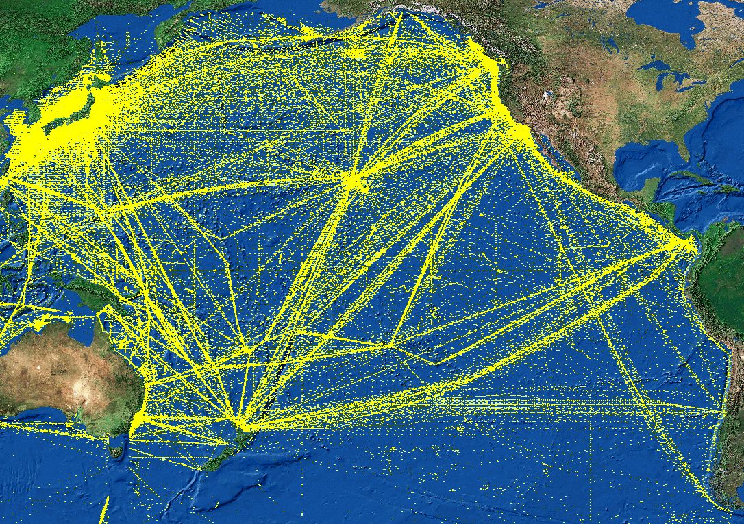
Figure 2: Total Traffic in the PACPLAN Area
Figure 3: Container Vessels Traffic
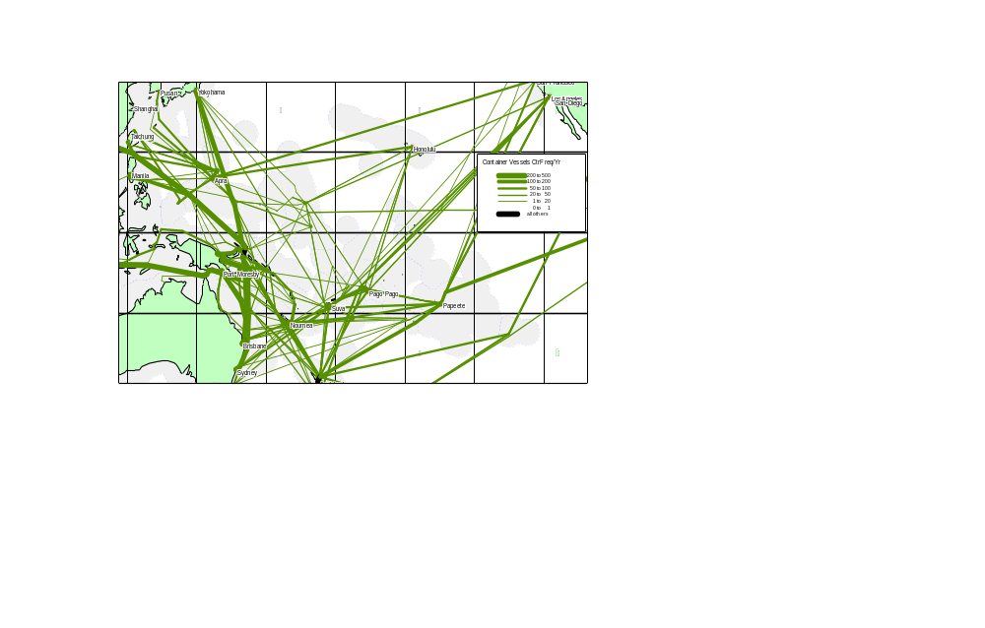
Figure 4: Longliners traffic in the PACPLAN Area
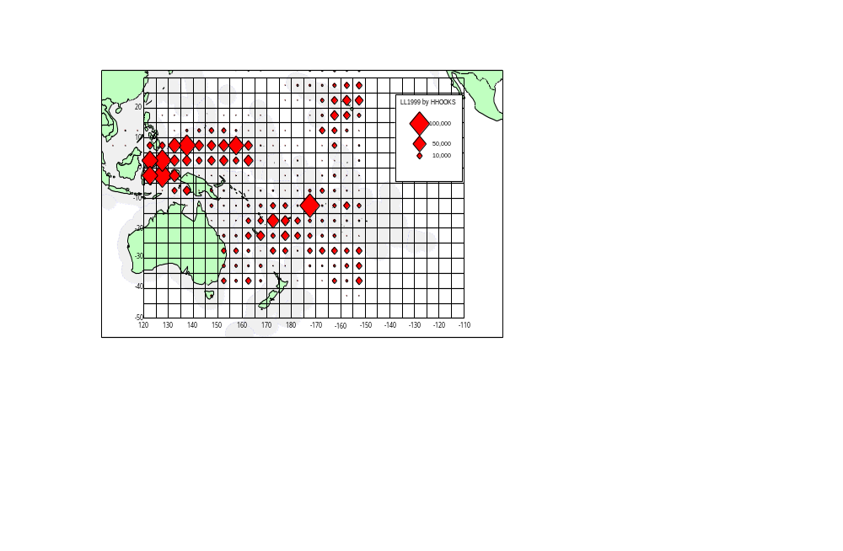
Figure5: Pur seiners traffic in the PACPLAN Area
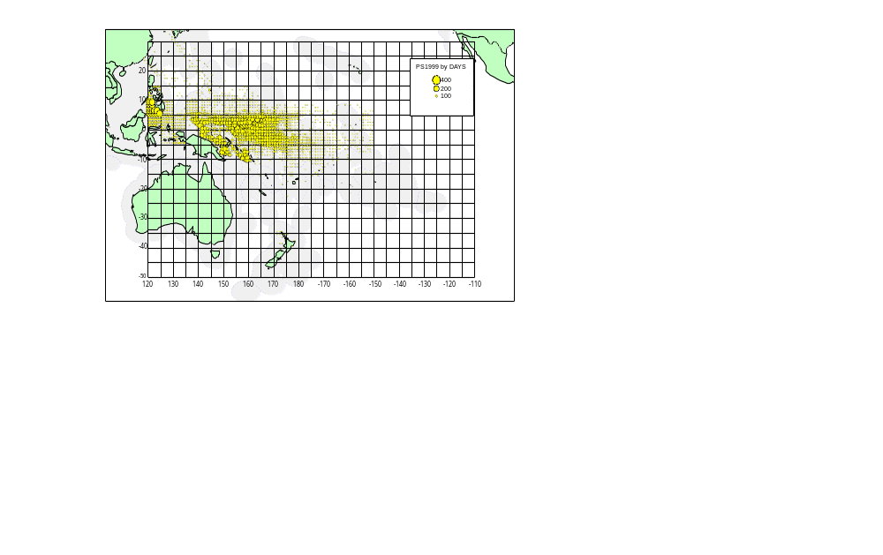
Figure 6: Oil Tanker Traffic in the PACPLAN Area
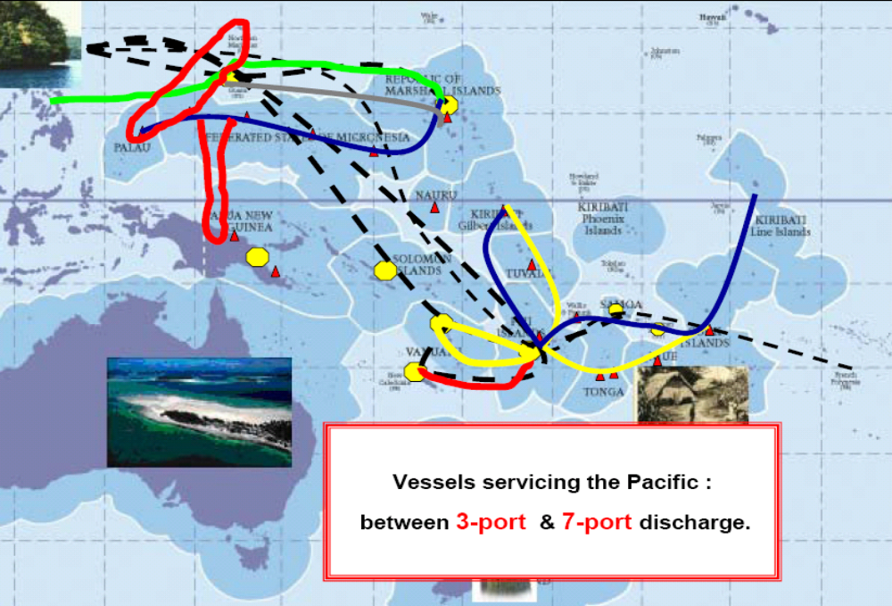
Figure 7 Nuclear Fuel and waste shipments by specialised vessels, world plan
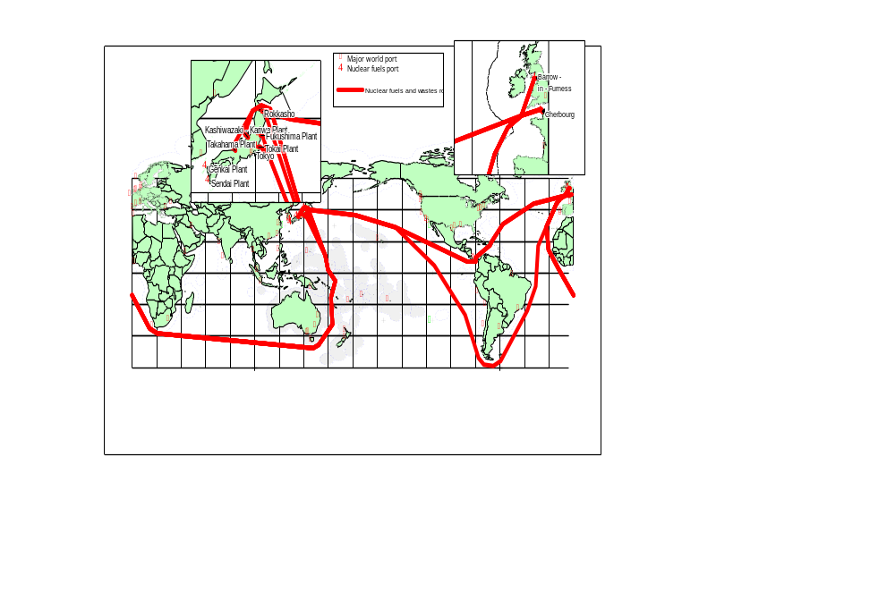
Figure 8: Grounding Risk Areas in the PACPLAN Area
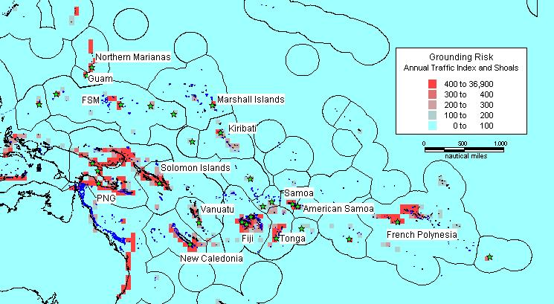
Figure 9: Total Casualties in the PACPLAN Area
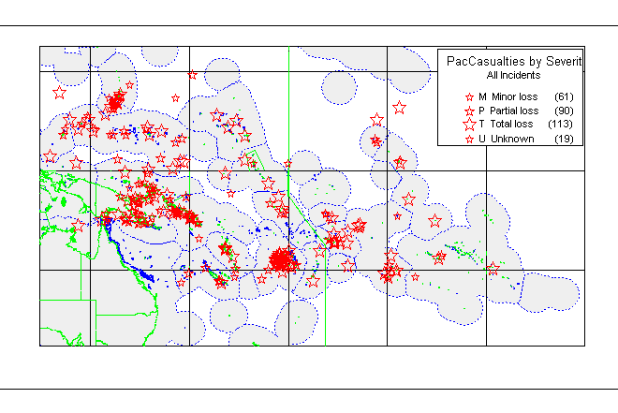
Figure 10: Regional Distribution of Port Risk
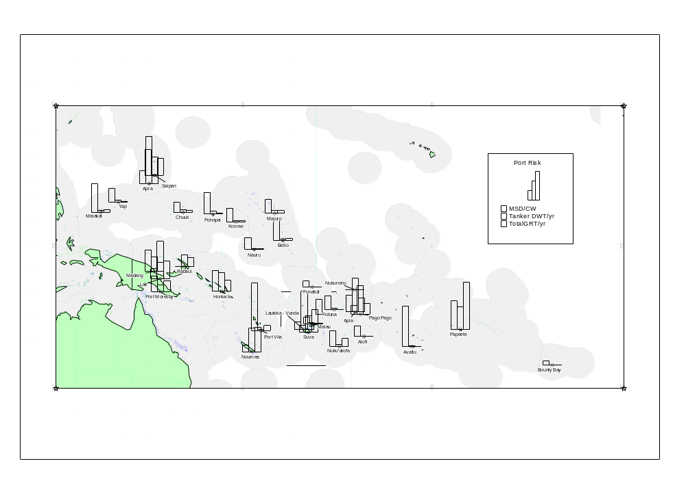

Attachment 7: List of SPREP Trained Marine Spill Responders as of Dec 2012.

No. | Name | Organisation | Country | Type of training | Place of training | Date of Training
1 | Jonetani Tawake | Fiji Ports Corporation Limited | Fiji | Level II | AMOSC | Jun-08
2 | Simione Teilai | Fiji Islands Maritime Safety Administration | Fiji | Level II | AMOSC | Jun-08
3 | Wallace Peter | Ministry of Transport & Communications | RMI | Level II | AMOSC | Jun-08
4 | Kalolo Bartley | MWTI | Samoa | Level II | AMOSC | Jun-08
5 | Tafaigata Toilolo | MWTI | Samoa | Level II | AMOSC | Jun-08
6 | Vuni Latu | Marine and Ports | Tonga | Level II | AMOSC | Jun-08
21 | Michael B. Livinai | NMSA | PNG | Level I | Port Moresby | Feb-08
22 | Steven S. Fareho | NMSA | PNG | Level I | Port Moresby | Feb-08
23 | Michael J. Pidi | NMSA | PNG | Level I | Port Moresby | Feb-08
24 | Carl K. Kamang | NMSA | PNG | Level I | Port Moresby | Feb-08
25 | Hanua Kora | NMSA | PNG | Level I | Port Moresby | Feb-08
26 | Karo Guria | NMSA | PNG | Level I | Port Moresby | Feb-08
27 | Thomas Semo | NMSA | PNG | Level I | Port Moresby | Feb-08
28 | Morea Vavine | PNG Ports Ltd | PNG | Level I | Port Moresby | Feb-08
29 | Gwema Salasie | PNG Ports Ltd | PNG | Level I | Port Moresby | Feb-08
30 | Joseph John | InterOil Refinery | PNG | Level I | Port Moresby | Feb-08
31 | Eka Elore | NMSA | PNG | Level I | Port Moresby | Feb-08
32 | Paul Malken | InterOil Refinery | PNG | Level I | Port Moresby | Feb-08
33 | Francis Aisi | PNGDF, Maritime | PNG | Level I | Port Moresby | Feb-08
34 | Kamilus M. Asil | PNGDF, Maritime | PNG | Level I | Port Moresby | Feb-08
106 | Bani Timbaci | Vanuatu Port and Harbor Department | Vanuatu | Level II | Suva | Oct-09
107 | Lolesio Lavea | Samoa Port Authority | Samoa | Level II | Suva | Oct-09
108 | Kemp Detanamo | Nauru Port Authority | Nauru | Level II | Suva | Oct-09
109 | Nelperson Etse | Pohnpei Port Authority | FSM | Level II | Suva | Oct-09
110 | Bim Nooroa Tou | Cook Islands Port Authority | Cook Is | Level II | Suva | Oct-09
111 | Ruoikabuti Tioon | Kiribati Port Authority | Kiribati | Level II | Suva | Oct-09
112 | Sitalingi Payne | Tonga Port Authority | Tonga | Level II | Suva | Oct-09
113 | Berry Willie Sofaea | Niue Bulk Fuel Corporations | Niue | Level II | Suva | Oct-09
114 | William Barlie | Solomon Islands Port Authority | Solomon Is | Level II | Suva | Oct-09
115 | David Deluckner | Bulk Fuel Installation | Nauru | Level II | Suva | Oct-09
116 | Vinesh Kumar | BP | Fiji | Level II | Suva | Oct-09
117 | Taito Taleimaibau | BP | Fiji | Level II | Suva | Oct-09
118 | Dorine Singh | Mobil | Fiji | Level II | Suva | Oct-09
119 | Tawake Sakaia | Mobil | Fiji | Level II | Suva | Oct-09
120 | Praveen Sharma | Mobil | Fiji | Level II | Suva | Oct-09
121 | Meli Tokalauvere | FIMSA | Fiji | Level II | Suva | Oct-09
122 | Phillip Hill | FIMSA | Fiji | Level II | Suva | Oct-09
123 | Emosi Navusolo | FPCL | Fiji | Level II | Suva | Oct-09
124 | Jolame Saukuru | FPCL | Fiji | Level II | Suva | Oct-09
125 | Jeke Vakararawa | FPCL | Fiji | Level II | Suva | Oct-09
126 | Michael Fong | Total | Fiji | Level II | Suva | Oct-09
127 | Kym Tausia | Total | Fiji | Level II | Suva | Oct-09
128 | Isireli Sovau | Total | Fiji | Level II | Suva | Oct-09
129 | Roland Leong | Total | Fiji | Level II | Suva | Oct-09
130 | Viliame Kasanawaqa | Total | Fiji | Level II | Suva | Oct-09
131 | Tevita Qalo | Total | Fiji | Level II | Suva | Oct-09
132 | Rex Dodo | Solomon Is | Fiji | Level II | Suva | Oct-09
133 | Hakaumotu Fakapelea | SPC-RMP | Fiji | Level II | Suva | Oct-09
134 | Panapasa Vakamino | FIMSA | Fiji | Level II | Suva | Oct-09
135 | Mr. Nooroa (Bim) Tou | Cook Islands Port Authority | Cook Is | Level II/III | Port Moresby | Dec-10
136 | Mr. Vavia Tangatataia | Cook Islands Environment Services | Cook Is | Level II/III | Port Moresby | Dec-10
137 | Mr. Trevayne Esiel | FSM Petroleum Corp | FSM | Level II/III | Port Moresby | Dec-10
138 | Mr. Clayton Santos | Pohnpei State EPA | FSM | Level II/III | Port Moresby | Dec-10
139 | Mr. Meli Tokalauvere | FIMSA | Fiji | Level II/III | Port Moresby | Dec-10
140 | Ms. Laisani Lewanavanua | DOE | Fiji | Level II/III | Port Moresby | Dec-10
141 | Capt. Koria Tamuera | Kiribati Port Authority | Kiribati | Level II/III | Port Moresby | Dec-10
142 | Mr. Noteti Karoua | MELAD | Kiribati | Level II/III | Port Moresby | Dec-10
143 | Mr. Kemp Detanemo | Nauru Port Authority | Nauru | Level II/III | Port Moresby | Dec-10
144 | Mr. Emil Edesomel | EQPB | Palau | Level II/III | Port Moresby | Dec-10
145 | Mr. Kalolo Bartley | MWTI | Samoa | Level II/III | Port Moresby | Dec-10
146 | Mr. Faleniu Alesana | MWTI | Samoa | Level II/III | Port Moresby | Dec-10
147 | Ms. Rose Babaua | Ministry of Environment | Solomon Is | Level II/III | Port Moresby | Dec-10
148 | Mr. 'Onesi Tu'ifua | Ministry of Transport | Tonga | Level II/III | Port Moresby | Dec-10
149 | Mr. Tevita Kaufusi | Tonga Port Authority | Tonga | Level II/III | Port Moresby | Dec-10
150 | Mr. Tepaukie Sotapu Paape | Ministry of Transport | Tuvalu | Level II/III | Port Moresby | Dec-10
151 | Mr. John Markmon Ambong Baite | Ministry of Infrastructure and Public Utilities | Vanuatu | Level II/III | Port Moresby | Dec-10
152 | Mr. Jason Martin | OTML/PNG | PNG | Level II/III | Port Moresby | Dec-10
153 | Mr. Simon Tarak | NMSA/PNG | PNG | Level II/III | Port Moresby | Dec-10
154 | Mr. Fred Siroi | NMSA/PNG | PNG | Level II/III | Port Moresby | Dec-10
155 | Mr. Nicholas Pion | NMSA/PNG | PNG | Level II/III | Port Moresby | Dec-10
156 | Mr. Waroi Ulea | NMSA/PNG | PNG | Level II/III | Port Moresby | Dec-10
157 | Mr. Danny Wame | PNGPCL/PNG | PNG | Level II/III | Port Moresby | Dec-10
158 | Mr. Steven Aisi | PNGPCL/PNG | PNG | Level II/III | Port Moresby | Dec-10
159 | Mr. Iamo Vere | PNGPCL/PNG | PNG | Level II/III | Port Moresby | Dec-10
160 | Mr. Ricardo Abrahan | IOL/PNG | PNG | Level II/III | Port Moresby | Dec-10
161 | Mr. Whally Hera | IOL/PNG | PNG | Level II/III | Port Moresby | Dec-10
162 | Mr. Vagi Reid | IOL/PNG | PNG | Level II/III | Port Moresby | Dec-10
163 | Mr. Gerald Ila | IOL/PNG | PNG | Level II/III | Port Moresby | Dec-10
164 | Mr. Kevin Holden | IOL/PNG | PNG | Level II/III | Port Moresby | Dec-10
165 | Mr. Job Opu | PNGPCL/PNG | PNG | Level II/III | Port Moresby | Dec-10
166 | Mr. Nooroa (Bim) Tou | Cook Islands Port Authority | Cook Is | OPRC-HNS | Port Moresby | Dec-10
167 | Mr. Vavia Tangatataia | Cook Islands Environment Services | Cook Is | OPRC-HNS | Port Moresby | Dec-10
168 | Mr. Trevayne Esiel | FSM Petroleum Corp | FSM | OPRC-HNS | Port Moresby | Dec-10
169 | Mr. Clayton Santos | Pohnpei State EPA | FSM | OPRC-HNS | Port Moresby | Dec-10
170 | Mr. Meli Tokalauvere | FIMSA | Fiji | OPRC-HNS | Port Moresby | Dec-10
171 | Ms. Laisani Lewanavanua | DOE | Fiji | OPRC-HNS | Port Moresby | Dec-10
172 | Capt. Koria Tamuera | Kiribati Port Authority | Kiribati | OPRC-HNS | Port Moresby | Dec-10
173 | Mr. Noteti Karoua | MELAD | Kiribati | OPRC-HNS | Port Moresby | Dec-10
174 | Mr. Kemp Detanemo | Nauru Port Authority | Nauru | OPRC-HNS | Port Moresby | Dec-10
175 | Mr. Emil Edesomel | EQPB | Palau | OPRC-HNS | Port Moresby | Dec-10
176 | Mr. Kalolo Bartley | MWTI | Samoa | OPRC-HNS | Port Moresby | Dec-10
177 | Mr. Faleniu Alesana | MWTI | Samoa | OPRC-HNS | Port Moresby | Dec-10
178 | Ms. Rose Babaua | Ministry of Environment | Solomon Is | OPRC-HNS | Port Moresby | Dec-10
179 | Mr. 'Onesi Tu'ifua | Ministry of Transport | Tonga | OPRC-HNS | Port Moresby | Dec-10
180 | Mr. Tevita Kaufusi | Tonga Port Authority | Tonga | OPRC-HNS | Port Moresby | Dec-10
181 | Mr. Tepaukie Sotapu Paape | Ministry of Transport | Tuvalu | OPRC-HNS | Port Moresby | Dec-10
182 | Mr. John Markmon Ambong Baite | Ministry of Infrastructure and Public Utilities | Vanuatu | OPRC-HNS | Port Moresby | Dec-10
183 | Mr. Jason Martin | OTML/PNG | PNG | OPRC-HNS | Port Moresby | Dec-10
184 | Mr. Simon Tarak | NMSA/PNG | PNG | OPRC-HNS | Port Moresby | Dec-10
185 | Mr. Fred Siroi | NMSA/PNG | PNG | OPRC-HNS | Port Moresby | Dec-10
186 | Mr. Nicholas Pion | NMSA/PNG | PNG | OPRC-HNS | Port Moresby | Dec-10
187 | Mr. Waroi Ulea | NMSA/PNG | PNG | OPRC-HNS | Port Moresby | Dec-10
188 | Mr. Danny Wame | PNGPCL/PNG | PNG | OPRC-HNS | Port Moresby | Dec-10
189 | Mr. Steven Aisi | PNGPCL/PNG | PNG | OPRC-HNS | Port Moresby | Dec-10
190 | Mr. Iamo Vere | PNGPCL/PNG | PNG | OPRC-HNS | Port Moresby | Dec-10
191 | Mr. Ricardo Abrahan | IOL/PNG | PNG | OPRC-HNS | Port Moresby | Dec-10
192 | Mr. Whally Hera | IOL/PNG | PNG | OPRC-HNS | Port Moresby | Dec-10
193 | Mr. Vagi Reid | IOL/PNG | PNG | OPRC-HNS | Port Moresby | Dec-10
194 | Mr. Gerald Ila | IOL/PNG | PNG | OPRC-HNS | Port Moresby | Dec-10
195 | Mr. Kevin Holden | IOL/PNG | PNG | OPRC-HNS | Port Moresby | Dec-10
196 | Mr. Job Opu | PNGPCL/PNG | PNG | OPRC-HNS | Port Moresby | Dec-10
197 | MR. JOHN TIEGMAI | Department of Transportation, Comms & Infrastructure | FSM | Level III | Apia | Oct-12
198 | MR. LEO LOKOPWE | Department of Transportation, Comms & Infrastructure | FSM | Level III | Apia | Oct-12
199 | MS. JOANN KOMANTA | RMI Environmental Protection Authority | RMI | Level III | Apia | Oct-12
200 | MR. JOHN KINTARO, JR | Palau Environmental Quality Protection | Palau | Level III | Apia | Oct-12
201 | MR. TELKAL SADANG | Ministry of Public Infrastructure, Industries and Commerce | Palau | Level III | Apia | Oct-12
202 | MR. PAWA LIMU | National Maritime Safety Authority | PNG | Level III | Apia | Oct-12
203 | MR. SIMON TARAK | National Maritime Safety Authority | PNG | Level III | Apia | Oct-12
204 | MRS. VASA TUISIGA SAITALA | Shipping / Port Officer | Tuvalu | Level III | Apia | Oct-12
205 | MRS. TILIA TIMA | Department of Environment | Tuvalu | Level III | Apia | Oct-12
206 | MS. KELELA TONGA | Ministry of Infrastructure | Tonga | Level III | Apia | Oct-12
207 | MR. PATELESIO MANUKEU | Ministry of Infrastructure | Tonga | Level III | Apia | Oct-12
208 | MR. IOANE TEBURORO | Kiribati Police Service | Kiribati | Level III | Apia | Oct-12
209 | MR. TAULEHIA PULEFOU | MELAD | Kiribati | Level III | Apia | Oct-12
210 | MR. MURAAI HERMAN | National Environment Service | Cook Is | Level III | Apia | Oct-12
211 | MR. PHILLIP STRICKLAND | National Environment Service | Cook Is | Level III | Apia | Oct-12
212 | MR. PHILIP HILL | Maritime Safety Authority | Fiji | Level III | Apia | Oct-12
213 | MR. LAISENIA GADE TAWALESU | Maritime Police | Fiji | Level III | Apia | Oct-12
214 | MR. JEREMIE KALTAVARA | Ministy of Agriculture Quaratine, Forestry and Fisheries | Vanuatu | Level III | Apia | Oct-12
215 | MR. ERICKSON SAMMY | Department of Geology, Mines and Water Resources | Vanuatu | Level III | Apia | Oct-12
216 | MR. KEMP DETENAMO | Director Maritime | Nauru | Level III | Apia | Oct-12
217 | MS. SAMANTHA KWAN | Ministry of Natural Resources & Environment | Samoa | Level III | Apia | Oct-12
218 | MR. TITIMANU SIMI | Ministry of Natural Resources & Environment | Samoa | Level III | Apia | Oct-12
219 | MR. MUAAUSA PAU IOANE | Ministry of Natural Resources & Environment | Samoa | Level III | Apia | Oct-12
220 | MR. SETOA APO | Ministry of Natural Resources & Environment | Samoa | Level III | Apia | Oct-12
221 | MS. FUATINO LEOTA | Ministry of Natural Resources & Environment | Samoa | Level III | Apia | Oct-12
222 | MR. MATAU ESAU | Maritime Police | Samoa | Level III | Apia | Oct-12
223 | MR. VELI LALOGAFAU | National Fire Service | Samoa | Level III | Apia | Oct-12
224 | MR. TAFAIGATA TOILOLO | Ministry of Works Transport and Infrastructure | Samoa | Level III | Apia | Oct-12
225 | MR. ULISESE AH SAM | Petroleum Product Supplies | Samoa | Level III | Apia | Oct-12
226 | MR. MATTHEW PASSI | Petroleum Product Supplies | Samoa | Level III | Apia | Oct-12
227 | MS. TUTOATASI SETU | Petroleum Product Supplies | Samoa | Level III | Apia | Oct-12
259 | Ilatia Tuisawau | Fiji Navy | Fiji | Level II | Suva | Jun-12
260 | Metuisela Railumu | Fiji Navy | Fiji | Level II | Suva | Jun-12
261 | Simione Qio | Fiji Navy | Fiji | Level II | Suva | Jun-12
262 | Sefanaia Bilivalu Tavura | Fiji Police Force | Fiji | Level II | Suva | Jun-12
263 | Laisenia Tawalesu | Fiji Police Force | Fiji | Level II | Suva | Jun-12
264 | Joseva Turagayawa | Fiji Ports Corporation Limited | Fiji | Level II | Suva | Jun-12
265 | Rusiate Lacarua | Fiji Ports Corporation Limited | Fiji | Level II | Suva | Jun-12
266 | Marika Koroi | Fiji Ports Corporation Limited | Fiji | Level II | Suva | Jun-12
267 | Jone Kuruituku | Fiji Ports Corporation Limited | Fiji | Level II | Suva | Jun-12
268 | Makereta Usumaki Taoi | Fiji Ships & Heavy Industries Ltd | Fiji | Level II | Suva | Jun-12
269 | Jone Radrodrao | Fiji Ships & Heavy Industries Ltd | Fiji | Level II | Suva | Jun-12
270 | Sefanaia Fuakilau | Mobil Oil | Fiji | Level II | Suva | Jun-12
271 | Nemani Salu | MSAF | Fiji | Level II | Suva | Jun-12
272 | Sekope Uasolala | MSAF | Fiji | Level II | Suva | Jun-12
273 | Eugene Young | MSAF | Fiji | Level II | Suva | Jun-12
274 | Netani Seruwaqa | MSAF | Fiji | Level II | Suva | Jun-12
275 | Eseroma Cakacaka | MSAF | Fiji | Level II | Suva | Jun-12
276 | Praveen Kumar | MSAF | Fiji | Level II | Suva | Jun-12
277 | Dhiren Chand | MSAF | Fiji | Level II | Suva | Jun-12
278 | Koli Rakoroi | NFA | Fiji | Level II | Suva | Jun-12
279 | Timoci Tagicaki Nakaruru | NFA | Fiji | Level II | Suva | Jun-12
280 | Ifereimi Vesikula | NFA | Fiji | Level II | Suva | Jun-12
281 | Samuela Panapasa | Pacific Energy SWP Ltd | Fiji | Level II | Suva | Jun-12
282 | Ashendra Prasad | Pacific Energy SWP Ltd | Fiji | Level II | Suva | Jun-12
283 | Grey Edward Vaurasi | Pacific Energy SWP Ltd | Fiji | Level II | Suva | Jun-12
284 | Pritanshu Singh | Pacific Energy SWP Ltd | Fiji | Level II | Suva | Jun-12
285 | Rajnesh Chand | Port Denarau Marina Limited | Fiji | Level II | Suva | Jun-12
286 | Leanne Mitchell | Port Denarau Marina Limited | Fiji | Level II | Suva | Jun-12
287 | Sikeli Naqoli | Port Denarau Marina Limited | Fiji | Level II | Suva | Jun-12
288 | Suneel Praveen Narayan | Total (Fiji) Ltd | Fiji | Level II | Suva | Jun-12
289 | Ronil Royindra Singh | Total (Fiji) Ltd | Fiji | Level II | Suva | Jun-12
290 | Savenaca Tamani | Total (Fiji) Ltd | Fiji | Level II | Suva | Jun-12
291 | Eroni Verevukivuki | Total (Fiji) Ltd | Fiji | Level II | Suva | Jun-12
292 | Tony Philp | Vuda Point Marina | Fiji | Level II | Suva | Jun-12
405 | Capt. Etekieru Iotua | Marine Training Centre | Kiribati | Level I | Tarawa | Aug-11
406 | Teema Biko | MELAD | Kiribati | Level I | Tarawa | Aug-11
407 | Arioka Kourataake | Marine Training Centre | Kiribati | Level I | Tarawa | Aug-11
408 | Raimon Kabobouea | KOIL | Kiribati | Level I | Tarawa | Aug-11
409 | Kararaua Temarebu | KOIL | Kiribati | Level I | Tarawa | Aug-11
410 | Naibeata Moote | KOIL | Kiribati | Level I | Tarawa | Aug-11
411 | Tiinoa Antonio | KOIL | Kiribati | Level I | Tarawa | Aug-11
412 | Mererin Ioakim | MEMRD | Kiribati | Level I | Tarawa | Aug-11
413 | Tenanoraoi Tokanang | Marine Division | Kiribati | Level I | Tarawa | Aug-11
414 | Ioteba Tebau | Marine Training Centre | Kiribati | Level I | Tarawa | Aug-11
415 | Tebuaua Itibwinnang | Kiribati Shipping Services Ltd | Kiribati | Level I | Tarawa | Aug-11
416 | Karure Tekarawa | KSSL | Kiribati | Level I | Tarawa | Aug-11
417 | Teweti Tetau | Kiribati Police Service | Kiribati | Level I | Tarawa | Aug-11
418 | Omirete Tabureka | Marine Division | Kiribati | Level I | Tarawa | Aug-11
419 | Koria Tamuera | KPA | Kiribati | Level II | Tarawa | Aug-11
420 | Noketi Karoua | MELAD | Kiribati | Level II | Tarawa | Aug-11
421 | John Mote | Kiribati Police Service | Kiribati | Level II | Tarawa | Aug-11
422 | Karure Tekarawa | Kiribati Shipping Services Ltd | Kiribati | Level II | Tarawa | Aug-11
423 | Capt. Omirete Tabureka | Marine Division | Kiribati | Level II | Tarawa | Aug-11
424 | Katangiman | TUC | Kiribati | Level II | Tarawa | Aug-11
425 | Neneia Tominiko | KPA | Kiribati | Level II | Tarawa | Aug-11
426 | Teema Biko | MELAD | Kiribati | Level II | Tarawa | Aug-11
427 | Arioka Kourataake | Maritime Training College | Kiribati | Level II | Tarawa | Aug-11
428 | Mele Ifatonga Tauati | Fisheries Division | Tonga | Level II | Nuku'alofa | Aug-11
429 | Siosifa Potesio Tu'angalu | Port Authority Tonga | Tonga | Level II | Nuku'alofa | Aug-11
430 | Taufatofua Ngalu | Friendly Island Shipping Agency | Tonga | Level II | Nuku'alofa | Aug-11
431 | Sosefo (Joe) Ngininginiofolanga | South Seas Shipping | Tonga | Level II | Nuku'alofa | Aug-11
432 | Latu Niumataevalu Lavaki | Port Authority Tonga (floating Plant) | Tonga | Level II | Nuku'alofa | Aug-11
433 | Kepueli Tupou | Port Authority Tonga (floating Plant) | Tonga | Level II | Nuku'alofa | Aug-11
434 | Ofa Lavemaavi | Port Authority Tonga (floating Plant) | Tonga | Level II | Nuku'alofa | Aug-11
435 | Saimone Taukolo | Port Authority Tonga (floating Plant) | Tonga | Level II | Nuku'alofa | Aug-11
436 | Taniela Pepe | Port Authority Tonga (floating Plant) | Tonga | Level II | Nuku'alofa | Aug-11
437 | Toavila Havili | Port Authority Tonga (floating Plant) | Tonga | Level II | Nuku'alofa | Aug-11
438 | Viliami Fotu | Port Authority Tonga (floating Plant) | Tonga | Level II | Nuku'alofa | Aug-11
439 | Finau Holami | Port Authority Tonga (floating Plant) | Tonga | Level II | Nuku'alofa | Aug-11
440 | Lominasa Kosema Funaki | Port Authority Tonga (floating Plant) | Tonga | Level II | Nuku'alofa | Aug-11
441 | Peni Finau | Port Authority Tonga (floating Plant) | Tonga | Level II | Nuku'alofa | Aug-11
442 | Ma'afu Tupou Hakekava Selupe | Port Authority Tonga (floating Plant) | Tonga | Level II | Nuku'alofa | Aug-11
443 | Sinamoni Kauvaka | Tonga Fire Service | Tonga | Level II | Nuku'alofa | Aug-11
444 | Aisake Fifita | Ministry of Labour & Commerce | Tonga | Level II | Nuku'alofa | Aug-11
445 | Viliami Vaka | Pacific Energy | Tonga | Level II | Nuku'alofa | Aug-11
446 | Sesimoni F. Tu'unga'a | MAFFF | Tonga | Level II | Nuku'alofa | Aug-11
447 | Senitua Lavaka | Port Authority Tonga (floating Plant) | Tonga | Level II | Nuku'alofa | Aug-11
448 | Kelepi Hafiafia | Police Force (Tactical Response Group) | Tonga | Level II | Nuku'alofa | Aug-11
449 | Samisoni Tuipulotu | Port Authority Tonga | Tonga | Level II | Nuku'alofa | Aug-11
450 | Lofieni Halafuka | Port Authority Tonga (floating Plant) | Tonga | Level II | Nuku'alofa | Aug-11
451 | Paea Sole | Port Authority Tonga (floating Plant) | Tonga | Level II | Nuku'alofa | Aug-11
452 | Molitoni Lilopau | Ministry of Transport (Marine Division) | Tonga | Level II | Nuku'alofa | Aug-11
453 | Fualapaha 'Aonga Fuavao | Ministry of Transport (Marine Division) | Tonga | Level II | Nuku'alofa | Aug-11
454 | Setepano Fifita | Port Authority Tonga (floating Plant) | Tonga | Level II | Nuku'alofa | Aug-11
455 | Afoloka Lavaki | Friendly Island Shipping Agency | Tonga | Level II | Nuku'alofa | Aug-11
456 | Roy Mafi | Port Authority Tonga (floating Plant) | Tonga | Level II | Nuku'alofa | Aug-11
457 | Takai Kaivelata | Tonga Defence Services (Navy) | Tonga | Level II | Nuku'alofa | Aug-11
458 | Siosifa Tuipulotu Hakaumotu | Ports Authority Tonga | Tonga | Level II | Nuku'alofa | Aug-11
459 | Semisi Tapueluelu | Tonga Defence Services (Navy) | Tonga | Level II | Nuku'alofa | Aug-11
460 | Soane Vakaahi Haseli | Ministry of Transport (Marine Division) | Tonga | Level II | Nuku'alofa | Aug-11
461 | Tevita Uata | Uata Shipping | Tonga | Level II | Nuku'alofa | Aug-11
462 | Fine Tohi | Dateline Transam Shipping Agency | Tonga | Level II | Nuku'alofa | Aug-11
463 | Serusi Lolohea | Port Authority Tonga (floating Plant) | Tonga | Level II | Nuku'alofa | Aug-11
464 | Kula Tangimana | Tonga Maritime Polytechnical Institute | Tonga | Level II | Nuku'alofa | Aug-11
465 | Tavita Koloi | Port Authority Tonga (floating Plant) | Tonga | Level II | Nuku'alofa | Aug-11
466 | Bese Fonua | Port Authority Tonga (floating Plant) | Tonga | Level II | Nuku'alofa | Aug-11
467 | Talafi Tuliluhakau | Port Authority Tonga (floating Plant) | Tonga | Level II | Nuku'alofa | Aug-11
468 | Senita Puafisi | Port Authority Tonga (floating Plant) | Tonga | Level II | Nuku'alofa | Aug-11
469 | Patelesio Manukeu | Ministry of Transport (Marine Division) | Tonga | Level II | Nuku'alofa | Aug-11
470 | Niu Fakakovikaetau | Ministry of Health | Tonga | Level II | Nuku'alofa | Aug-11
471 | Viliami Pua | Ports Authority Tonga | Tonga | Level II | Nuku'alofa | Aug-11
472 | Sylvia 'Atiola | Crown Law Department | Tonga | Level II | Nuku'alofa | Aug-11
606 | MATAIO TEKINENE | Environment Dept | Tuvalu | Level I | Funafuti | Mar-11
607 | Apisai Kilima | TCS Shipping | Tuvalu | Level I | Funafuti | Mar-11
608 | TALAFOU IOSEFA | TCS Shipping | Tuvalu | Level I | Funafuti | Mar-11
609 | FRED SELUKA | Marine Dept | Tuvalu | Level I | Funafuti | Mar-11
610 | VASA TUISIGA | Marine Dept | Tuvalu | Level I | Funafuti | Mar-11
611 | TUPULAGA TAUSI | Marine Dept | Tuvalu | Level I | Funafuti | Mar-11
612 | NITO LIPINE | Marine Dept | Tuvalu | Level I | Funafuti | Mar-11
613 | TANIELU ITALELI | Marine Dept | Tuvalu | Level I | Funafuti | Mar-11
614 | TEPAUKIE SOTAGA | Ministry of Communications, Fisheries and Transport | Tuvalu | Level I | Funafuti | Mar-11
615 | SUMEO SILU | National Disaster Management | Tuvalu | Level I | Funafuti | Mar-11
616 | TUALUA TEPOGA | Police | Tuvalu | Level I | Funafuti | Mar-11
617 | KEN SIONE | Police | Tuvalu | Level I | Funafuti | Mar-11
618 | FREDA HOMASI | Customs | Tuvalu | Level I | Funafuti | Mar-11
619 | TUSAGA IOSEFA | Tuvalu Maritime Training Institute | Tuvalu | Level I | Funafuti | Mar-11
620 | PUANITA TAOMIA | Tuvalu Maritime Training Institute | Tuvalu | Level I | Funafuti | Mar-11
621 | WILSON KAEA | Tuvalu Maritime Training Institute | Tuvalu | Level I | Funafuti | Mar-11
622 | KATEPU MALAGA | Tuvalu Maritime Training Institute | Tuvalu | Level I | Funafuti | Mar-11
623 | Mika Elisaia | Pacific Energy | Tuvalu | Level I | Funafuti | Mar-11
624 | Hesus Setsuo | Blue Bay | Palau | Level I | Koror | Sep-10
625 | Manuel Daria | Kuniyoshi Fishing Company | Palau | Level I | Koror | Sep-10
626 | Fennally Seklii | Div of Marine Law Enforcement | Palau | Level I | Koror | Sep-10
627 | Vincente Pua | PPUC | Palau | Level I | Koror | Sep-10
628 | Dominic Rekemsik | PPUC | Palau | Level I | Koror | Sep-10
629 | Flavin Tiaki | BPW/Div of Fire & Rescue | Palau | Level I | Koror | Sep-10
630 | Doug Kesolei | Belau Transfer & Terminal Company | Palau | Level I | Koror | Sep-10
631 | King Sam | Koror State Government | Palau | Level I | Koror | Sep-10
632 | Mayleen Joshua | NEMO | Palau | Level I | Koror | Sep-10
633 | Mathias Smus | Palau International Traders | Palau | Level I | Koror | Sep-10
634 | Wilbert Kamerang | Palau shipping Co | Palau | Level I | Koror | Sep-10
635 | Flavin Tiaki | Div. of Fire and Rescue | Palau | Level I | Koror | Sep-10
636 | Harry Blesam | Koror State Government | Palau | Level I | Koror | Sep-10
637 | Benraick Isaac | Palau shipping Co | Palau | Level I | Koror | Sep-10

Attachment 8: Model Memorandum of Understanding or Technical Agreement for Bilateral Co-operation

(This model MoU or TA is available in electronic format from the SPREP if required)

Memorandum of Understanding (MoU) or Technical Agreement (TA) between
(Responsible Authority for Government of ) and (Responsible Authority for Government of )
on Marine Spill Preparedness and Response

- In accordance with the provisions of the International Convention on Oil Pollution Preparedness, Response and Co-operation 1990 (OPRC 90), and the Protocol Concerning Co-operation in Combating Pollution Emergencies in the South Pacific Region (Noumea Pollution Protocol), (insert name of Responsible Authority) and (insert name of Responsible Authority), hereafter the “Participants” which are the national Lead Agencies responsible for the overall command and control of the response to marine pollution incidents in (country/territory) and (country/territory) respectively, hereby place on record their intention to co-operate on marine spill preparedness and response.

- In the event of a marine pollution incident, each national Responsible Authority can request assistance from the other Participant. The requesting Participant should be the sole judge of the need for such assistance.

- Requests for assistance will be directed through (channels to be agreed and details inserted).

- The Participants intend to keep each other advised of the designations of officers authorised to request assistance under his MoU or TA.

- Subject to availability of relevant resources under their direct control, each Participant should provide equipment, materials and personnel for the purpose of assisting the response to a marine pollution incident. The Participant receiving the request may also make equipment, materials and personnel not under the direct control of a Participant, for example those under the control of the oil industry, available following a special approach for those resources.

- When requesting equipment, the requesting Participant should itemise the equipment by referencing the type, name, size etc from the national equipment inventory lists as provided from time to time.

- Reimbursement of costs of assistance will be determined in accordance with the provisions of OPRC 90.

- Experienced personnel should accompany specialised equipment at the discretion of the providing Participant.

- To facilitate Customs requirements all equipment and materials will be entered on behalf of the government of the requesting party.

- Transport of equipment, materials and personnel should be by the most convenient means and should be arranged at the time of the incident after consultations between each Participant.

- Each Participant intends to regularly consult on matters relating to marine spill response, including exchanging:
- information on changes in equipment and materials;
- copies of contingency plans and marine pollution laws;
- information on significant pollution incidents;
and conducting joint exercises and training activities.

- The Participants intend to co-operate in the enforcement of marine pollution laws.

- This MoU or TA becomes operative at the date of signing and remains so unless discontinued by either Participant, in which event it should endeavour to give the other Participant six months notice in writing.

Signed in duplicate at (insert location) on this ……………. day of …(insert month/year)……….

…………………………………………. ………………………………………
(insert name/ position of authorised signing officer) (insert name/position of authorised signing officer)

Attachment 9: Standard Request for Assistance Form

(This standard form is available in electronic format from the SPREP if required)

PACPLAN
Pacific Islands Regional Marine Spill Contingency Plan

REQUEST for ASSISTANCE

Requesting Country/Territory: __________________________________________________________________________

Responsible Authority: ________________________________________Contact person: __________________________
Phone: _________________________ Fax: ______________________ Email: _______________________________

Request to: _________________________________________________________ Fax: ____________________________

Nature of Pollution Incident: ___________________________________________________________________________
___________________________________________________________________________________________________

Type of pollutant spilled: ___________________________________ Quantity: __________________________________

Potential quantity of pollutant:

Location of spill (Latitude & Longitude): _________________________________________________________________

Source of spill: ______________________________________________________________________________________

Environmental impacts (actual and threatened): ____________________________________________________________
______________________________________________________________________________________________________________________________________________________________________________________________________

Action taken to date: _________________________________________________________________________________
______________________________________________________________________________________________________________________________________________________________________________________________________

Assistance Required: _________________________________________________________________________________
___________________________________________________________________________________________________
___________________________________________________________________________________________________
___________________________________________________________________________________________________
Technical Advice? If yes, in what areas? _______________________________________________________________
______________________________________________________________________________________________________________________________________________________________________________________________________
___________________________________________________________________________________________________
___________________________________________________________________________________________________
___________________________________________________________________________________________________
Personnel?: If yes, what areas of expertise?: ____________________________________________________________
___________________________________________________________________________________________________
___________________________________________________________________________________________________
___________________________________________________________________________________________________
Equipment?: If yes, what types and for what purpose?: ___________________________________________________
___________________________________________________________________________________________________
_______________________________________________________________________________________________________________________________________________________________________________________________________________________________________________________________________________________________________________________________________________________________________________________________________________________________________________________________________________________________________________
Are customs, immigration and quarantine procedures cleared for incoming personnel and equipment?
Details: ____________________________________________________________________________________________
___________________________________________________________________________________________________
___________________________________________________________________________________________________
Are logistics, including transport and accommodation, in place for incoming personnel and equipment?
Details:____________________________________________________________________________________________
______________________________________________________________________________________________________________________________________________________________________________________________________

(Attach additional information if required)

Attachment 10.1: Guideline to Tier 1 & 2 Equipment Stockpile.

Model Tier 2 kit for South Pacific Island Ports

Item | Quantity | Comments
Fence boom | 150m | Quantities of these may vary but a minimum of 300m total is recommended
Curtain boom | 150m
Shore sealing boom | 150m
Air inflation and water ballast pumps | 1 set
Towing ends | 6 sets
Anchor connections | 4 sets
Temporary storage | 2 | 10,000 litre capacity self supporting or frame and tank design
Sorbent pads | 300 | e.g. 450mm x 450mm
Sorbent boom | 200m
Skimmer | 1 | Passive weir skimmer
Recovery pump* | 1
Anchor kits | 15 x 20kg kits | Kit includes anchor, chain, rope, buoys and fittings.

* It would be preferable if water ballast pump can be fitted with oil resistant seals so they can double as recovery pumps

Model Tier 2 kit for North Pacific Island Ports

Item | Quantity | Comments
Fence boom | 100m | Quantities of these may vary but a minimum of 300m total is recommended
Curtain boom | 200m
Shore sealing boom | 40m
Air inflation and water ballast pumps | 1 set
Towing ends | 6 sets
Anchor connections | 4 sets
Temporary storage | 3 | 10,000 litre capacity self supporting or frame and tank design
Sorbent pads | 300 packages | e.g. 450mm x 450mm
Sorbent boom | 200m
Sorbent Sweep | 200m
Skimmer with suitable diesel pump | 1 | Passive weir skimmer
transfer pump | 1 | Peristaltic (none priming)
3” recovery pump hose | 40m
Anchor kits | 15 x 20kg kits | Kit includes anchor, chain, rope, buoys and fittings.

Model Tier 1 kit for Pacific Island Ports
Item | Quantity | Comments
Fence boom | 100m | Quantities of boom may vary but a minimum total of 200m is recommended
Curtain boom | 100m
Shore sealing boom | 100m
Air inflation and water ballast pumps* | 1 set
Towing ends | 4 sets
Anchor connections | 2sets
Temporary storage | 2 | 10,000 litre capacity self supporting or frame and tank design
Sorbent pads | 200 | e.g. 450mm x 450mm
Sorbent boom | 100m
Skimmer | 1 | Passive weir skimmer
Recovery pump* | 1
Anchor kits | 10 x 20kg kits | Kit includes anchor, chain, rope, buoys and fittings

* It would be preferable if water ballast pump can be fitted with oil resistant seals so they can double as recovery pumps

Attachment 10.2: Equipment Inventory.

This is an inventory of oil spill equipment in each of the major stockpiles within the PACPLAN Area of operation:

- American Samoa (USCG and oil industry/contractor)
- Fiji (Oil Industry)
- Guam (USCG and oil industry/contractor)
- New Caledonia (French Navy).

And the most significant stockpiles of equipment adjacent to the PACPLAN Area of Operations:

- Auckland (New Zealand National Plan resources).
- Brisbane, Darwin, Melbourne, Sydney & Townsville (Australian National Plan resources)
- Geelong (AMOSC)
- Hawaii (USCG )
- San Francisco (USCG Pacific Strike Team)
- Singapore (OSRL)

Equipment Inventory
Group A – American Samoa, Guam, Hawaii and San Francisco (To be updated)
Equipment Description  Inventory last revised: mm/dd/yy |  | Pago Pago | Guam | Hawaii | San Francisco
Spilled Oil Recovery
 | Skimmer Vessel System
 | Skimmer System e.g. Weir
 | Booms (type, size and O/A length)
 | Boom handling Boat (size and O/A length)
 | Boom tending boats (size and O/A length)
 | Oil Storage Bladders (size)
Casualty Offloading
 | Pump transfer system (type)
 | Floating hose system
 | Fender system (size)
Ancillary Equipment
 | Command system (e.g. van, trailer)
 | Communications system (satellite phones)
 | Oil/water separator (size and type)
 | Foreshore cleanup system (type and size)

Group B – Brisbane, Darwin, Melbourne, Sydney, Townsville, Cairns, Geelong
The equipment listing for Brisbane, Darwin, Melbourne, Sydney, Townsville, and Cairns can be found below. Geelong (AMOSC) stockpile list can be downloaded from the following site - http://www.amosc.com.au/equipment.php
MOSES Number | Item | Children Items | Qty
Brisbane - MacArthur Avenue East, Pinkenba
PDI76608 | Containment-Boom-Shoreline-Structureflex Land Sea 1/5 |  | 320
PDJ6377 | Containment - Sweep System - Nofi Vee |  | 1
PAG106373 |  | BOOM REEL RECOVERY NOFI 'V' SWEEP
PAG106373 |  | NOFI 'V' SWEEP EXTENDER - SHORT | 20m
PAG106373 |  | NOFI 'V' SWEEP EXTENDER - LONG | 100m
PAG106373 | Containment - Boom - Offshore - Rapid Response Ocean High Sprint Boom |  | 300m
PAH5136 | COMPRESSOR, PORTABLE, HONDA 3.5hp |  | 1
PAK12471 | DECONTAMINATION STATION - TOWN |  | 1
PDA109481 | DECONTAMINATION STATION REMOTE |  | 1
PDA106115 | DECONTAMINATION STATION REMOTE |  | 1
PDA12612 | DECONTAMINATION STATION REMOTE |  | 1
BP111792 | PUMP WATER ONGA/HONDA |  | 1
PAH1171 | PUMP, SHORELINE FLUSHING, LARGE |  | 1
PAL107189 | PUMP, TRANSFER, DISPERSANT PACIFIC/HONDA |  | 1
PAM5473 | PUMP, SALVAGE, AMSA PATTERN |  | 1
PAM4340 | PUMP, SALVAGE, AMSA PATTERN |  | 1
PAM5128 | PUMPING SET OFFLOADING MARFLEX |  | 1
PAM5129 | PUMPING SET OFFLOADING MARFLEX |  | 1
PAM4319 | PUMP SET OFFLOADING THUNE EUREKA |  | 1
PAM105341 | PUMP SET, SALVAGE, TSB OFFLOADING |  | 1
PAM11983 | PUMP SET, SALVAGE, TSB OFFLOADING |  | 1
PAH105280 | PUMP, SHORELINE FLUSHING, SMALL |  | 1
PDD4379 | SKIMMER, ROPE MOP, OMI 260 |  | 1
IP111776 | INFLATOR, BOOM, BACK PACK, STIHL BR 420 |  | 1
 | AFEDO single point spray system |  | 1
 | AFEDO single point spray system |  | 1
WCE9900 | Storage - Towable - Lancer Barge 25t |  | 1
wce9901 | Storage - Towable - Lancer Barge 25t |  | 1
PBD109508 | Storage - Stationary - Flexidam 10t, Structureflex |  | 1
PBD109509 | Storage - Stationary - Flexidam 10t, Structureflex |  | 1
PBD105401 | Storage - Towable - TSB, Canflex 10t |  | 1
PBD105400 | Storage - Towable - TSB, Canflex 10t |  | 1
PBD105399 | Storage - Towable - TSB, Canflex 10t |  | 1
PBD105398 | Storage - Towable - TSB, Canflex 10t |  | 1
PBD12519 | Storage - Towable - TSB, Canflex 10t |  | 1
PBD105402 | Storage - Towable - TSB, Canflex 10t |  | 1
PBD105407 | Storage - Towable - TSB, Canflex 25t |  | 1
PBD105404 | Storage - Towable - TSB, Canflex 25t |  | 1
PBD105403 | Storage - Towable - TSB, Canflex 25t |  | 1
PBD105397 | Storage - Towable - TSB, Canflex 25t |  | 1
PBD105405 | Storage - Towable - TSB, Canflex 50t |  | 1
PBD105396 | Storage - Towable - TSB, Canflex 50t |  | 1
PBD105395 | Storage - Towable - TSB, Canflex 50t |  | 1
PAL122098 | PUMP, TRANSFER, DISPERSANT FIXED WING |  | 1
PAL4919 | PUMP, TRANSFER, DISPERSANT HONDA/PACIFIC |  | 1
PDK4289 | SPRAY BUCKET, DISPERSANT, HELI, SIMPLEX6810 |  | 1
Whyte Island - Port of Brisbane
18 Howard Smith Drive, Port of Brisbane
WCF4278 | Recovery - Oil Recovery Vessel - Marco Harbour 28,"Alpha" |  | 1
PAN105279 |  | MOTOR, OUTBOARD, HONDA, 4 STROKE, 75HP, Port | 1
PAN105278 |  | MOTOR, OUTBOARD, HONDA, 4 STROKE,75HP, Strb | 1
VCA4282 |  | TRAILER, MARCO, TANDEM AXLE | 1
WCE5082 | BARGE, RECOVERED OIL, ALUMINIUM, 9t, 'TIGRIS' |  | 1
PDA5471 | SKIMMER, WEIR, DESM1 250 |  | 1
 |  | Power Pack | 1
 |  | Desmi Hydraulic & Dischage Hose Reel | 1
 |  | Boom Clearance Tube | 1
MOSES Number | Item |  | Qty
Darwin - Oil Spill Shed, East Arm Wharf, Berrimah, Darwin
PDI107776 | Containment - Boom - Shoreline - Structureflex Land Sea |  | 100m
PDI11634 | Containment - Boom - Shoreline - Structureflex Land Sea |  | 100m
PDI12491 | Containment - Boom - Shoreline - Structureflex Land Sea |  | 140m
PDI12520 | Containment - Boom - Shoreline - Structureflex Land Sea |  | 200m
PDF7661A | BOOM, SELF BOUYANT, SLICKBAR, Mk32 |  | 600m
PDH4239 | Containment - Boom - General Purpose - Self Inflating - Versatech Zooom 12/18 |  | 350m
PBD112594 | TOWABLE STORAGE BAG 20t COVERTEX |  | 1
BP111803 | PUMP, BALLASTING, ONGA/HONDA |  | 1
BP111802 | PUMP, BALLASTING, ONGA/HONDA |  | 1
 | PUMP, BALLASTING, ROBIN |  | 1
 | PUMP, BALLASTING, ROBIN |  | 1
PAL13003 | PUMP, DISPERSANT TRANSFER, DAVEY |  | 1
PAL107856 | PUMP, DISPERSANT TRANSFER, FIXED WING |  | 1
PDD4463 | SKIMMER, ROPE MOP, ORI PIRANHA 1000 |  | 1
PDK13008 | BUCKET, SPRAY, DISPERSANT, HELICOPTER, SIMPLEX 6810 |  | 1
PDK5098 | BUCKET, SPRAY, DISPERSANT, HELICOPTER, SIMPLEX 6810 |  | 1
PBD4475 | Storage - Towable - Recovered Oil Tank, Transpac 2.6t |  | 1
PBD4385 | Storage - Towable - Recovered Oil Tank, Transpac 2.6t |  | 1
VCA4229 | TRAILER, BOX, TANDEM AXLE |  | 1
 | BOOM, INFLATABLE, GP, CANADYNE |  | 100m
 | BOOM, INFLATABLE, GP, CANADYNE |  | 100m
 | BOOM, INFLATABLE, GP, CANADYNE |  | 100m
 | BOOM, INFLATABLE, GP, CANADYNE |  | 100m
 | BOOM, INFLATABLE, GP, CANADYNE |  | 100m
 | Containment - Boom - Offshore - Rapid Response Ocean High Sprint Boom |  | 300m
 | Containment - Boom - Offshore - LAMOR Heavy Duty Open Water
 | Wild life kit |  | 1
Equipment Number | Item
Melbourne - Unit 5 10-16 Southey Street, Williamstown North
PDJ11636 | Containment - Boom - Shoreline - Structureflex Land Sea
PDI2494 | Containment - Boom - Shoreline - Structureflex Land Sea
2494 | Robin Water Pump
PDG4265 | BOOM, INFLATABLE VIKOMA OCEAN 1500
PDH4279 | Containment - Boom - General Purpose - Self Inflating - Versatech Zooom 12/18
PDH4847 | Containment - Boom - General Purpose - Self Inflating - Versatech Zooom 12/18
 | Containment - Boom - Offshore - Rapid Response Ocean High Sprint Boom
 | Containment - Boom - Offshore - Roulands Ro-Bay 1500
 | Containment - Sweep System -Current Buster
PDI112606 | BOOM, BEACH, CANADYNE SHORELINE BARRIER
PDI112605 | BOOM, BEACH, CANADYNE SHORELINE BARRIER
PDI112604 | BOOM, BEACH, CANADYNE SHORELINE BARRIER
PDI112601 | BOOM, BEACH, CANADYNE SHORELINE BARRIER
PDI112600 | BOOM, BEACH, CANADYNE SHORELINE BARRIER
PDI112599 | BOOM, BEACH, CANADYNE SHORELINE BARRIER
PBD112593 | TOWABLE STORAGE BAG COVERTEX 20t
BP111796 | PUMP, WATER, ONGA/HONDA
BP111795 | PUMP, WATER, ONGA/HONDA
PAL12209E | PUMP, DISPERSANT TRANSFER FIXED WING
PAM10976 | PUMP, SALVAGE, ELASTEC S3E
SH5470 | SKIMMER HEAD - WEIR - DESMI 250
 | Lamor 50T weir skimmer
PDD4961 | SKIMMER, ROPE MOP, OMI 140
PDD4964 | SKIMMER, ROPE MOP, OMI 260
PDD4452 | SKIMMER, ROPE MOP, ORI BARRACUDA 2000
PDE4429 | SKIMMER, BELT, ROADSIDE, SHARK 2000 SERIES
PDK4257 | SPRAY BUCKET, DISPERSANT, HELI, SIMPLEX 6810
IP111780 | Ancillary - Blower Back-Pack - Stihl BR420
IP111779 | Ancillary - Blower Back-Pack - Stihl BR420
PBD5114 | Storage - Towable - Recovered Oil Tank, Transpac 2.6t
PBD5115 | Storage - Towable - Recovered Oil Tank, Transpac 2.6t
PBD4407 | Storage - Towable - Recovered Oil Tank, Transpac 2.6t
PBD4992 | Storage - Towable - Recovered Oil Tank, Transpac 2.6t
PBD5513 | Storage - Towable - Recovered Oil Tank, Transpac 2.6t
PBD4415 | Storage - Towable - Recovered Oil Tank, Transpac 2.6t
PBD4991 | Storage - Towable - Recovered Oil Tank, Transpac 2.6t
PBD4990 | Storage - Towable - Recovered Oil Tank, Transpac 2.6t
PBD4989 | Storage - Towable - Recovered Oil Tank, Transpac 2.6t
VCA4361 | TRAILER BOAT, Single Axle
VCA4980 | TRAILER, BOAT, SINGLE AXLE
VCA | TRAILER, BOAT, SINGLE AXLE
WCF4969 | Recovery - Oil Recovery Vessel - Marco Harbour 28,"Charlie"
 | BEACH TECH Sweepy
 | LAMOR BEACH TECH SWEEPY
 | AFEDO single point spray system
 | AFEDO single point spray system

Glebe Sydney - Somerville Rd Glebe
Parent item | Children items | Qty
Containment - Boom - Offshore - Rapid Response Ocean High Sprint Boom |  | 300m
AFEDO single point spray system |  | 1
AFEDO single point spray system |  | 1
Containment - Boom - Shoreline - Structureflex Land Sea | Containment | 460m
PUMP, BALLASTING, BOOM, BEACH, STRUTURFLEX LAND SEA |  | 1
Ancillary - Anchor - Large, Set of 6 |  | 1 set
Containment - Boom - Offshore - Roulands Ro-Bay 1500 |  | 600m
Containment - Boom - Offshore - Roulands Ro-Bay 1500 |  | 600m
PUMP, BALLASTING, BOOM, BEACH, STRUTURFLEX LAND SEA |  | 1
PUMP, BALLASTING, BOOM, BEACH, ONGA/HONDA |  | 1
PUMP, DISPERSANT TRANSFER, FIXED WING |  | 1
SPRAY BUCKET, DISPERSANT, HELICOPTER, SIMPLEX 6810 |  | 1
SPRAY BUCKET, DISPERSANT, HELICOPTER, SIMPLEX 6810 |  | 1
Containment - Boom - General Purpose - Inflatable, Structureflex GP |  | 125m
Containment - Boom - General Purpose - Inflatable, Structureflex GP |  | 125m
Containment - Boom - General Purpose - Inflatable, Structureflex GP |  | 125m
Containment - Boom - General Purpose - Inflatable, Structureflex GP |  | 100m
Containment - Boom - General Purpose - Inflatable, Structureflex GP |  | 125m
Storage - Towable - TSB, Canflex 16t |  | 1
Storage - Towable - TSB, Canflex 50t |  | 1
Recovery - Oil Recovery Vessel - Marco Harbour 28,"Anadara" |  | 1
Blower BackPack Sthil SR400 |  | 1
BackPack Blower |  | 1
Skimmer Hoylet Power Pack
29 Ton Towable Storage Bag |  | 1
Port Botany - International Terminal Access Road
Recovery - Oil Recovery Vessel - Marco Harbour 28,"Bravo" |  | 1
Townsville - 60 Ross Road  Item |  | Qty
Containment - Boom - Offshore - Rapid Response Ocean High Sprint Boom |  | 300m
AFEDO single point spray system |  | 1
AFEDO single point spray system |  | 1
Containment - Boom - Shoreline - Structureflex Land Sea |  | 120m
Containment - Boom - Offshore - Roulands Ro-Bay 1500 |  | 600m
Containment - Boom - General Purpose - Self Inflating - Versatech Zooom 12/18 |  | 625m
Containment - Sweep System - Nofi Vee |  | 1
PUMP, WATER, ONGA/HONDA ENGINE |  | 1
PUMP, WATER, ONGA/HONDA ENGINE |  | 1
PUMP, DISPERSANT TRANSFER, FIXED WING |  | 1
PUMP, DISPERSANT TRANSFER, PACIFIC/HONDA |  | 1
SKIMMER, WEIR, PHAROS GT185 |  | 1
SKIMMER, ROPE MOP, OMI 140 |  | 1
BUCKET, SPRAY, DISPERSANT, HELI, SIMPLEX 6810 |  | 1
Ancillary - Blower Back-Pack - Stihl BR420 |  | 1
Ancillary - Blower Back-Pack - Stihl BR420 |  | 1
Storage - Towable - TSB, Covetex 20t |  | 1
Storage - Towable - TSB, Covetex 20t |  | 1
Storage - Towable - Recovered Oil Tank, Transpac 2.6t |  | 1
Storage - Towable - Recovered Oil Tank, Transpac 2.6t |  | 1
Storage - Towable - Recovered Oil Tank, Transpac 2.6t |  | 1
Storage - Towable - Recovered Oil Tank, Transpac 2.6t |  | 1
Storage - Towable - Recovered Oil Tank, Transpac 2.6t |  | 1
Recovery - Oil Recovery Vessel - Marco Harbour 28 "Natica" |  | 1
Cairns - 64-66 Tingira St
Containment - Boom - Offshore - Roulands Ro-Bay 1500 |  | PDG
Containment - Boom - General Purpose - Self Inflating - Versatech Zooom 12/18 |  | 300m
PUMP DISPERSANT TRANSFER HONDA PACIFIC |  | PAH

Group C – Auckland, New Caledonia, Fiji and Singapore
Equipment Description  Inventory last revised: 28/11/12 |  | Auckland | New Caledonia | Fiji (Suva and Vuda)
Spilled Oil Recovery
 | Skimmer Vessel System | 1 DIP Skimmer System
 | Skimmer System e.g. Weir | 2 Global Weir,  1 Minimax Weir,  2 Terminator Weir,  2 Terminator Disc/brush cassette attachment,  1 Komara 12K disc,  1 Komara 7K disc,  2 Ramjet Rope mop,  4 Omi and Aquaguard Rope mop,  2 Aquaguard Disc/brush | 1 KOMARA 20  2 weir FOILEX TDS 200  1 brush LAMOR | PE: 3 Canadyne 12/18 multiskimmer brush and disc  3 Pacific weir  MSAF: 2 weir skimmers  Mobil: 2 Lamor minimax 20W brush skimmer
 | Pump Systems | 6 - 5 hp x water pump  2 Framo TK5 150T/hr  3 Framo TK6 500T/hr  2 Spate pumps 30T/hr | 2 AQUAFAST floating motor pump  1hydraulic power pack FOILEX TDS 200  1oil transfer pump KOMARA 20  1hydraulic power pack KOMARA 20 | MSAF: 3 water pumps  Mobil: 1 Honda pump
 | Booms (type, size and O/A length) | 3 Ro-Boom 1500mm on reel  1 current buster on reel  10 Fence boom 750mm (100m lots)  10 land sea boom (80m lots)  5 Rapid deployment boom (99m lots)  10 General purpose boom 20m lengths |  | TOTAL: 360m fence booms  PE: 240m land sea booms  520m fence boom DW600  220m fence boom DW800  MSAF: 210m fence boom  240m land sea boom  Mobil: 400m fence boom DW600  60m land sea booms  180m fence boom  400m boom reel
 | Boom handling Boat (size and O/A length) | 1 x 5.5m RIB 60hp  1 x 4.5m Al hull 40hp  1 x 8m oil recovery vessel 180hp  6 x 2.5m hard plastic muck boat. | 30 boom on stainless steel reel REYCAU 130 (High sea’s boom)  20 boom on stainless steel reel BROCHIER INF 600 (High sea’s boom)  15 port boom STRUCTURFLEX  10 oil boom CANARIES 120 (Port boom)
 | Boom tending boats (size and O/A length) |  |  | Total 1 small outboard  PE: 2 x 70hp boats  MSAF: 2 x 90hp boats
 | Oil Storage Bladders (size) | 4 Frame Tanks 25T  2 Frame Tanks 15T  2 Flexidams 25T  2 Flexidams 10T  1 Flexidams 5T  2 Tow Tanks 5T  4 Tow Tanks 10T  2 Inflatable barges 100T  3 Sea Slugs 25T  2 Sea Slugs 10T | 1 collapsible oil recovery tanks 10000L (FLEXIDAM)  2 floating storage bladders 6m3  4 floating storage bladders on stainless steel reel 16m3 MUSTHANE  3 storage rack STRUCTURFLEX  1 containerised containainment recovery barge POLLUTANK 50M3  1 containerised containainment boom systems REYCAU 130  1 containerised containainment boom systems CANARIES 120  1 containerised containainment FOILEX TDS 200  1 oil spill recovery barge POLLUTANK 100M3  1 containerised containainment recovery barge POLLUTANK 100M3 | PE: 3 x 5000Ltr tow tank  Mobil: 1 x 5000Ltr tow tank  1 x 2000Ltr tow tank  1 x 5000Ltr fast tank
 | Dispersant systems | 4 x 50L spray sets  2 x 1000L helo spray buckets  2 Afedo nozzle 50TS  1 Afedo nozzle 100TS
 | Dispersants | 12500ltrs Gamlen OSD LT  2260ltrs Shell VDC  26720ltrs Corexit 9500  10360ltrs Corexit 9527  61600ltrs Slickgone LTSW  16000ltrs Tergo 2-005 |  | TOTAL 600ltres
Casualty Offloading
 | Pump transfer system (type)
 | Floating hose system
 | Fender system (size) | 1 fender system 3mx1.5m  5 fender system 5mx2.5m
Ancillary Equipment
 | Command system (e.g. van, trailer) |  | none
 | Communications system (satellite phones) | 1 satellite phone  12 VHF, 6 charger pods | 2 VHF  Mobile phones
 | Oil/water separator (size and type)
 | Foreshore cleanup system (type and size) | 10 foreshore cleanup beach flush  5 inflatable blowers | none
 |  | 4 air shelters  1 wildlife trailer  10 vent covers  3 lighting sets |  | PE: 3 absorbent incinerators.
OSRL equipment list and status report can be downloaded from the following site:
http://www.oilspillresponse.com/activate-us/equipment-stockpile-status-report

Attachment 11: Claims Guide.

1 INTRODUCTION

This Manual is a guide for the filing of claims. Its purpose is to assist claimants by listing the particulars which a claim should contain and by explaining the nature of the supporting documentation which is required. It does not address legal questions but is intended to give information of a practical nature in respect of the presentation of claims. In case of doubt, it is recommended that claimants seek appropriate advice.

2 HOW SHOULD A CLAIM BE PRESENTED?

A claim should be made in writing (including telefax or telex). In all cases, a claim should be presented clearly and in sufficient detail so that it is possible to assess the amount of the damage on the basis of the facts and the documentation presented. Each item of a claim must be supported by an invoice or other relevant documentation, such as worksheets or explanatory notes. In the case of clean-up measures, it is essential that the expenses are linked with the actions taken at specified work sites.

It is essential that comprehensive records are kept detailing all operations and expenditures resulting from the incident. Daily work sheets should be compiled by supervisory personnel to record the operations in progress, the equipment in use, where and how it is being used, the number of personnel employed, how and where they are deployed and the materials consumed. Recording such information is facilitated by using standard worksheets (see example of Daily Worksheet attached) which should be designed to suit the particular circumstances of the spill and the response organisation in the country concerned.

Major expenditures are often incurred for the use of aircraft, vessels, specialised equipment, heavy machines, truck and personnel. Some of these resources may be government owned and whereas others may be the subject of contractual arrangements. Detailed records should be kept of actual time employed on clean-up and for what purpose. The appointment of a financial controller to the response team may be valuable, to ensure that adequate records are kept and that expenditure is controlled.

The speed which claims are settled depends largely on how long it takes for claimants to provide the information required. It is in the interest of claimants, therefore, to follow this Manual as closely possible.

3. WHAT PARTICULARS SHOULD A CLAIM CONTAIN?

3.1 General

Each claim should contain the following basic information:

- The name and address of the claimant or any representative;
- The identity of the ship involved in the incident;
- The date, place and specific details of the incident, the type of oil involved;
- The clean-up measures taken and/or the kind of pollution damage sustained, as well as the places affected; and
- The amount of the claim.

The following general criteria apply to claims:

- Any expense/loss must actually have been incurred;
- Any expense must relate to measures which are deemed reasonable and justifiable;
- A claimant’s expense/loss or damage is admissible only if and to the extent that it can be considered as caused by contamination;
- There must be a link of causation between the expense/loss or damage covered by the claim and the contamination caused by the spill;
- A claimant is entitled to compensation only if he has suffered a quantifiable economic loss; and
- A claimant has to prove the amount of his loss or damage by producing appropriate documents or other evidence.

Pollution incidents may give rise to claims of different types. Examples of types of claims are given below, along with guidance on how each type may be broken down under various headings.

3.2 Costs of Preventive Measures and Clean-up Operations

- Delineation of the area affected describing the extent of pollution and identifying those areas which were most heavily contaminated. This should be presented in the form of a map or nautical chart, supported by photographs or video tapes.
- Analytical and/or other evidence linking the oil pollution with the tanker involved in the incident (e.g. chemical analysis of oil samples, relevant wind, tide and current data, observation and plotting of floating oil movements).
- Summary of events, including a description of the work carried out at sea, in coastal waters and on shore, together with an explanation of why the various working methods were selected.
- Dates on which work was carried out.
- Labour costs (number and categories of response personnel, regular or overtime rates of pay, hours or days worked, other costs).
- Travel, accommodation and living costs for response personnel.
- Equipment costs (types of equipment used, rate of hire or cost of purchase, quantity used, over what period).
- Consumable materials (description, quantity, unit cost and where used).
- In respect of purchased equipment and materials, any remaining value at the end of the operations.
- In respect of equipment not purchased for the incident in question, the age of the items.
- Transport costs (number and types of vehicles, vessels or aircraft used, number of hours or days operated, rate of hire or operating cost).
- Cost of temporary storage (if applicable) and of final disposal of recovered oil and oily material.

3.3. Replacement and Repair Costs

- Extent of pollution damage to property.
- Description of items destroyed, damaged or needing replacement, repair or cleaning (e.g. boats, fishing gear, roads, clothing), including their location.
- Cost of repair work, cleaning or replacement of items.
- Age of items to be replaced.
- Cost of restoration after clean-up, such as repair of roads, piers and embankments damaged by the clean-up operations.

3.4. Economic Loss

- Nature of loss, including proof that the alleged loss resulted directly from the incident.
- Comparative figures for earnings in previous periods and during the period when economic loss was suffered.
- Comparison with similar areas outside the area affected by the oil spill.
- Method of assessment of loss.

Economic losses can include (but are not limited to): loss of income resulting from restriction of fishing activity or from closure of coastal industrial or processing installations, as well as loss of income by resort operators (hoteliers and restaurateurs). However, any saved overheads or other normal expenses not incurred as a result of the incident must be subtracted in the claims calculation.

If a claimant has received any extra income as a result of the incident, this should be indicated. For example, information should be given of any proceeds from the sale of recovered oil. Similarly, allowance should be made in the claims for income earned as a result of the incident, for instance, by fisherman through employment in the clean-up operations.
DAILY WORKSHEET (SAMPLE)
NAME of INCIDENT
Shoreline clean-up: Daily Worksheet
Date of Work:

ITEMS | EXECUTING BODY | REMARKS
Personnel | No.
Project Manager | 1
Logistic Chief | 1
Administrator | -
Foreman | 2
Team Leader | 4
50% Saturday overtime | -
Worker (total 52) | 45
50% Saturday overtime | -
In-water worker | 1
50% Saturday overtime | -
Guard | 1
Driver | 7
50% Saturday overtime | -
Mechanic | 1
Equipment
High Pressure Washer | 3
Fresh Water Tank | 3
Generator 4 | 4
Transfer Pump | 7
Motor pump | 1
Hoses | -
Storage Tanks | 15
Transport
Truck | 3
Bus | 2
Loader | 1
Excavator | -
Pick up | 4
Van | 1
Automobile | 2
Other (Boat) | 1
Miscellaneous
Sorbent Boom (m) | 1143 | Since beginning
Other

Signed by Executing Body Date:

