
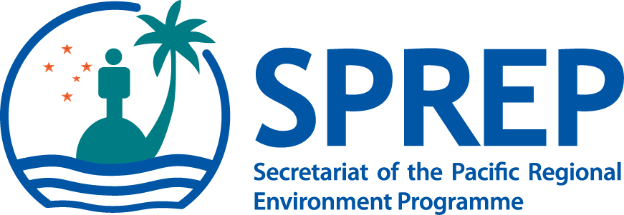

PO Box 240, Apia, Samoa
E: sprep@sprep.org
T: +685 21929
F: +685 20231
W: www.sprep.org

The Pacific environment, sustaining our livelihoods and natural heritage in harmony with our cultures.


BACKGROUND TO THE PACIFIC CLIMATE CHANGE PORTAL
The Secretariat of the Pacific Regional Environment Programme, in collaboration with its partners, is developing the Pacific Climate Change Portal: www.pacificclimatechange.net. The Pacific Climate Change Roundtable (PCCR) and subsequent SPREP meetings (2009 & 2011) approved the development of the Pacific Climate Change Portal (PCCP).

Regional and national institutions in the Pacific Island region hold a substantial amount of climate change‐related information and tools. The Pacific Climate Change Portal aims to ensure this information is readily accessible in a coordinated and user-friendly manner.
The portal will provide a platform for institutions and governments in the Pacific region to share information that can be readily accessed by linking to information repositories such as the Pacific Islands Global Ocean Observing System.

The Pacific Climate Change Portal will improve and strengthen understanding of climate change issues by a greater number of people in the Pacific region. Improved access to information will strengthen communication and collaboration to cope with climate change regionally and locally. This portal is also anticipated to leverage more climate change initiatives and innovation in Pacific Island Countries and Territories.

The major target groups expected to use the portal are national stakeholders (PICTs), regional stakeholders (CROP agencies) and development partners. A broader audience, however, is not excluded.

OBJECTIVES OF THE PORTAL
- Improve timely access to and delivery of climate change information and tools;
- Communicate and promote climate change challenges, issues and activities in the region and globally;
- Act as a hub for climate change information and knowledge sharing;
- Assist decision makers through the provision of information concerning climate change adaptation and mitigation;
- Identify gaps in current programme activities;
- Facilitate enhanced cooperation on climate change adaptation projects in the region.
GOVERNING BODIES
In February 2012, the Advisory Committee was formed comprising of partners, PIFS, SPC, USP and SPREP with the mandate to advise on the strategic direction of the portal. The Technical Sub Committee was also formed to provide technical guidance during portal development.

PORTAL FEATURES:
- Events calendar – contains the details of all regional meetings and workshops relating to climate change.
- Experts Directory – contains a list of experts in the region and their area of expertise. These experts are available if the PICTs need assistance in their work relating to climate change.
- Documents – contains links to documents and knowledge products that are of relevance to climate change.
- Pacific Climate Change Projects Database – intended to be a monitoring and evaluation tool for PIFACC, the database will contain information on projects from 2011- 2015. Users will have access to country profiles, CROP profiles and a search function for querying the online database.
- Pacific Climate Change Glossary - contains a list of common climate change terms that maybe of use to climate change practitioners in the Pacific. Whats unique about this list is that it simplifies the definitions making it easier for climate change and non climate change people to understand.
- National and regional committees – contains a list of national and regional committees and working groups.
- Image Library – contains a library of images collected from around the Pacific.
- Links – links to virtual libraries in the Pacific that have climate change related material and links to other useful sites for example on climate financing.
FUTURE DEVELOPMENT
- Geographical Information System (GIS) module – tool to illustrate, geographically, data to assist in decision making.
- Practical tools – tools to assist the PICTs in meeting their obligations to PIFACC and the UNFCCC for example the development of National Communications, etc.

