
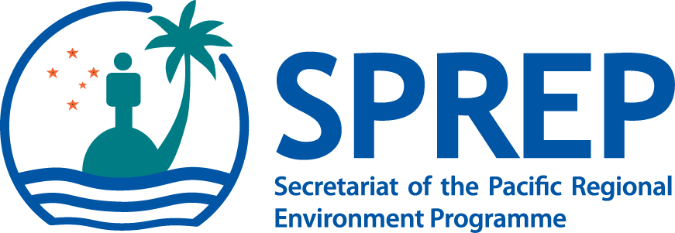

PO Box 240, Apia, Samoa
E: sprep@sprep.org
T: +685 21929
F: +685 20231
W: www.sprep.org

The Pacific environment, sustaining our livelihoods and natural heritage in harmony with our cultures.

Access and Benefit Sharing (ABS) Negotiation Training
5 - 8 August, 2014
and
Pacific joint preparatory meeting to the CBD COP12, CMS COP11 and Ramsar COP12
11 - 19 August, 2014
Nadi, Fiji

PICT Members Nomination Form

- It is important to note that participants from PICs attending the ABS Training Workshop will stay on for the CBD portion of the preparatory meeting.
- For Territories, nomination is limited to attendance at the ABS Training only
- For those countries that are parties to CMS a separate nomination form with guidelines is attached for information and appropriate action. For more information, contact Ms. Penina Solomona peninas@sprep.org
- Please return this completed nomination form with an official endorsement cover letter to Makerita Atiga makeritaa@sprep.org and copy Anna Bertram annab@sprep.org by close of business 27th May, 2014.

Country
Name (as shown on passport)
Job Title/designation
Focal point for (tick as appropriate) | CBD | ABS |  | CMS |  | Ramsar Convention
Name of Organisation/Department/Ministry
Postal Address
 | Fax: |  | Email
Phone
Brief statement on involvement in ABS, CBD, CMS and Ramsar


